

Communicate Unique Stock Calls Successfully So Others Take Action

Learner Workbook
NOTE: Please ensure you can interact with this document during the workshop in one of these methods:
- With a keyboard (as a Word document); or
- With pen (as a hard copy)

This document has been created for registered participants of AnalystSolutions’ workshops and should not be copied or re-distributed

Communicate Unique Stock Calls Successfully So Others Take Action

Acknowledgements
Some of the content for this workshop comes from Best Practices for Equity Research Analysts authored by James J. Valentine, CFA and published by McGraw-Hill.

Trademarks & Copyright Acknowledgements
None of the material in this document can be reproduced or distributed without the written consent of:

AnalystSolutions, LLP
1685 Burr Oak Dr.
Libertyville, IL 60048-9477
USA
+1-203-321-9400
AnalystSolutions.com

Table of Contents

Overview 1
Purpose & Learning Objectives 1
3-Step Communication Process 2
Opening Case 2
Step 1: Improve Content Quality With the ENTER™ Quality Framework 9
Be Expectational in Your Approach 9
Is the Analyst’s Research Expectational and Novel? 10
Revisit the Opening Case 13
Step 2: Utilize the Optimal Channel 18
Delivery Channel Trade-offs 18
Step 3: Improve Message Quality With the ADViCE™ Framework 19
Simulation, Part A: Identify Critical Factors 19
Simulation, Part B: Draft an Email Using ADViCE™ 24
Simulation, Part C: Refine Critical Factors 30
Simulation, Part D: Ensure Content is Differentiated 34
Simulation, Part E: Utilize Scenarios 37
Simulation, Part F: Draft Page 1 of Report 40
Simulation, Part G: Draft Slide Presentation 48
Appendix 64
Transformation Action Plan (TAP) 64
Notes 66

Overview

Purpose & Learning Objectives
 | Why a Communicate Unique Stock Calls Successfully So Others Take Action program?  Portfolio managers want unique forward-looking insights communicated in an easy-to-digest manner. And yet, in our study of PMs around the world, they criticize that over 75% of research is backward-looking or undifferentiated. A poorly constructed research report or presentation often is a symptom of a bigger problem, namely a lack of research to justify the call. Even when the content is high quality, analysts often are ineffective in concisely communicating how their differentiated, forward-looking view is supported with validated research.  Analysts utilize our frameworks to improve the quality of their content and message. Before analysts begin to communicate the first word of new research, it’s critical to ensure the content meets or exceeds our ENTER™ Quality Framework, which ensures the research is Expectational, Novel, Thorough, Examinable and Revealing. From there, we provide our ADViCE™ framework to ensure the stock call message is delivered effectively, via conversation, email, report or presentation. This hands-on, practical approach demonstrates the analyst’s message is Aware (of alternate views), Differentiated, Validated, Conclusion-oriented and Easy-to-consume. By using these frameworks, analysts maximize the impact in communicating their stock calls.
 | Learning Objectives  After completing this program, participants will be able to:  - Use our ENTER™ framework to identify when your research meets or exceeds a quality threshold, to determine if it’s ready to be communicated to others  - Be expectational in conducting research, even when analyzing historical data  - Design and construct an email, slide presentation and research report that meets all of the ENTER™ and ADViCE™ elements required for impactful stock communications  - Evaluate research reports and presentations using the ADViCE™ system to ensure they are being communicated in a manner that portfolio managers and other institutional investors prefer to receive  - Choose the optimal communication channel for delivering your stock ideas to balance the efficiency of delivery with the importance of motivating others to act on your ideas

3-Step Communication Process

Opening Case: Lucas Proposed Tonda Upgrade
Instructions for the Opening Case: Lucas Proposes Tonda Upgrade
- Read the following case study of an analyst’s initial presentation to his investment committee to ensure he has researched the investment thesis thoroughly enough to justify his recommendation
- Evaluate the analyst using the checklist below by responding Yes, No or Not Clear
- After you are done, review the answer key on the page following your answers
- For the purpose of evaluating a one-year price target, assume the case is occurring on January 1st and therefore any reference to “next year” begins in 12 months
ENTER™ Quality Checklist (to be used before starting the communication of a stock recommendation) | Yes/No/Not Clear
Expectational
Does the analyst have a forward-looking view in terms of the stock and the critical factor(s) likely to move the stock?
Has the analyst identified the catalyst(s) likely to move his stock and important dates when the catalyst is most likely to cause the stock to move to his price target?
Has the analyst framed company management’s forecast in terms of his independent financial forecast (rather than just repeat management)?
Novel
Does the analyst have a piece of information or insight that is new and not widely understood within the financial markets?
Has the analyst explained where his view falls within the FaVeS™ framework, in terms of identifying if he has a superior Financial forecast, Valuation method/multiple, or unique view about market Sentiment?
Does the analyst know why the market does not have his view?
Thorough
For the critical factors that are key to the stock call, did the analyst research more than one source or confirm the insight with an independent source?
Did the analyst conduct detailed modeling in the area surrounding the critical factor(s)?
Does the analyst avoid using management guidance as the primary justification for the call?
Examinable
Do you think the analyst has the following details that he could present to the committee?
- Data or insights about the critical factor(s)?
- Detailed financial forecast or valuation analysis, key to the investment thesis?
Revealing
Has the analyst created upside, downside, and base-case scenarios to identify where the investment thesis could have flaws?
Has the analyst identified specific risks beyond the macro?
Has the analyst provided his conviction level to others, even if it is not strong?

z | Narrator: Lucas Gallo is an equity research analyst at Nickel Mine Asset Management, having graduated with an MBA from a prestigious university before joining the firm five months ago. Lucas covers the consumer discretionary sectors including autos. He has not made any changes to the ratings of the stocks since being given the sector because he is still conducting initial research to develop his own unique view.  During their first year at his firm, each new analyst is assigned to a senior portfolio manager, to be his or her mentor. Lucas has been assigned to Alice Torres, an experienced PM and chair of the firm’s 5-member investment committee. The investment committee of three portfolio managers and two senior analysts has just come together in the firm’s conference room to hear Lucas’ presentation.
  Alice’s Dialogue | Lucas’ Dialogue | Your Thoughts
  Lucas, please share your thoughts with the committee. | I’ve been doing work on Tonda Motor Company for the past 3 months and have decided to initiate coverage with a buy rating. My $30 price target is 20% above the stock’s $25 closing price. I get to my target by applying a 10x P/E multiple on my forecast of $3.00 for next year. The reason for the upgrade is based on a meeting I had with the company’s management about a month ago. I went to their headquarters with a sell-side analyst and a few other buy-side analysts, where we heard management tell us it’s comfortable with the consensus estimate for this year and next, which are currently $2.77 and $2.98, respectively. During the meeting, they reiterated points made during their last investor day, by showing us some of their upcoming new car and truck models and saying their preliminary research suggested they are going to be hot sellers.
  Thank you, Lucas. What are the critical factors that will move the stock from $25 to $30? | I suspect the market doesn’t believe in the $2.98 EPS consensus estimate, or maybe it doesn’t understand how well the new models are going to sell.
  What research have you done to confirm these views? | I’ve read all of the company’s regulatory filings for the past 3 years and reviewed the quarterly transcripts from the past 4 quarters.
  Have you spoken to anyone about your view? Specifically, this notion you have that the market doesn’t believe in the $2.98 estimate? | No. But I have a gut feeling I’m right.
  What are the catalysts that will bring the market around to your thinking and drive the stock from $25 to $30? | Hmmm…maybe when the new models start selling really well, the market will get excited.
  Can you show us your earnings model? | Yes, I’ve printed copies of the basic earnings model that shows my forecast for everyone.
  Lucas, this model is formatted like those I see from Morningstar. Did you create this on your own? | I used Morningstar’s model but made a few changes.
  Such as? | I have Tonda’s pricing improving slightly more than their forecast.
  How does the pricing assumption relate to your investment thesis that Tonda’s cars are selling better than expected? | I guess if the cars are selling hot, that will lead to better pricing.
  Lucas, where could you be wrong? | I’m sorry, I don’t understand the question.
  What part of your thesis could turn out to be incorrect, and thus lead the stock to be dead money or even drop from current levels? | Well, I can’t imagine the stock going down from here, because management said on its last quarterly call that it’s comfortable with consensus expectations. Also, valuation levels seem low.
  How do you draw this conclusion? | The stock has been trading between a 9x and 10x forward earnings multiple for the past two years, and right now it’s at 9x.
  Is there anything else you would like to share with us? | No, that sums up my work.
  Thank you, Lucas. Please stop by my office later so we can discuss.

z | Exhibit 1: ENTER™ Quality Checklist  After you have completed your responses above, review the answer key on the following page
  ENTER™ Quality Checklist | Yes/No/Not Clear
  Expectational
  Does the analyst have a forward-looking view in terms of the stock and the critical factor(s) likely to move the stock?
  Has the analyst identified the catalyst(s) likely to move his stock and important dates when the catalyst is most likely to cause the stock to move to his price target?
  Has the analyst framed company management’s forecast in terms of his independent financial forecast (rather than just repeat management)?
  Novel
  Does the analyst have a piece of information or insight that is new and not widely understood within the financial markets?
  Has the analyst explained where his view falls within the FaVeS™ framework, in terms of identifying if he has a superior Financial forecast, Valuation method/multiple, or unique view about market Sentiment?
  Does the analyst know why the market does not have his view?
  Thorough
  For the critical factors that are key to the stock call, did the analyst research more than one source or confirm the insight with an independent source?
  Did the analyst conduct detailed modeling in the area surrounding the critical factor(s)?
  Does the analyst avoid using management guidance as the primary justification for the call?
  Examinable
  Do you think the analyst has the following details that he could present to the committee?
  - Data or insights about the critical factor(s)?
  - Detailed financial forecast or valuation analysis, key to the investment thesis?
  Revealing
  Has the analyst created upside, downside, and base-case scenarios to identify where the investment thesis could have flaws?
  Has the analyst identified specific risks beyond the macro?
  Has the analyst provided his conviction level to others, even if it is not strong?

z | Exhibit 2: ANSWER KEY TO OPENING CASE STUDY
  ENTER™ Quality Checklist (to be used before starting the communication of a stock recommendation) | Yes/No/Not Clear
  Expectational
  Does the analyst have a forward-looking view in terms of the stock and the critical factor(s) likely to move the stock? | Not clear: He has a forecast but it’s not clear he’s done any work on understanding the critical factor(s) that will drive his forecast.
  Has the analyst identified the catalyst(s) likely to move his stock and important dates when the catalyst is most likely to cause the stock to move to his price target? | No: He’s unsure as to what will move the stock.
  Has the analyst framed company management’s forecast in terms of his independent financial forecast (rather than just repeat management)? | Not clear: It appears as though he’s just accepting management guidance.
  Novel
  Does the analyst have a piece of information or insight that is new and not widely understood within the financial markets? | Not clear: He doesn’t offer any unique insight based on research.
  Has the analyst explained where his view falls within the FaVeS™ framework, in terms of identifying if he has a superior Financial forecast, Valuation method/multiple, or unique view about market Sentiment? | No: He has the same estimates as consensus and believes the stock will trade within its historical valuation multiple range.
  Does the analyst know why the market does not have his view? | No: He says he hasn’t spoken to anyone about his view.
  Thorough
  For the critical factors that are key to the stock call, did the analyst research more than one source or confirm the insight with an independent source? | No. He only read regulatory filings, transcripts and met with management.
  Did the analyst conduct detailed modeling in the area surrounding the critical factor(s)? | No: He mentioned his modeling is for better pricing, not volume growth due to the new models selling better than expected.
  Does the analyst avoid using management guidance as the primary justification for the call? | No: It appears based primarily on management guidance.
  Examinable
  Do you think the analyst has the following details that he could present to the committee?  - Data or insights about the critical factor(s)?  - Detailed financial forecast or valuation analysis, key to the investment thesis? | No: It doesn’t appear as though he has any unique data or a detailed financial forecast to support his view.
  Revealing
  Has the analyst created upside, downside, and base-case scenarios to identify where the investment thesis could have flaws? | No: He doesn’t have an answer when Nadia asks him, “Where could you be wrong?”
  Has the analyst identified specific risks beyond the macro? | Same as above
  Has the analyst provided his conviction level to others, even if it is not strong? | No

Step 1: Improve Content Quality With the ENTER™ Quality Framework

Be Expectational in Your Approach
Instructions for the “Be Expectational in Your Approach” Exercise:
- Too often, analysts are focusing on historical data and past events, at the expense of conducting research to forecast the future
- Read the example quotes below which could be from a typical analyst’s report or presentation, and notice how the “Bad Practice” in column 1 is converted to a “Best Practice” in column 2
- Even though you are being asked to review the analyst’s message (which is covered later as Step 3 of our 3-step process), try to focus on Step 1, by specifically asking, “Is the analyst approaching his or her research efforts in a manner to be expectational?”
- If you brought your own sample research, review to see if it focuses primarily on the past, present or future
z | Exhibit 3:Examples for “Be Expectational in Your Approach” Exercise
  Bad Practice:  Backward looking (reviewing old news) | Best Practice:  Using the past to support forward-looking view | Recommendations
  “Apple’s quarterly results fell short of consensus expectations because iPhone sales were weaker than expected.” | “Even though Apple’s near-term results fell short due to weak iPhone sales, we should note the stock outperformed the S&P 500 more than 10% during the three months leading up to prior iPhone product launches, which we forecast to occur again in the upcoming months before the next launch.” | If referencing the past, analyze and quantify historical trends as they pertain specifically to the critical factors likely to impact the stock in the future. (Don’t review the past unless it helps forecast the future.)
  “We attended AT&T’s analyst meeting on Wednesday where management discussed its strategy.” | “Our bullish view towards AT&T was further confirmed at Wednesday’s analyst meeting because the company continues to succeed in improving margins by moving more of its mobile subscribers to data-centric pricing.” | Prepare for the meeting by focusing on the critical factors likely to be discussed.  If you differ from consensus on any critical factor, probe that area with management. (Make the meeting an opportunity to compare your scorecard against theirs, rather than be a passive journalist.)
  “During Daimler’s quarterly call, management reiterated its €6B cost savings and goal to keep truck margins at least flat.” | “Based on our work, we believe Daimler’s €6B cost savings plan will take at least 12 months longer to achieve than the target management discussed on its quarterly call.” | Prepare for the call by focusing on the critical factors likely to be discussed.  If you differ from consensus on any critical factor, probe that area in advance with your information sources.

Is the Analyst’s Research Expectational and Novel?
Instructions for the “Is the Analyst’s Research Expectational and Novel?” exercise:
- This exercise has two brief examples of bullet points found in an analyst’s report about a stock
- In the table that follows, identify if the analyst’s approach is missing either of these elements:
  - Expectational
  - Novel
- When you have finished, read the answer key that follows
- If you brought your own sample research, review to see if the first 2-3 bullets or paragraphs are expectational and novel
z | Example 1: Excerpt from analyst’s report on company ABC (household and personal care company):  “Based on its quarterly release, ABC's 2Q sales increased 3% year-over-year, which compared to the 2% growth in 1Q. The data shows the strong volume growth in paper towel and toilet tissue were offset by weakness elsewhere in the portfolio. Market share was up in paper towels, toilet tissue, toothpaste, and deodorants, but down in diapers, laundry, batteries, and razor blades. We continue to recommend buying the stock.”
  ENTER™ Element | Does it have this element? | What does the reader want the analyst to convey in the first paragraph to fully meet this criteria?
  Expectational (the analyst should offer a unique, forward-looking view in terms of the stock or the critical factor being discussed)
  Novel (the analyst should have a new piece of information or insight impacting a critical factor that is not widely understood by the market)
z | Example 2: Excerpt from analyst’s report on company DEF (clothing retailer targeted to adolescents):  “We toured seven of DEF’s stores in the suburbs of Metropolis, where we made some very insightful observations. Most stores had a larger stock of blue jeans than we expected, and were out of the new line of Pinky Inky shoes. We didn’t like the new layout of the stores, where the merchandise is denser in the front of the store, but we were impressed to see that the company is using new environmentally-friendly hangers that are recyclable. We continue to rate DEF over-weight.”  After you have finished above, continue to the answer key that follows
  ENTER™ Element | Does it have this element? | What does the reader want the analyst to convey in the first paragraph to fully meet this criteria?
  Expectational (the analyst should offer a unique, forward-looking view in terms of the stock or the critical factor being discussed)
  Novel (the analyst should have a new piece of information or insight impacting a critical factor that is not widely understood by the market)
z | Exhibit 4: ANSWER KEY for “Is the Analyst’s Research Expectational and Novel?”
  ENTER™ Element | Does it have this element? | What does the reader want the analyst to convey in the first paragraph to meet this criteria?
  Example 1
  Expectational (the analyst should offer a unique, forward-looking view in terms of the stock or the critical factor being discussed) | No | Are these trends sustainable into the future or one-time in nature? If sustainable, do these observations impact future earnings or cash flow growth?
  Novel (the analyst should have a new piece of information or insight impacting a critical factor that is not widely understood by the market) | No | Is this trend different than consensus, and if so why is it occurring and will it continue?
  Example 2
  Expectational (the analyst should offer a unique, forward-looking view in terms of the stock or the critical factor being discussed) | No | Do these observations impact future earnings or cash flow growth? If so, by how much?
  Novel (the analyst should have a new piece of information or insight impacting a critical factor that is not widely understood by the market) | Maybe (it was unique work, but not clear if it’s material) | Are these observations from only seven store material? If so, are they different than consensus? If so, why is it occurring and will it continue?

Revisit the Opening Case
Instructions for “Revisit the Opening Case” Exercise:
- Similar to the opening case, evaluate the case below using the ENTER™ checklist that follows by responding Yes, No or Not Clear
- After you are done, review the answer key on the page following your answers
- For the purpose of evaluating a one-year price target, assume the case is occurring January 1st and therefore, “next year” begins in 12 months
z | Narrator: After Alice has mentored Lucas for the past few weeks, he has come back with another stock recommendation for the investment committee.  .
  Alice’s Dialogue | Lucas’ Dialogue | Your Thoughts
  Lucas, please go ahead and present your thoughts. | Thank you. First, I want to apologize for being unprepared for my last stock call. I hope you’ll see that I’ve done quite a bit of additional work. I would like to initiate coverage of General Bavarian Motors, ticker GBM, with a buy rating and a one-year price target of $75, which would be 18% upside from last night’s close of $63.50. The buy-rating is based on the stock maintaining its current 11x forward earnings on my estimate of $6.80 per share for next year, which is about 15% above consensus expectations. I’m assuming the stock continues to trade at a 20% discount to the market’s multiple. Based on three conversations I’ve had with sell-side analysts and three other buy-side analysts, I believe the market is overly concerned with two issues:  - Potential labor unrest by GBM’s unionized employees in Europe, who have their labor contract coming due in four months; and  - Competitive pressures in emerging markets such as China and India
  Have you done any work on these issues? | Yes. Here’s what I’ve discovered: The European labor union suffered a bad defeat five months ago when it went on strike at another company’s plant that was subsequently shut down and all of the employees lost their jobs. The union leaders are potentially going to be voted out of office by their members because so many jobs have been lost. Based on our conversation with two labor consultants, the union leadership is much more concerned about improving its members’ job security than trying to increase wages above inflation.
  How does your estimate differ than consensus? | As you can see on row 35 of my earnings model, my $6.80 EPS estimate assumes labor costs rise only 4% next year, whereas most sell-side analysts have it increasing 6-7%.
  And what about competition in the emerging markets? | As for China and India, we’ve read a number of trade journals that explain that lower-cost domestic start-ups are struggling to maintain quality levels as they expand, which is allowing GBM to capitalize on its higher quality products. We confirmed our thesis by speaking with two industry consultants who specialize in the emerging market auto sector. As you’ll see in row 18 of my earnings model, my forecast does not have any decline to pricing in those markets, but the average sell-side model expects it to drop 3%-5%. Under my upside scenario, the company’s higher quality could allow it to raise pricing 3%-4%, similar to levels over the past four years.
  Why is the market missing these two points? | The company’s management says it’s comfortable with next year’s consensus estimate of $5.90 per share, but we believe the company is taking a conservative stance because it’s about to begin labor negotiations and doesn’t want to appear too profitable. We went back and looked at the last three rounds of labor negotiations over the past 12 years, and each time, after the negotiations are settled, the company beats numbers, presumably because management kept a lid on sell-side expectations during the negotiations.
  So, what’s going to bring the market around to your thinking? | I believe once the labor agreement is reached, the company will be more vocal about putting to rest concerns about competitive pressures in China and India. Based on my estimates, the company should start to beat current EPS expectations in about two quarters and should significantly beat estimates four quarters from now. I also expect J&J Auto Quality awards to be released in three months, which should show the quality challenges of GBM’s competitors in China and India.
  What are the risks to your thesis? | My $75 price target is my base-case scenario, whereas I have a downside scenario of $60 and an upside scenario of $85. The biggest risk to my thesis is if the labor negotiations deteriorate and the company experiences much higher wage inflation. There’s also the risk that the competition in China and India cut prices, which could have a negative impact, but only if the competitors can close the quality gap. For a down-side scenario, I assume labor costs rise to the company’s 10-year average and auto pricing drops 3% in China and India, which lowers my $6.80 EPS estimate to $5.75. If I apply the 10-year average relative multiple of a 25% discount to the market’s multiple on my $5.75, I arrive at a downside of $60. I’m still relatively new to this business, so I can’t say that I have 100% conviction, but I’m much more confident with this call than I was with my earlier Tonda call.

z | Exhibit 5: ENTER™ Quality Checklist  After you are done above, review the answer key on the following page
  ENTER™ Quality Checklist | Analyst #1  Yes/No/Not Clear | Analyst #2 (optional)  Yes/No/Not Clear
  Expectational
  Does the analyst have a forward-looking view in terms of the stock and the critical factor(s) likely to move the stock?
  Has the analyst identified the catalyst(s) likely to move his stock and important dates when the catalyst is most likely to cause the stock to move to his price target?
  Has the analyst framed company management’s forecast in terms of his independent financial forecast (rather than just repeat management)?
  Novel
  Does the analyst have a piece of information or insight that is new and not widely understood within the financial markets?
  Has the analyst explained where his view falls within the FaVeS™ framework, in terms of identifying if he has a superior Financial forecast, Valuation method/multiple, or unique view about market Sentiment?
  Does the analyst know why the market does not have his view?
  Thorough
  For the critical factors that are key to the stock call, did the analyst research more than one source or confirm the insight with an independent source?
  Did the analyst conduct detailed modeling in the area surrounding the critical factor(s)?
  Does the analyst avoid using management guidance as the primary justification for the call?
  Examinable
  Do you think the analyst has the following details that he could present to the committee?
  - Data or insights about the critical factor(s)?
  - Detailed financial forecast or valuation analysis, key to the investment thesis?
  Revealing
  Has the analyst created upside, downside, and base-case scenarios to identify where the investment thesis could have flaws?
  Has the analyst identified specific risks beyond the macro?
  Has the analyst provided his conviction level to others, even if it is not strong?
z | Exhibit 6: ANSWER KEY TO “Revisit the Opening Case” Exercise
  ENTER™ Quality Checklist (to be used before starting the communication of a stock recommendation) | Yes/No/Not Clear
  Expectational
  Does the analyst have a forward-looking view in terms of the stock and the critical factor(s) likely to move the stock? | Yes: He has identified two critical factors and has a forward-looking view.
  Has the analyst identified the catalyst(s) likely to move his stock and important dates when the catalyst is most likely to cause the stock to move to his price target? | Yes, he believes earnings will begin to beat expectations in two quarters. He also expects the J&J Auto Quality Awards to be released in three months. He also identifies the labor agreement settlement as a catalyst but doesn’t forecast a specific timetable.
  Has the analyst framed company management’s forecast in terms of his independent financial forecast (rather than just repeat management)? | Yes: He says, “management says it’s comfortable with next year’s consensus estimate of $5.90 per share,” and then explains, “we believe the company is taking a conservative stance because it’s about to begin labor negotiations and doesn’t want to appear too profitable.”
  Novel
  Does the analyst have a piece of information or insight that is new and not widely understood within the financial markets? | Yes: He has spoken to the sell-side, buy-side, and industry contacts as well as read trade journals to determine the two critical factors are misunderstood by the market.
  Has the analyst explained where his view falls within the FaVeS™ framework, in terms of identifying if he has a superior Financial forecast, Valuation method/multiple, or unique view about market Sentiment? | Yes: He explains that his EPS estimate is $6.80 whereas consensus is €5.90. He’s using a 10-year average valuation multiple and so that’s not unique about his call.
  Does the analyst know why the market does not have his view? | Yes: He explains that the market is following management’s guidance which he believes is conservative. He also explains that the competitor’s quality problems in China are probably not understood by the market.
  Thorough
  For the critical factors that are key to the stock call, did the analyst research more than one source or confirm the insight with an independent source? | Yes: He spoke to two consultants for each critical factor.
  Did the analyst conduct detailed modeling in the area surrounding the critical factor(s) | Yes: He identifies specific areas in his financial model that help the committee dig deeper to see his assumptions.
  Does the analyst avoid using management guidance as the primary justification for the call? | Yes: In fact, he’s well above management’s guidance.
  Examinable
  Do you think the analyst has the following details that he could present to the committee?  - Data or insights about the critical factor(s)?  - Detailed financial forecast or valuation analysis, key to the investment thesis? | Yes: He explained he has spoken to four industry consultants, three sell-side analysts and three buy-side analysts as well as read industry trade journals that support his thesis. He also explained how the company beat expectations in the past after labor negotiations were settled.
  Revealing
  Has the analyst created upside, downside, and base-case scenarios to identify where the investment thesis could have flaws? | Yes: He has conducted a base-case, upside and downside scenario analysis to show how the stock will likely react based on outcomes of the two critical factors he has researched
  Has the analyst identified specific risks beyond the macro? | Yes: He discussed the risk if labor costs should go up at historical averages or if the company’s competitors cut rates.
  Has the analyst provided his conviction level to others, even if it is not strong? | Yes: He states, “I’m still relatively new to this business, so I can’t say that I have 100% conviction, but I’m much more confident with this call than I was with my earlier Tonda call.”

Step 2: Utilize the Optimal Channel

Delivery Channel Trade-offs
z | 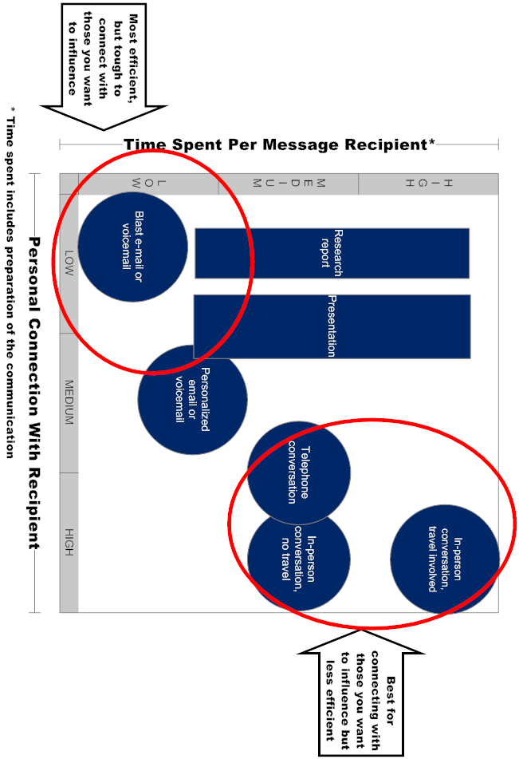

Step 3: Improve Message Quality With the ADViCE™ Framework

Simulation, Part A: Identify Critical Factors
Simulation Background:
You continue to follow Lucas Gallo in the simulation below. As a reminder, Lucas is a buy-side analyst mentored by his PM, Alice Torres. The simulation has been created to illustrate Lucas is following the ENTER™ framework for generating high-quality research content, but due to time constraints, the primary goal is to become comfortable using the ADViCE™ framework to communicate your stock-related messages.

Lucas will travel to attend “Ship-Con,” the largest freight shipper conference in the country (recall Lucas is responsible for researching the transportation universe of stocks). Ship-Con is regularly attended by many of the large customers of the freight transportation companies and their management. Sell-side or buy-side analysts do not often attend which means Lucas is more likely to obtain insights not widely known by consensus than attending a sell-side hosted conference.

Mid-day on Tuesday, Lucas flies to attend the conference, which begins with a cocktail hour Tuesday evening followed by dinner. Wednesday is filled with formal educational and informal networking sessions. Lucas’ goal is to build contacts to further his research effort in this area and identify the critical factors most likely to move his stock. He has no idea that the upcoming week could advance his career if he effectively communicates the insights he learns. As background, it is currently December and all discussions about earnings per share (EPS) estimates in the case pertain to the upcoming calendar year or the calendar year after.
Instructions for Simulation, Part A:
- As you read the passage below for Part A, underline or highlight factors that could potentially move Lucas’ universe of stocks
- Be mindful as you read the passage, some of the content is required later in the workshop and so do your best to comprehend the information, even if it is not used for this portion of the simulation.
- Your work will not be collected, so feel free to make any type of notes that will help you recall this information more easily for this or upcoming lessons.

z | To keep the simulation concentrated on developing communications skills, we will focus on only the following four stocks in Lucas’ universe:  Exhibit 7: Information about select stocks in Lucas' universe
  Company Name (ticker) | Background
  Railroads
  Grand Western Railroad (GWR) | Average performer; nothing especially unique. Commands P/E ratio that is the average among its peers
  Central Route Railroad (CRR) | Considered the best-run railroad in the industry, primarily due to skilled management team. Commands the highest P/E ratio among its peers
  Northern & Southern Railroad (NSR) | Turn-around story that is starting to be realized. Currently commands the lowest P/E multiple in the industry
  Trucking
  Next-Day Trucking (NDT) | Premium next-day delivery company that currently serves 50% of the country, (due to the nature of next-day deliveries, NDT is not a long-haul trucking company and does not haul bulk commodities)
z |  | Part A: Lucas’s Research Conducted on Tuesday Evening  On Tuesday evening, Lucas attends the pre-conference cocktail hour and dinner where he “works the room” to learn the following:  - A large steel shipper says that new regulations limiting the weight trucks can carry is going to make longer-haul truckers less competitive with railroads for shipping bulk commodities.  - A hospital supply company manager says he was recently asked by his Next Day Trucking (NDT) salesperson how much additional business he would potentially give to the carrier if it were to expand its next-day service from its current 50% of the country to 75% of the country.  - Two large retailers and one large auto manufacturer say the railroads are taking up customer pricing at unprecedented levels, ranging from 4% to 6%. Lucas’ estimate is for a 3% increase, which he thinks may be in-line or slightly above consensus expectations. An industry “old-timer,” who helped to found the Ship-Con event 32 years ago, said to a small group that he has never seen a better environment for the railroads to take up customer pricing.  - The manufacturer of a new technology, the radio-frequency identification (RFID) tag, explains their technology will improve transport companies' asset utilization and lower their customer's inventory costs. This is done by inserting the relatively inexpensive RFID tag (less than 5-cents each) into every item that is produced by a company, which can then be read by devices throughout the logistics supply chain. He believes their product will lower transportation logistics costs for retail and manufacturing customers by 10%.  - When Lucas asks, four shippers tell him they see the current economy growing at a faster rate than recent trends. The other five tell him it’s about "normal."  That evening, Lucas wants to prioritize where he should spend his time the next day at the conference and what information he should communicate to his PM, Alice Torres, in an email that evening. Simulate Lucas’ efforts by completing the exercise that follows, which prioritizes the factors above (important for a later part of the workshop).
Instructions for evaluating the critical factors for Simulation, Part A:
- Lucas understands he should focus on critical factors in his research because they are the foundational building blocks for generating alpha. To help prioritize his time and communications, he has developed the table on the next page (Exhibit 8), based on the EPIC™ framework which he learned is a best practice of successful analysts.
- To speed up the discovery stage of the research for the simulation, we have:
  - Provided additional details found in Exhibit 8; and
  - Rated each factor using our EPIC™ framework (the headings in each of the columns), on a scale of 1 to 5 with 5 as “strongly agree”. (In the real world you would derive these ratings based on your research before and during the conference.) Note we assume a factor must move EPS at least 10% to be material for this simulation.
- After reviewing Exhibit 8, select the two best factors worth additional research and communicating to Lucas’ portfolio manager
- If you’re unclear about how to define a factor’s ranking in Exhibit 8, consider these guidelines:
EPIC™ Framework | Ask yourself:
Exceeds my materiality threshold of 10% | Will changes in consensus expectations exceed my materiality threshold if this factor were to occur during my investment time horizon?
Probably going to occur during my time horizon | What is the probability this factor will occur, become much more certain to occur, or deviate materially from the consensus trend, during my investment time horizon?
I'm good at forecasting the factor and catalyst | Based on my research on the topic, am I good at forecasting this factor and its catalyst? (it’s not just a guess)
Consensus is poor at forecasting or spotting factor | Based on the information in the current market, is the overall consensus poor at accurately forecasting or spotting changes in this factor?

z |  | Exhibit 8: First Round for Identifying Where Lucas Should Focus His Research Time and Communications (using EPIC™ framework)  Ratings are on a scale of 1 to 5 with 5 as “strongly agree”  - Based on what you have learned to this point, highlight in the table above, the two most ideal factors where Lucas should spend his time conducting further research and communicating to Alice Torres.  After you have selected the two, continue to the text below to review our view
  # | Factor | Exceeds my materiality threshold of 10% | Probably going to occur during my time horizon | I'm good at forecasting the factor and catalyst | Consensus is poor at forecasting or spotting factor
  1 | Factor: New regulations limiting trucks weights will impact bulk commodities  Critical?: Not for the truck stock in Lucas’ universe (NDT) because it doesn’t haul bulk commodities. Might be a slight benefit to the railroads but bulk trucking freight is a very small market compared to the railroad industry’s total revenue base | 1 | Not worth investigating because it’s not material | 2  (Could be higher, with more research, but why bother?) | 4
  2 | Factor: NDT may potentially expand to another 25% of the country. As background, the company has expanded in recent years in a flawless manner.  Critical?: Probably, but need verification from others. Your current forecast (excluding this potential expansion) is for the company to grow revenues 7% next year and 5% the year after. | 4 | Need verification | Could be high with more research | Need verification
  3 | Factor: Railroads are taking up customer pricing at unprecedented levels  Critical?: Probably…it doesn’t appear to be in consensus but need to verify. Every 1% better-than-expected pricing, results in 10% higher EPS for the railroads (assuming the railroad’s business is not under long-term contract and can be re-priced at current rates). | 5 | 4 | 4 | Need verification
  4 | Factor: RFID will lower transportation logistics costs for retail and manufacturing  Critical?: Possibly for transportation customers, but not clear how it impacts the railroads and trucking companies | Unknown | Unknown | Unknown | 5 (nobody is talking about it)
  5 | Factor: Economic growth faster than recent trends. It’s worth noting during the last two economic recoveries when the economy was accelerating, the railroad’s P/E ratios expanded by 20%  Critical?: Possibly, because it will increase volumes and allow for better pricing, but difficult to forecast, especially over the long term | 4 | 3 | 2 | 4
Our view on where Lucas should spend his time conducting further research and communicate to Alice Torres
- We would focus more time and communications with Alice on the following two factors:
  - Factor #3 (railroad pricing): It’s high on 3 of the 4 criteria and your suspicion is that it’s high on the 4th criteria as well, which makes it a perfect critical factor that will generate alpha
  - Factor #2 (NDT geographic expansion): it’s material and not likely in consensus. If you can validate with another source, it will likely be high on the two other criteria.
- Here are why the other factors did not make our “top 2” list:
  - For #1 (new truck regulations): even if you verified it to be likely, it’s not material to these stocks and so don’t spend another second on it. Pass along to fellow colleagues if they cover stocks that would be impacted.
  - For #4 (RFID): it’s not clear when it would impact the carriers or even if it would impact them (recall the interviewee said it’s likely to help the carrier’s customers).
  - For #5 (economic growth): it’s helpful to know for forecasting earnings and pass along in a communication to PMs and colleagues (especially for economically-sensitive stocks), but given that you don’t make a living forecasting the economy; it’s too macro to make it the primary rationale for your stock recommendation. (There’s not much value in upgrading a specific stock solely because you’ve heard the economy is getting better.)

Simulation, Part B: Draft an Email Using ADViCE™
Instructions for “Draft an Email Using ADViCE™” Exercise:
- The purpose of Part B is to use the ADViCE™ framework to draft an email conveying insight about a stock that others will find useful and easy to understand
- After the cocktail party and dinner, Lucas needs to compose an email to Alice Torres to explain what he has learned (not to upgrade a stock yet). Using only the information in Part A, draft the email using the ADViCE™ template below.
- For the purpose of time, only write the email about one of the two potential critical factors above (#2 or #3).
- The template in Exhibit 9 that follows is intended to be a guide. Focus on the first column “Element” and second column “Wording” in order to create your draft of the email in the “Your Version” column
- There will be some elements in the template not worth communicating at this point because Lucas still needs to conduct additional research before changing a rating or revising earnings estimates. Recall the first bullet above, in that this is not an exercise for writing an upgrade report. Do not get frustrated if there isn’t enough information to complete all elements of the template below –remember the goal is to utilize the ADViCE™ framework to help maximize the effectiveness of your message.
- Recall Lucas is at a buy-side firm and so he is not restricted about discussing potential earnings or rating changes, which is often a restriction at sell-side firms
- Based on the file type of your Learner Workbook:
  - If you are utilizing an electronic version of this file (Microsoft Word): enter your response in the right column below by typing over the existing text, making sure to use any helpful text from the “Wording” column or the earlier passage about Lucas
  - If you are utilizing a hard-copy version of this file, use the table below as a template and write your version on the lined page that follows
z | Exhibit 9: Template for “Draft an Email Using ADViCE™” Exercise  This table continues onto the next page…
  Element | Wording | Your Version:
  Brief Conclusion | We are/I am…  - recommending the purchase of…  - upgrading/downgrading…  - more bullish/more bearish/concerned towards…  - raising/lowering our estimate/price target for…  - reinforcing/revisiting our positive/negative view towards…  [AND]  …[stock name(s) followed by ticker(s)] because…  - our/my work shows/suggests…  - we/I can now conclude…  - we/I have discovered…  [AND]  …[the critical factor(s)] is/will likely…  - be better/worse than consensus/we/I expected  - not in consensus expectations  - occur sooner/later than consensus/we/I expected | Allows others to decide if they want to spend more timing consuming your message
  Price target math | We/I derive a one-year price target of $XX, which is XX% above/below yesterday’s close by…  [When using an absolute or relative valuation multiple]  …applying a X [valuation multiple] multiple on our/my XX.00 [EPS, CFPS, BV] estimate for 20XX [time period]  [OR]  …applying a X% premium/discount to the market’s multiple on our/my XX.00 [EPS, CFPS, BV] estimate for 20XX [time period]  [AND/OR]  [When using an intrinsic valuation method such as DCF, EVA, RI, etc.]  …using a [DCF, EVA, RI, etc.] analysis with the following assumptions: [state assumptions for key variables such as long-term revenue growth, changes to margins, the risk-free rate, equity risk premium, cost of equity, WACC, terminal value and years of forecast before terminal value is reached] | DON’T WORK ON THIS ELEMENT BECAUSE LUCAS DOESN’T HAVE A NEW PRICE TARGET YET
  FaVeS™ element that is being changed (be brief) | Our/my view about [critical factor(s)] compels/allows/motivates us/me to…  [here is where you briefly discuss your superior view, as defined by at least one of the following]  - [Superior forecast: when your forecast differs materially from consensus]  - …raise/lower/initiate coverage with our/my EPS/CFPS/growth rate forecast for this year/next year, putting us/me XX% higher/lower than consensus  [AND/OR]  - [Superior valuation: when your valuation assumptions are different from current consensus]  - …justify a valuation multiple of XX, which is XX% above/below its current/historical level.  [AND/OR]  …justify using a [new valuation method not used by consensus] because [explain why this valuation method provides a more accurate price target than the conventional method] | Briefly highlights your: a) superior forecast (vs. consensus); and/or b) superior valuation method/multiple; and/or c) superior read on short-term sentiment towards the stock
z | …this is a continuation of the table from the prior page  After you have completed this portion, continue to review the answer key
  Element | Wording | Your Version:
  Research to support unique FaVeS™ element | [If there is more than one critical factor driving the story, you may want to communicate this element and the one directly below for each critical factor at a time]  Our/my conclusion/above/below-consensus estimate is based on…  - our/my analysis of…  - discussions with…  - data we/I collected from…  - our/my unique modeling of… | Validates view based on fundamental research and not just a hunch or guestimate
  Quantify unique FaVeS™ element | Specifically, we/I believe this results in $XX/XX%…  - higher/lower EPS/CF/BV…  - faster/slower EPS/CF growth rate…  …for 20XX [time period] than…  - current consensus expectations**  - our/my prior estimate  AND/OR  - expansion/contraction of the stock’s relative/absolute valuation multiple from X to Y | Answers “materiality” question by quantifying how your view differs from the consensus
  When and why will consensus adopt your view? | We/I believe consensus does not reflect our view because [put your rationale here and avoid repeating your research above (instead focus on why consensus hasn’t come around to your way of thinking yet)]. We believe the consensus/market will adopt/understand our/my view by [specific quarter or time of year] due to [catalyst that will drive the market to your way of thinking]. | Explains how your view of the catalyst(s) differs from the consensus thinking and when it will become clear to the market
  What could go wrong? | We/I have a high/low/modest degree of conviction/confidence in our/my call because [explain why your analysis above is valid or uncertain]. Our/my downside scenario results in a stock price of XX (XX% below yesterday’s close), and our/my upside scenario is XX (XX% above yesterday’s close). | Conveys your conviction level and provides alternative scenarios to demonstrate you’re not oblivious to where you could be wrong
 | The blank lines that follow are for those working with a hard copy of the Learner Workbook
 | After you have completed this portion, continue to the next page to review the answer key
Answer Key for “Draft an Email Using ADViCE™” Exercise:
- Compare the answer key below to the email you composed above.
- Writing is subjective and so don’t expect to have the exact wording. More importantly, see if you captured the key ideas of each element – remember the goal is to utilize the ADViCE™ framework to help maximize the effectiveness of your message.
- Hopefully, your version followed the ADViCE™ framework, but if not, use the right-most column below in Exhibit 10 to identify how your version could have been improved
- Note:
  - In the answer key below, we have blended the discussion about critical factors #2 and #3 even though the assignment was to only focus on one of the two factors
  - If you were composing a sell-side report, some of the content below would not be suitable for publication because it’s still too speculative

z | Exhibit 10: Answer Key for “Draft an Email Using ADViCE™” Exercise:
  Element | Wording | How could you have improved your version above for this element?
  Brief Conclusion | I need to confirm some of the information I’m gathering, but it looks like I may be raising my estimates for Grand Western Railroad (GWR), Central Route Railroad (CRR) and Northern & Southern Railroad (NSR) as well as the trucking stock Next Day Trucking (NDT). Based on my initial conversations I have discovered railroad pricing is increasing at unprecedented levels and NDT may be expanding geographically to another 25% of the country.
  Price target math | [It may be premature to be providing price target math because Lucas still needs to conduct more work]
  Change or update of superior FaVeS™ element | If my work is confirmed through additional conversations, I’ll be taking up my EPS estimates for the railroads, potentially 10%-30%. I may also raise my numbers for NDT but will need to research how prior expansion has helped its EPS. I may also be able to justify expanding P/E multiples if earnings momentum is accelerating.
  Research to support unique FaVeS™ element | My conclusion about better railroad pricing is based on conversations with two large retailers and one large auto manufacturer who told me the railroads are taking up customer pricing at unprecedented levels, ranging from 4% to 6%, which compares to the 3% in my model. Also, the person who helped found this conference 32 years ago told a small group that he has never seen a better environment for the railroads to take up pricing. And finally, there are potentially new regulations that are going to shift some bulk commodities from long-haul truck to railroads.  My conclusion about NDT is based on a large hospital supplier who was recently asked by his NDT salesperson how much additional business he would potentially give to the carrier if it were to expand its next-day service from its current 50% of the country to 75% of the country.
  Quantify unique FaVeS™ element | If railroad pricing increases better than expected, every 1% increase results in 10% higher EPS. My current estimate is for pricing to increase 3%, but it could be as high as 6% if these shippers are representative. In terms of valuation multiples, during the last two economic recoveries, when the carriers’ earnings were accelerating, their P/E ratio expanded by 20%.  For NDT, before any expansion, my current estimate has it growing revenue 7% next year and 5% the year after. If it expands to 25% more of the country from its current 50% coverage, it would result in raising my revenue estimates. I’ll need to do some research on the past to determine how quickly the geographic expansion grows revenues and EPS.
  When and why will consensus adopt your view? | I suspect this new information will differ from consensus because: 1) it doesn’t understand the strength of the railroad pricing environment and 2) it isn’t forecasting NDT’s geographic expansion. If my preliminary research is correct, the railroads and NDT will likely exceed consensus expectations by late next year, causing consensus to raise its estimates.
  What could go wrong? | I have a high degree of conviction about the railroad pricing thesis because I’ve heard it from four independent sources that have no connections with the companies. The primary downside risk to this thesis would be a sudden slowdown in the economy, which is opposite of what I’m hearing from several shippers.  I have a lower level of confidence in the NDT expansion thesis, only because I haven’t heard it from more than one contact yet. If it turns out NDT is expanding, there’s always execution risk, but the company has expanded in the past flawlessly.

Simulation, Part C: Refine Critical Factors
Instructions for “Refine Critical Factors” Exercise:
- The purpose of Part C is to further refine Lucas’ list of factors down to just the key critical factor(s) so that his communications are focused on the most likely drivers of a stock
- Read the passage below, where Lucas’ research efforts continue the next day
- Lucas reviewed his potential critical factor table (Exhibit 8 found in Part A) and is going to spend the rest of the conference attempting to get clarity on open issues
- As you read the passage, underline or highlight information that helps complete elements missing from Exhibit 8
- This passage will also be used later for drafting a research report and slide presentation and so take your time to ensure you understand the content
- To help speed up completing Exhibit 8, we have organized the content below by factor

z | Part C: Lucas’s Research Conducted on Wednesday  Conversations to determine if NDT’s is likely to expand  - At a private breakfast arranged by Lucas, a local commercial real estate lessor who specializes in freight transportation property confirms NDT is looking for new terminal space in that city, which is an area it doesn’t currently serve  - Later in the day, when asked, two large shippers tell Lucas they would like to see NDT expand to more regions of the country because they provide great service at competitive pricing. One of them said an NDT salesperson asked how much additional business his company might give to NDT if it began to serve the western region (25% of the country) in the second quarter of the upcoming year.  - A truck manufacturer tells Lucas that NDT normally replaces 25% of its trucks in a given year, but for some reason, the company has placed an order for enough trucks to replace half of its fleet next year  Conversations to determine if railroads are taking up customer pricing and which company has the most exposure  - At an open shipper forum session, the industry’s shipper association president says his members are upset because he’s hearing that railroad pricing is increasing 4%-6% this year, compared to only 1%-2% in each of the past 5 years.  - In the afternoon, at the end of a session Lucas is attending, the speaker who is a railroad car lessor says there is a shortage of railroad cars and locomotives, which is giving the railroads better pricing power with their customers  - During the cocktail hour that evening, Lucas finds local sales people from two railroads he doesn’t cover, who independently confirm there is a shortage of railcars, which is making it easier to raise customer pricing  - That evening, Lucas goes into his railroad earnings models to test the sensitivity of the insights he’s gathered over the past two days. About a month ago, as he was speaking with the investor relations contacts to learn about the railroads, he created a detailed spreadsheet of the percentage of new contracts rolling over at each railroad for the upcoming year. (If a customer is under contract, the railroad cannot raise its rate until the contract expires.) He has determined:  Conversations to determine if economic growth is faster than recent trends, which will be incorporated into his upside, downside and base-case scenarios  - When addressing shippers at a session of the conference, NSR's CEO is asked about current business conditions and he replies, "They’re very good.” Among the shippers Lucas speaks with during the day, about half say economic growth is accelerating while the other half say it's about normal.  - That night before going to bed, Lucas emails three fellow analysts from his firm who cover the manufacturing and retail sectors, asking them about what they are seeing in the current economy and how it compares to the financial market’s expectations. All three reply by the next morning that the economy is “good” to “accelerating” and have the view that the financial market is too cautious about the current economy.  Conversations to determine how much the factors above are in consensus expectations  - While waiting at the airport for his flight home, Lucas calls three of the best sell-side transportation analysts but doesn’t mention where he is. He asks them to gauge the market’s current consensus expectations in a few areas, including:  Conversations to develop clarity around RFID technology  - The keynote lunch speaker is the retail industry’s association president, who says he hopes RFID technology will become an industry-standard over the next 5 years  - Sales managers of two large privately held trucking companies agree that RFID technology should improve their company’s and customer’s asset utilization but don’t believe the customers are willing to spend the money on the technology, at least not over the next year or two.  - Back in his hotel room, when searching his favorite industry websites for the term "RFID", he finds an article from a reputable industry blogger titled "RFID Utilization Benefits Remain Elusive" which explains the benefits are almost impossible to quantify, partly because they are not that significant.  Research for the upside, base-case and downside EPS impact for NDT, if it should expand, by using prior expansion as a guide  - Lucas has discovered that as NDT has expanded geographically in the past, even into less populated areas, the company generally saw about as much EPS growth as its geographic expansion (i.e. a 10% expansion led to 10% better EPS growth above the company’s organic growth).
  Company Name (ticker) | Percentage of customer revenue under long-term contract (more than one year)
  Grand Western Railroad (GWR) | 50%
  Central Route Railroad (CRR) | 75%
  Northern & Southern Railroad (NSR) | 25%
  Factor | Sell-side View
  The economy | All three say their financial models are based on “normal” economic growth into the foreseeable future
  The amount of the railroad industry’s pricing power | Each says they have 1%-2% customer pricing in their railroad models for the upcoming year
  The amount of geographic expansion built into ANY of their forecasts for trucking companies | Each says they have just normal economic growth built into their forecasts
Instructions for Evaluating the Critical Factors Based on Information from Part C:
- Go back to Exhibit 8 in Part A and find cells that are missing numbers (if using the electronic version of the Learner Workbook, you may want to use the split-screen feature)
- If the information above pertains to a factor, attempt to replace the text with a number (note, not all factors in Exhibit 8 were researched above)
- After you have completed the steps above, review Exhibit 11 to see how we have updated the table (updated cells are underlined, including the rankings)
- We have added the right-most column which is the sum of the four EPIC™ factors. Recall higher scores cause a “factor” to be a “critical factor”, which are the foundational building blocks required for alpha-generating stock calls
- How does the ranking help Lucas prioritize his time? Could you use a similar framework to help you prioritize your time?

z | Exhibit 11: Second Round for Identifying Where Lucas Should Focus His Research Time and Communications (using EPIC™ framework)  Rating is on a scale of 1 to 5 with 5 as “strongly agree”
  # | Factor | Exceeds my materiality threshold of 10% | Probably going to occur during my time horizon | I'm good at forecasting the factor and catalyst | Consensus is poor at forecasting or spotting factor | Total
  1 | Factor: New regulations limiting trucks weights will impact bulk commodities  Critical?: No | 1 | He didn’t waste time verifying because not material | 2 | 4 | 6
  2 | Factor: NDT may potentially expand to another 25% of the country. As background, the company has expanded in recent years in a flawless manner.  Critical?: Yes | 4 | 4 | 4 | 4 | 16
  3 | Factor: Railroads are taking up customer pricing at unprecedented levels  Critical?: Yes | 5 | 4 | 4 | 5 | 18
  4 | Factor: RFID will lower transportation logistics costs for retail and manufacturing  Critical?: Doesn’t appear to be | 2 | 1 | 3 | 5 | 11
  5 | Factor: Economic growth faster than recent trends. It’s worth noting during the last two economic recoveries when the economy was accelerating, the railroad’s P/E ratios expanded from 10x to 12x forward earnings  Critical?: More as help in conducting scenario analysis but not in creating a differentiated call | 4 | 3 | 2 | 4 | 13

Simulation, Part D: Ensure Content is Differentiated
Instructions for the “Ensure Content is Differentiated” exercise:
- The purpose of this exercise is to determine if Lucas’ stock call would be differentiated from consensus
- Recall a price target is comprised of 3 elements when using relative P/E ratios:
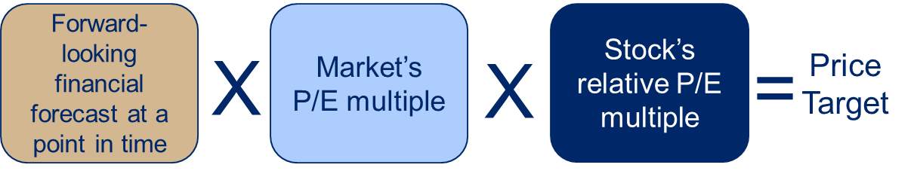
- Lucas has decided he’s going to upgrade one of three railroads he covers, but he’s not sure which one
- The table below illustrates his potential price targets for the 3 stocks
- In Sections 1 and 2 of the table, he has provided the consensus view about the stocks, specifically:
  - Current stock price
  - Next 12-month (“NTM”) consensus EPS forecast at present (we are about to begin "Year 1")
  - Stock's current P/E multiple based on Year 1 EPS
  - Current market P/E multiple (for a broad index like the S&P 500)
  - Each stock's current premium or discount to the market multiple
  - The “next 12-month” (NTM) consensus in Year 2 (i.e. current forecast for Year 2)
  - Difference between Year 2 and Year 1 consensus EPS forecasts
- In Sections 3 and 4 of the table, Lucas has provided his information, specifically:
  - His base-case EPS estimates for Year 1 and Year 2
  - His forecast of the optimal valuation multiple likely to be afforded each stock one year from now
  - A one-year price target based on his EPS estimate in Year 2 multiplied by his future valuation multiple
- To avoid overcomplicating this exercise, assume Lucas’ EPS forecasts for Year 1 and Year 2 were the same as consensus before the conference. All of his upward revisions are taking place only in Year 2.
- Answer the questions below the table
- For more advanced participants only: we have provided an optional relative valuation chart, which shows the movement of NSR’s P/E ratio relative to the S&P 500 P/E ratio on next-12-months (NTM) EPS. A chart like this is critical in identifying an objective relative P/E ratio for the one-year price target, but is beyond the scope of this workshop

z | Exhibit 12: “Ensure Content is Differentiated” Exercise  * NTM = next twelve months  - Answer these questions  After you have completed this portion, continue to the next page to review the answer key (and optional relative P/E chart)
   | GWR | CRR | NSR
  1. Current data
  Current stock price | $10.00 | $10.00 | $10.00
  Next 12-month (“NTM”) consensus EPS forecast at present (we call this "Year 1") | $0.83 | $0.77 | $0.91
  Stock's current valuation multiple based on Year 1 EPS | 12.0 | 13.0 | 11.0
  Current market multiple on NTM consensus (for the broad market such as S&P 500) | 14.0 | 14.0 | 14.0
  Stock's current premium or discount to the market multiple | -14% | -7% | -21%
  2. Change from consensus EPS between Year 1 and Year 2
  NTM consensus in Year 2 (i.e. forecast at beginning of Year 2 for Year 2) | $0.89 | $0.88 | $1.02
  Difference between Year 2 and Year 1 consensus EPS forecasts | 7% | 14% | 12%
  3. Change due to analyst's financial forecast differing from consensus
  Analyst's NTM EPS forecast in one year (i.e. forecast for Year 2) | $1.03 | $0.97 | $1.20
  Difference between analyst's estimate in Year 2 and that of consensus | 15% | 11% | 18%
  4. Change due to analyst's future valuation multiple differing from current multiple
  Analyst's estimate of market multiple at beginning of Year 2 (in this case, it’s the same as present) | 14.0 | 14.0 | 14.0
  Analyst's estimate of stock's premium or discount to market multiple at beginning of Year 2 | -5% | 0% | -10%
  Valuation multiple used for price target at beginning of Year 2 | 13.3 | 14.0 | 12.6
  Difference between analyst's future multiple and stock's current multiple | 11% | 8% | 15%
  5. Price target | $13.64 | $13.62 | $15.12
  Change from current price | 36% | 36% | 51%
  Company where Lucas’s stock call is the most out of consensus:
  Company where Lucas’ stock call is the least out of consensus:

z | Exhibit 13: NSR’s Relative P/E and Next-12-Month (“NTM”) EPS
z | Answer Key to “Ensure Content is Differentiated” Exercise  - Lucas’ price target that is the most differentiated is NSR because his EPS estimate is 18% higher than consensus and his valuation multiple is 15% above current levels  - Lucas’ price target that is the least differentiated is CRR because his EPS is only 11% higher than consensus and his valuation multiple is only 8% above current levels

Simulation, Part E: Utilize Scenarios
Instructions for the “Utilize Scenarios” Exercise:
- Great stock calls include an upside, downside and base-case scenario in order to illustrate to others the analyst is Aware (the “A” in ADViCE™) of alternative views, including those who may be on the opposite side of the trade as the analyst
- Given that this workshop focuses on communications (rather than forecasting and price targets), we do not have time to build a complete scenario table and therefore we have created the one for NSR that follows (note that the table below is for only NSR, unlike the prior table that showed 3 companies). It will be required to help you communicate your message in a later lesson
- In an effort to become familiar with the table, complete the following:
  - How much does Lucas’ downside and upside EPS scenarios for Year 2 differ from his base-case?
    - Downside EPS:_______
    - Upside EPS:_______
  - What are the relative multiples he uses for valuation purposes under each scenario:
    - Downside:_____%
    - Base-case:_____%
    - Upside:_____%

z | Exhibit 14: Upside, Downside and Base Case Scenarios for NSR  After you have provided an answer to the questions above, review the answer key that follows
   | Downside | Base | Upside
  Assumptions for Critical Factors*
  1. Impact from better customer pricing
  EPS Impact vs. Base-case | -$0.10 | $0.00 | $0.20
  2. Impact from accelerating economy
  EPS Impact vs. Base-case | -$0.10 | $0.00 | $0.08
  3. Impact of fuel inflation (assuming it is not passed through)
  EPS Impact vs. Base-case | -$0.08 | $0.00 | $0.05
  Total Impact of 3 factors above | -$0.28 | $0.00 | $0.33
  EPS forecast for next 12 months ("NTM") | $0.63 | $0.91 | $1.24
  Expected growth of EPS between NTM and year after | 15% | 32% | 25%
  Year 2 EPS (i.e.12-month forward EPS one year from now) | $0.72 | $1.20 | $1.55
  P/E Multiple (applying peak multiple to upside scenario) | Trough | Average | Peak
  Historical relative P/E ratios | 40% discount | 21% discount | Market multiple (100%)
  Adjustment to multiple for the future price target | 5% higher | 11% higher | 5% lower
  Company's relative multiple 1 year from now | 35% discount | 10% discount | 5% discount
  Market multiple 1 year from now | 14.0 | 14.0 | 14.0
  Probable stock multiple 1 year from now | 9.1 | 12.6 | 13.3
  Price Target | $6.58 | $15.12 | $20.60
  Current stock price | $10.00 | $10.00 | $10.00
  One Year Change | -34% | 51% | 106%
z
Answer Key for the “Utilize Scenarios” exercise:
- How much does Lucas’ downside and upside EPS scenarios for Year 2 differ from his base-case?
  - Downside EPS: $0.72, which is $0.48 lower than base case of $1.20
  - Upside EPS: $1.55, which is $0.35 higher than base case of $1.20
- What are the relative multiples he uses for valuation purposes under each scenario:
  - Downside: 65% (or 35% discount to the index)
  - Base-case: 90% (or 10% discount to the index)
  - Upside: 95% (or 5% discount to the index)

Simulation, Part F: Draft Page 1 of Report
Instructions for the “Draft Page 1 of Report” exercise:
- Using the ADViCE™ template introduced during the email-writing exercise earlier, construct the first page of a research report to upgrade NSR
- You will need to rely on information or concepts you have learned throughout the simulation (including Exhibit 12 and Exhibit 14) and therefore refer back to prior exercises when necessary
- After you have created the first page of your report, continue to the answer key, which provides our model answer. (Due to the subjective nature of writing, your answer will differ in style, but hopefully contain the same components.)
- To avoid overcomplicating this exercise, assume Lucas’ EPS forecast for Year 1 and Year 2 were the same as consensus before he attended the conference. All of his upward revisions are taking place only in Year 2.
- When writing about time periods in the future, substitute an actual year (e.g., 2024, 2025) for the terms “Year 1” and “Year 2” found in the template
z | Exhibit 15: ADViCE™ Template for Drafting Page 1 of Report  After you have completed your report, review the answer key that follows.
  Element | Wording
  Level 1 (email, page 1 of report, slides for brief presentation or voicemail script)
  Brief Conclusion | We are/I am…  - recommending the purchase of…  - upgrading/downgrading…  - more bullish/more bearish/concerned towards…  - raising/lowering our estimate/price target for…  - reinforcing/revisiting our positive/negative view towards…  [AND]  …[stock name(s) followed by ticker(s)] because…  - our/my work shows/suggests…  - we/I can now conclude…  - we/I have discovered…  [AND]  …[the critical factor(s)] is/will likely…  - be better/worse than consensus/we/I expected  - not in consensus expectations  - occur sooner/later than consensus/we/I expected
  Price target math | We/I derive a one-year price target of $XX, which is XX% above/below yesterday’s close by…  [When using an absolute or relative valuation multiple]  …applying a X [valuation multiple] multiple on our/my XX.00 [EPS, CFPS, BV] estimate for 20XX [time period]  [OR]  …applying a X% premium/discount to the market’s multiple on our/my XX.00 [EPS, CFPS, BV] estimate for 20XX [time period]  [AND/OR]  [When using an intrinsic valuation method such as DCF, EVA, RI, etc.]  …using a [DCF, EVA, RI, etc.] analysis with the following assumptions: [state assumptions for key variables such as long-term revenue growth, changes to margins, the risk-free rate, equity risk premium, cost of equity, WACC, terminal value and years of forecast before terminal value is reached]
  FaVeS™ element that is being changed (be brief) | Our/my view about [critical factor(s)] compels/allows/motivates us/me to…  [here is where you briefly discuss your superior view, as defined by at least one of the following]  - [Superior forecast: when your forecast differs materially from consensus]  - …raise/lower/initiate coverage with our/my EPS/CFPS/growth rate forecast for this year/next year, putting us/me XX% higher/lower than consensus  [AND/OR]  - [Superior valuation: when your valuation assumptions are different from current consensus]  - …justify a valuation multiple of XX, which is XX% above/below its current/historical level.  [AND/OR]  - …justify using a [new valuation method not used by consensus] because [explain why this valuation method provides a more accurate price target than the conventional method]
  Research to support unique FaVeS™ element | [If there is more than one critical factor driving the story, you may want to communicate this element and the one directly below for each critical factor at a time]  Our/my conclusion/above/below-consensus estimate is based on…  - our/my analysis of…  - discussions with…  - data we/I collected from…  - our/my unique modeling of…
  Quantify unique FaVeS™ element | Specifically, we/I believe this results in $XX/XX%…  - higher/lower EPS/CF/BV…  - faster/slower EPS/CF growth rate…  …for 20XX [time period] than…  - current consensus expectations**  - our/my prior estimate  AND/OR  - expansion/contraction of the stock’s relative/absolute valuation multiple from X to Y
  When and why will consensus adopt your view? | We/I believe consensus does not reflect our view because [put your rationale here and avoid repeating your research above (instead focus on why consensus hasn’t come around to your way of thinking yet)]. We believe the consensus/market will adopt/understand our/my view by [specific quarter or time of year] due to [catalyst that will drive the market to your way of thinking].
  What could go wrong? | We/I have a high/low/modest degree of conviction/confidence in our/my call because [explain why your analysis above is valid or uncertain]. Our/my downside scenario results in a stock price of XX (XX% below yesterday’s close), and our/my upside scenario is XX (XX% above yesterday’s close).
z
z | Exhibit 16: Answer Key for “Draft Page 1 of Report” Exercise in ADViCE™ Template Format (Northern & Southern Railroad – NSR)  We provide the answer key below in the ADViCE™ template format, followed by a more traditional report format
  Element | Wording | Your Text
  Level 1 (email, page 1 of report, slides for brief presentation or voicemail script)
  Brief Conclusion | We are/I am…  - recommending the purchase of…  - upgrading/downgrading…  - more bullish/more bearish/concerned towards…  - raising/lowering our estimate/price target for…  - reinforcing/revisiting our positive/negative view towards…  [AND]  …[stock name(s) followed by ticker(s)] because…  - our/my work shows/suggests…  - we/I can now conclude…  - we/I have discovered…  [AND]  …[the critical factor(s)] is/will likely…  - be better/worse than consensus/we/I expected  - not in consensus expectations  - occur sooner/later than consensus/we/I expected | I am recommending the purchase of Northern & Southern Railroad (NSR) because my work suggests the company’s customer pricing will be much better than the consensus expects.
  Price target math | We/I derive a one-year price target of $XX, which is XX% above/below yesterday’s close by…  [When using an absolute or relative valuation multiple]  …applying a X [valuation multiple] multiple on our/my XX.00 [EPS, CFPS, BV] estimate for 20XX [time period]  [OR]  …applying a X% premium/discount to the market’s multiple on our/my XX.00 [EPS, CFPS, BV] estimate for 20XX [time period]  [AND/OR]  [When using an intrinsic valuation method such as DCF, EVA, RI, etc.]  …using a [DCF, EVA, RI, etc.] analysis with the following assumptions: [state assumptions for key variables such as long-term revenue growth, changes to margins, the risk-free rate, equity risk premium, cost of equity, WACC, terminal value and years of forecast before terminal value is reached] | I derive a one-year price target of $15.00, which is 50% above yesterday’s close by applying a 10% discount to the market multiple to my $1.20 EPS estimate for 2024 [from Exhibit 12]
  FaVeS™ element that is being changed (be brief) | Our/my view about [critical factor(s)] compels/allows/motivates us/me to…  [here is where you briefly discuss your superior view, as defined by at least one of the following]  - [Superior forecast: when your forecast differs materially from consensus]  - …raise/lower/initiate coverage with our/my EPS/CFPS/growth rate forecast for this year/next year, putting us/me XX% higher/lower than consensus  [AND/OR]  - [Superior valuation: when your valuation assumptions are different from current consensus]  - …justify a valuation multiple of XX, which is XX% above/below its current/historical level.  [AND/OR]  - …justify using a [new valuation method not used by consensus] because [explain why this valuation method provides a more accurate price target than the conventional method] | My view is more bullish than my prior view and current consensus, which compels me to raise my EPS forecast for 2024 from $1.02 to $1.20 [from Exhibit 12], putting me 18% higher than consensus. In addition, I believe NSR’s relative valuation multiple will rise from its current 21% discount to the market [from Exhibit 12] to only a 10% discount [from Exhibit 14].
  Research to support unique FaVeS™ element | [If there is more than one critical factor driving the story, you may want to communicate this element and the one directly below for each critical factor at a time]  Our/my conclusion/above/below-consensus estimate is based on…  - our/my analysis of…  - discussions with…  - data we/I collected from…  - our/my unique modeling of… | My above-consensus EPS is based on discussions with multiple industry participants whom I met at Ship-Con, a large industry conference. Furthermore, about half of the shippers I spoke with said the economy appears to be accelerating faster than consensus expectations.  The industry’s association president stated railroad customer rates are going up 4%-6% which was confirmed by three large shippers I spoke with. This compares to 1%-2% consensus expectations. One of the founders of the conference who has been in the industry for 32 years said he’s never seen a better environment for railroads to take up pricing. The better pricing is being driven by a shortage of railroad cars and locomotives.  Based on my work, NSR has the least amount of its revenue under long-term contract (only 25%) compared to its peers and therefore will see the greatest near-term benefit from better customer pricing.
  Quantify unique FaVeS™ element | Specifically, we/I believe this results in $XX/XX%…  - higher/lower EPS/CF/BV…  - faster/slower EPS/CF growth rate…  …for 20XX [time period] than…  - current consensus expectations**  - our/my prior estimate  AND/OR  - expansion/contraction of the stock’s relative/absolute valuation multiple from X to Y | Specifically, I forecast better customer pricing will result in $0.18 higher EPS than my prior 2024 forecast. Given that this trend is likely to continue into 2025 and the company is still in a turnaround phase, I believe its relative valuation multiple will rise from its current 21% discount to the market to only a 10% discount.
  When and why will consensus adopt your view? | We/I believe consensus does not reflect our view because [put your rationale here and avoid repeating your research above (instead focus on why consensus hasn’t come around to your way of thinking yet)]. We believe the consensus/market will adopt/understand our/my view by [specific quarter or time of year] due to [catalyst that will drive the market to your way of thinking]. | I differ from consensus because I do not believe consensus understands the car and locomotive shortage is leading to improved pricing initiatives. I spoke to 3 sell-side analysts yesterday and they each have only 1%-2% pricing in their models and do not appear to have an accelerating economy in their estimates.  I believe consensus will adopt my view no later than this time next year when the higher pricing will result in EPS much higher than consensus. It may occur sooner, as railroad management discusses these better pricing initiatives during their quarterly calls and analyst meetings.
  What could go wrong? | We/I have a high/low/modest degree of conviction/confidence in our/my call because [explain why your analysis above is valid or uncertain]. Our/my downside scenario results in a stock price of XX (XX% below yesterday’s close), and our/my upside scenario is XX (XX% above yesterday’s close). | I have a high degree of conviction in my call because I spoke to so many individuals who corroborated my thesis. My downside scenario results in a stock price of $6.60 (34% below yesterday’s close) which could occur if pricing is only 1%-2%, the economy weakens, the company cannot pass along fuel inflation to its customers and the stock trades near a trough multiple (unlikely in our view). My upside scenario calls for a stock price of $20.60 (106% above yesterday’s close), which is driven by pricing at the higher end of my expectations, an accelerating economy and the stock trading at only a 5% discount to the market.  [The logic for the text in this box is from Exhibit 14]
z | Answer Key for “Draft Page 1 of Report” Exercise in Report Format  This is how the text from the answer key above might look like as page 1 of an authentic report:  Raising NSR to Buy Based on Better Customer Pricing  Conclusion: I am recommending the purchase of Northern & Southern Railroad (NSR) because my work suggests the company’s customer pricing will be much better than the consensus expects.  - Price target: I derive a one-year price target of $15.00, which is 50% above yesterday’s close by applying a 10% discount to the market multiple to my $1.20 EPS estimate for 2024.  - What’s Changed: My view is more bullish than my prior view and current consensus, which compels me to raise my EPS forecast for 2024 from $1.02 to $1.20, putting me 18% higher than consensus. In addition, I believe NSR’s relative valuation multiple will rise from its current 21% discount to the market to only a 10% discount.  - Research:  - My above-consensus EPS is based on discussions with multiple industry participants whom I met at Ship-Con, a large industry conference. Furthermore, about half of the shippers I spoke with said the economy appears to be accelerating faster than consensus expectations.  - The industry’s association president stated railroad customer rates are going up 4%-6% which was confirmed by three large shippers I spoke with. This compares to 1%-2% consensus expectations. One of the founders of the conference who has been in the industry for 32 years said he’s never seen a better environment for railroads to take up pricing. The better pricing is being driven by a shortage of railroad cars and locomotives.  - Based on my work, NSR has the least amount of its revenue under long-term contract (only 25%) compared to its peers and therefore will see the greatest near-term benefit from better customer pricing.  - Quantifying the Impact: Specifically, I believe better customer pricing will result in $0.18 higher EPS than my prior 2024 forecast. Given that this trend is likely to continue into 2025 and the company is still in a turnaround phase, I believe its relative valuation multiple will rise from its current 21% discount to the market to only a 10% discount.  - How I Differ: I differ from consensus because I do not believe consensus understands the car and locomotive shortage is leading to improved pricing initiatives. I spoke to 3 sell-side analysts yesterday and they each have only 1%-2% pricing in their models and do not appear to have an accelerating economy in their estimates. I believe consensus will adopt my view no later than this time next year when the higher pricing will result in EPS much higher than consensus. It may occur sooner, as railroad management discusses these better pricing initiatives during their quarterly calls and analyst meetings.  - Where Could I Be Wrong?: I have a high degree of conviction in my call because I spoke to so many individuals who corroborated my thesis. My downside scenario results in a stock price of $6.60 (34% below yesterday’s close) which could occur if pricing is only 1%-2%, the economy weakens, the company cannot pass along fuel inflation to its customers and the stock trades near a trough multiple (unlikely in our view). My upside scenario calls for a stock price of $20.60 (106% above yesterday’s close), which is driven by pricing at the higher end of my expectations, an accelerating economy and the stock trading at only a 5% discount to the market.

Simulation, Part G: Draft Slide Presentation
Instructions for the “Draft Slide Presentation” Exercise:
- Using the ADViCE™ template that follows, construct the following for a brief presentation (such as a 5-10 minute investment committee or stock selection committee meeting)
  - Bullet points for the presentation (as if they are projected on the screen to your audience)
  - Script (this will be the text you will read that elaborates on the slide content)
- If you brought materials for a stock of interest, including a report(s) you already have written, use them to build your presentation
- If you did not bring your own materials, create a presentation to upgrade Next Day Trucking (NDT)
- Current consensus expectations are for the company to earn $1.00 EPS for the next year
- Regardless of the stock being discussed, let’s make this exercise all about ensuring you utilize the ADViCE™ framework and don’t get too concerned about computing EPS estimates or valuation multiples. (Unlike your real job, make up the numbers if you would like so you can put your focus on ensuring you include all elements of the framework)
- As you have seen, there are seven rows in our ADViCE™ template. When creating a slide presentation, you may want to combine two or more of the rows on one slide so as to reduce the number of slides in the presentation
- In a typical slide presentation you would want to include relevant exhibits, but given our limited time for this workshop, simply describe the type of exhibit you would include
- When you are done (or if you get stuck), see the answer key that follows, in table format and also as a more authentic slide presentation
  - We provide an answer key for a presentation based on the NDT upgrade, but since some numbers are not provided earlier in the case they won’t match your numbers

z
z | Exhibit 17: ADViCE™ Template for “Draft Slide Presentation” Exercise  After you have completed your slides above, review the answer key that follows
  Element | Wording | Text for Your Slide Presentation
  Brief Conclusion | We are/I am…  - recommending the purchase of…  - upgrading/downgrading…  - more bullish/more bearish/concerned towards…  - raising/lowering our estimate/price target for…  - reinforcing/revisiting our positive/negative view towards…  [AND]  …[stock name(s) followed by ticker(s)] because…  - our/my work shows/suggests…  - we/I can now conclude…  - we/I have discovered…  [AND]  …[the critical factor(s)] is/will likely…  - be better/worse than consensus/we/I expected  - not in consensus expectations  - occur sooner/later than consensus/we/I expected | Slide Title:  Bullets for Presentation:  - Bullet #1:  - Bullet #2:  - Bullet #3:  Script for This Element:
  Price target math | Applying a X [valuation multiple] multiple on our/my XX.00 [EPS, CFPS, BV] estimate for 20XX [time period], results in a year-end/six-month/one-year price target of XX, which is XX% above yesterday’s close. | Slide Title:  Bullets for Presentation:  - Bullet #1:  - Bullet #2:  - Bullet #3:  Script for This Element:
  FaVeS™ element that is being changed (be brief) | Our/my view about [critical factor(s)] compels/allows/motivates us/me to…  [here is where you briefly discuss your superior view, as defined by at least one of the following]  - [Superior forecast: when your forecast differs materially from consensus]  - …raise/lower/initiate coverage with our/my EPS/CFPS/growth rate forecast for this year/next year, putting us/me XX% higher/lower than consensus  [AND/OR]  - [Superior valuation: when your valuation assumptions are different from current consensus]  - …justify a valuation multiple of XX, which is XX% above/below its current/historical level.  [AND/OR]  …justify using a [new valuation method not used by consensus] because [explain why this valuation method provides a more accurate price target than the conventional method] | Slide Title:  Bullets for Presentation:  - Bullet #1:  - Bullet #2:  - Bullet #3:  Script for This Element:
  Research to support unique FaVeS™ element | [If there is more than one critical factor driving the story, you may want to communicate this element and the one directly below for each critical factor at a time]  Our/my conclusion/above/below-consensus estimate is based on…  - our/my analysis of…  - discussions with…  - data we/I collected from…  - our/my unique modeling of… | Slide Title:  Bullets for Presentation:  - Bullet #1:  - Bullet #2:  - Bullet #3:  Script for This Element:
  Quantify unique FaVeS™ element | Specifically, we/I believe this results in $XX/XX%…  - higher/lower EPS/CF/BV…  - faster/slower EPS/CF growth rate…  …for 20XX [time period] than…  - current consensus expectations**  - our/my prior estimate  AND/OR  - expansion/contraction of the stock’s relative/absolute valuation multiple from X to Y | Slide Title:  Bullets for Presentation:  - Bullet #1:  - Bullet #2:  - Bullet #3:  Script for This Element:
  When and why will consensus adopt your view? | We/I believe consensus does not reflect our view because [put your rationale here and avoid repeating your research above (instead focus on why consensus hasn’t come around to your way of thinking yet)]. We believe the consensus/market will adopt/understand our/my view by [specific quarter or time of year] due to [catalyst that will drive the market to your way of thinking]. | Slide Title:  Bullets for Presentation:  - Bullet #1:  - Bullet #2:  - Bullet #3:  Script for This Element:
  What could go wrong? | We/I have a high/low/modest degree of conviction/confidence in our/my call because [explain why your analysis above is valid or uncertain]. Our/my downside scenario results in a stock price of XX (XX% below yesterday’s close), and our/my upside scenario is XX (XX% above yesterday’s close). | Slide Title:  Bullets for Presentation:  - Bullet #1:  - Bullet #2:  - Bullet #3:  Script for This Element:
z | Exhibit 18: Answer Key for “Draft Slide Presentation” Exercise Using ADViCE™ Template Format (NDT-Next Day Trucking)  We provide the answer key below in the ADViCE™ template format, followed by a more traditional slide format
   | Wording | Your Text
  Level 1 (email, page 1 of report, slides for brief presentation or voicemail script)
  Brief Conclusion | We are/I am…  - recommending the purchase of…  - upgrading/downgrading…  - more bullish/more bearish/concerned towards…  - raising/lowering our estimate/price target for…  - reinforcing/revisiting our positive/negative view towards…  [AND]  …[stock name(s) followed by ticker(s)] because…  - our/my work shows/suggests…  - we/I can now conclude…  - we/I have discovered…  [AND]  …[the critical factor(s)] is/will likely…  - be better/worse than consensus/we/I expected  - not in consensus expectations  - occur sooner/later than consensus/we/I expected | Slide Title: Recommend Purchase of NDT  Bullets for Presentation: (for brevity, we have combined this element and the next two into one slide – we have the script still split up by element)  - Recommending purchase of Next Day Trucking (NDT)  - Potential expansion to another 25% of country not in expectations  - Raising 2024 EPS from $1.00 to $1.20 (consensus is at $1.00)  - $17 one-year price target is 20% above yesterday’s close  Script for This Element:  I am recommending the purchase of Next Day Trucking (NDT) because I believe the company will be expanding to another 25% of the country in the next year, which is not currently in consensus expectations.
  Price target math | We/I derive a one-year price target of $XX, which is XX% above/below yesterday’s close by…  [When using an absolute or relative valuation multiple]  …applying a X [valuation multiple] multiple on our/my XX.00 [EPS, CFPS, BV] estimate for 20XX [time period]  [OR]  …applying a X% premium/discount to the market’s multiple on our/my XX.00 [EPS, CFPS, BV] estimate for 20XX [time period]  [AND/OR]  [When using an intrinsic valuation method such as DCF, EVA, RI, etc.]  …using a [DCF, EVA, RI, etc.] analysis with the following assumptions: [state assumptions for key variables such as long-term revenue growth, changes to margins, the risk-free rate, equity risk premium, cost of equity, WACC, terminal value and years of forecast before terminal value is reached] | Script for this Element:  By applying a market multiple of 14x forward earnings on my $1.20 estimate for 2024 results in a one-year price target of $17.00 stock which is 20% above yesterday’s close.
  FaVeS™ element that is being changed (be brief) | Our/my view about [critical factor(s)] compels/allows/motivates us/me to…  [here is where you briefly discuss your superior view, as defined by at least one of the following]  - [Superior forecast: when your forecast differs materially from consensus]  - …raise/lower/initiate coverage with our/my EPS/CFPS/growth rate forecast for this year/next year, putting us/me XX% higher/lower than consensus  [AND/OR]  - [Superior valuation: when your valuation assumptions are different from current consensus]  - …justify a valuation multiple of XX, which is XX% above/below its current/historical level.  [AND/OR]  - …justify using a [new valuation method not used by consensus] because [explain why this valuation method provides a more accurate price target than the conventional method] | Script for this Element:  My expectation that expansion occurs in the next year compels me to raise my 2024 EPS estimate from $1.00 to $1.20. I assume the stock continues to trade at a market multiple.
  Research to support unique FaVeS™ element | [If there is more than one critical factor driving the story, you may want to communicate this element and the one directly below for each critical factor at a time]  Our/my conclusion/above/below-consensus estimate is based on…  - our/my analysis of…  - discussions with…  - data we/I collected from…  - our/my unique modeling of… | Slide Title: Research to Support Thesis  Bullets for Presentation:  - NDT is asking customers if they need service in markets it doesn’t currently serve  - NDT is looking for new terminal space in a location it doesn’t serve  - NDT is ordering more trucks next year than a normal replacement cycle  Script for this Element:  My conclusion is based on discussions with multiple industry participants whom I met at Ship-Con earlier this week, a large industry conference.  - Two large shippers I spoke with were recently asked by their NDT salespeople if they have expansion needs in regions NDT doesn’t currently serve  - A local commercial real estate lessor confirmed NDT is looking for new terminal space in a city it doesn’t serve  - A truck manufacturer said NDT normally replaces 25% of its trucks in a given year, but the company has placed an order for enough trucks to replace half of its fleet next year  - Two shippers confirmed the company has great service and competitive pricing, which suggests it continues to execute well
  Quantify unique FaVeS™ element | Specifically, we/I believe this results in $XX/XX%…  - higher/lower EPS/CF/BV…  - faster/slower EPS/CF growth rate…  …for 20XX [time period] than…  - current consensus expectations**  - our/my prior estimate  AND/OR  - expansion/contraction of the stock’s relative/absolute valuation multiple from X to Y | Slide Title: Our Estimates vs. Consensus  Bullets for Presentation:  - [Provide the table found below this table]  Script for this Element:  - As you can see in the table on this slide, our new estimate of $1.20 is 20% higher than our prior estimate and consensus  - We went back and looked at prior expansions for NDT and the company generally saw about as much EPS growth as its geographic expansion  Given that we believe it is expanding by 25%, we conservatively assume our EPS estimates need to rise by 20%
  When and why will consensus adopt your view? | We/I believe consensus does not reflect our view because [put your rationale here and avoid repeating your research above (instead focus on why consensus hasn’t come around to your way of thinking yet)]. We believe the consensus/market will adopt/understand our/my view by [specific quarter or time of year] due to [catalyst that will drive the market to your way of thinking]. | Slide Title: Timing and Catalyst  Bullets for Presentation:  - Likely by 2Q16  - Not in Consensus Expectations  Script for this Element:  I believe consensus does not expect the company to take on a major expansion. Based on conversations I had with three of the best sell-side analysts, none have anything other than normal economic growth built into their forecasts.  I believe this expansion will be announced by the end of 2Q16 because one of the shippers I spoke with mentioned he was given this timetable by his salesperson and because the large new truck order suggests it will likely be occurring soon.  Our EPS estimate rises for the year after because it will take time for the expansion to take place, but we believe within the next six months the market will begin to include the higher EPS growth into their forecasts and valuation of the stock.
  What could go wrong? | We/I have a high/low/modest degree of conviction/confidence in our/my call because [explain why your analysis above is valid or uncertain]. Our/my downside scenario results in a stock price of XX (XX% below yesterday’s close), and our/my upside scenario is XX (XX% above yesterday’s close). | Slide Title: Potential Risks  Bullets for Presentation:  - Timing  - Magnitude  - Competitive Pressures  - Scenarios (provide a table with scenarios)  Script for this Element:  I have a high degree of confidence the company is going to expand, but am still uncertain about the timing and magnitude. As I mentioned earlier, I expect the company to expand by 25% but my EPS is rising by only 20%, which leaves upside.  Under my upside scenario, EPS will rise to $1.30, which would result in a stock price of $18.20, using a 14x market multiple (28% above yesterday’s close). Under my downside scenario, I assume the company runs into competitive pressures as it expands and experiences no EPS increase over my prior forecast. If we apply a 14x multiple to that figure, the stock would be at $14, or near its current price.
z | Exhibit 19:Summary of My New and Former Estimates Compared to Consensus
  Company | My Former Estimate for 2024 | My New Estimate for 2024 | Change in My Estimate | Current Consensus for 2024 | My New Estimate vs. Consensus for 2024
  NDT | $1.00 | $1.20 | 20% | $1.00 | 20%
z | Answer Key for Draft Slide Presentation Exercise Using Slide Format (NDT-Next Day Trucking)  This is how the text from the answer key above, might look like as an authentic slide presentation:  Slide 1:  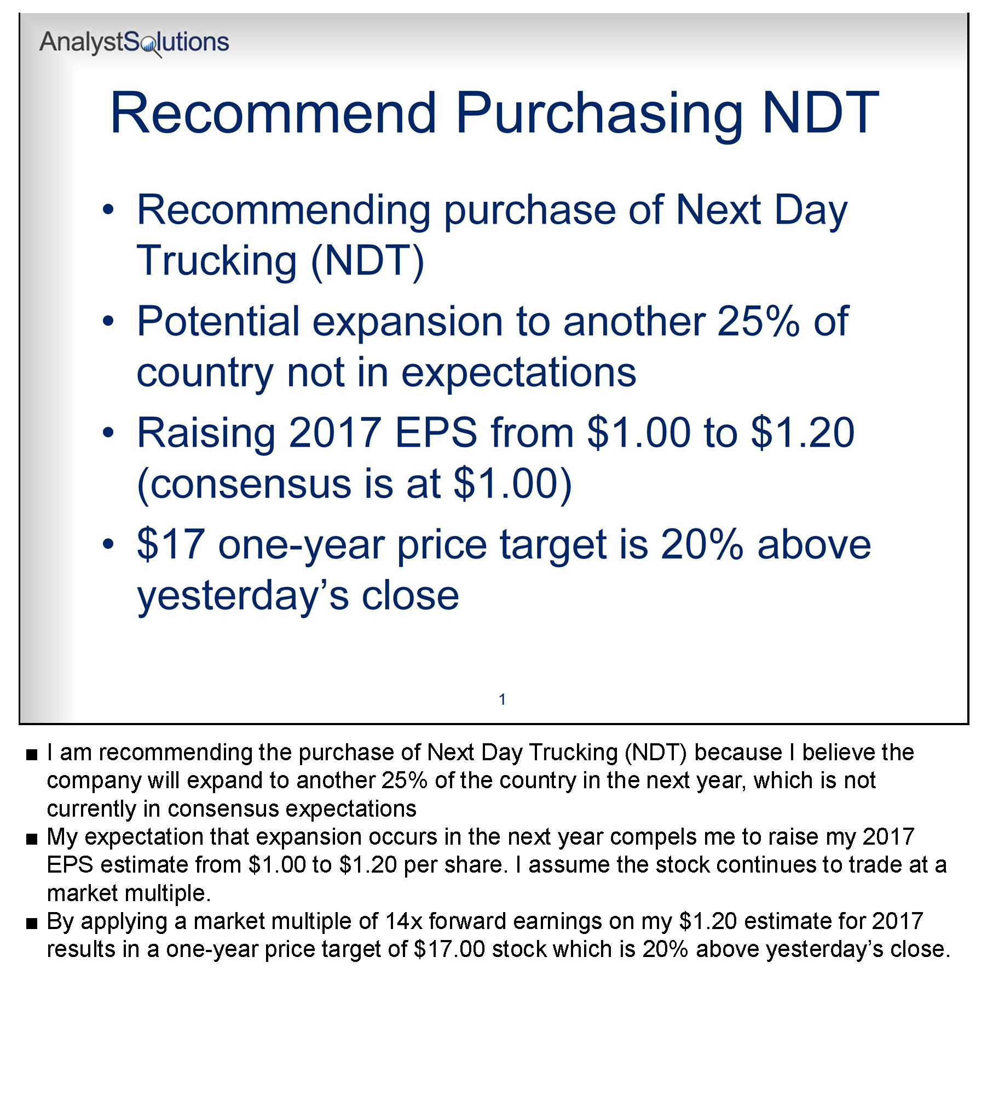
z | Slide 2:  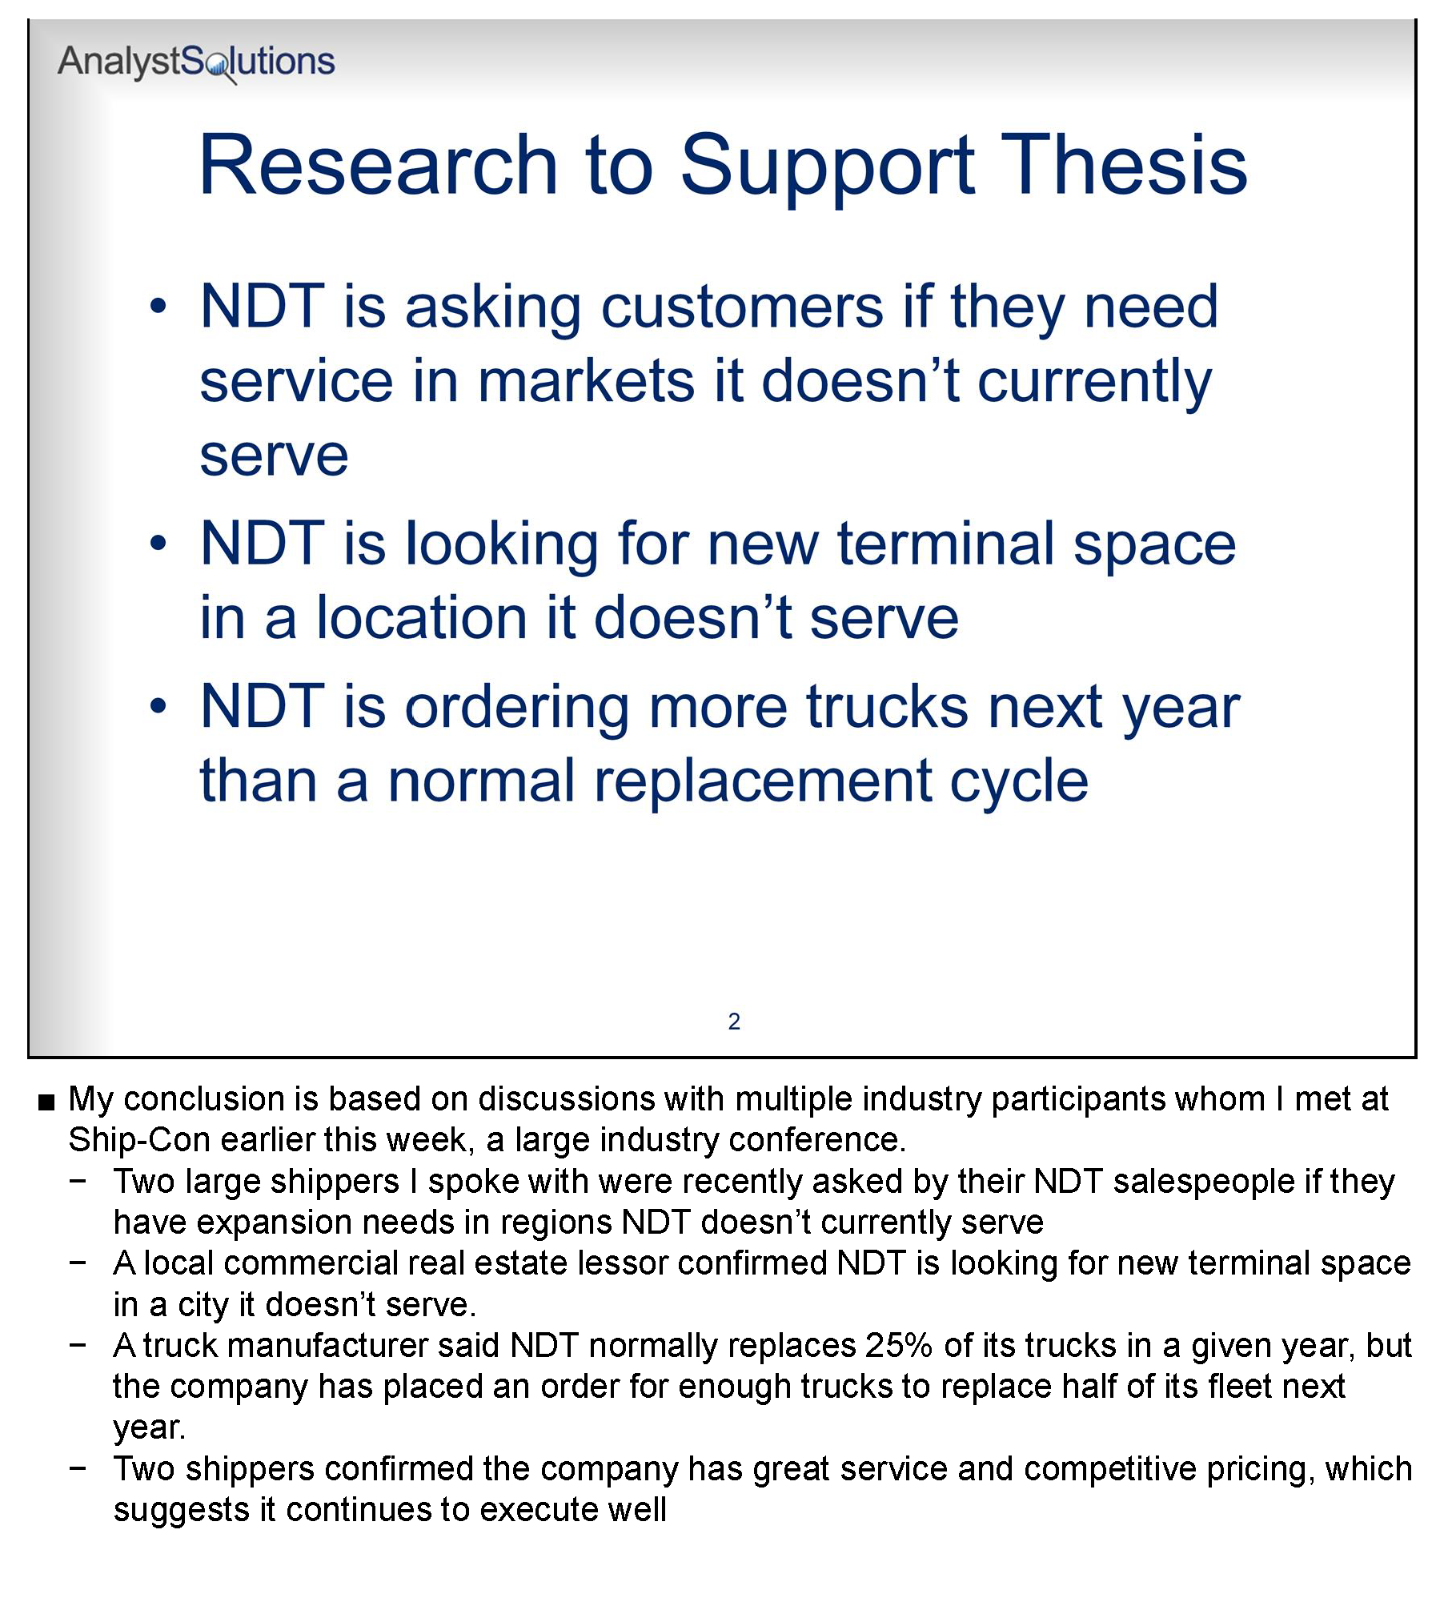
z | Slide 3:  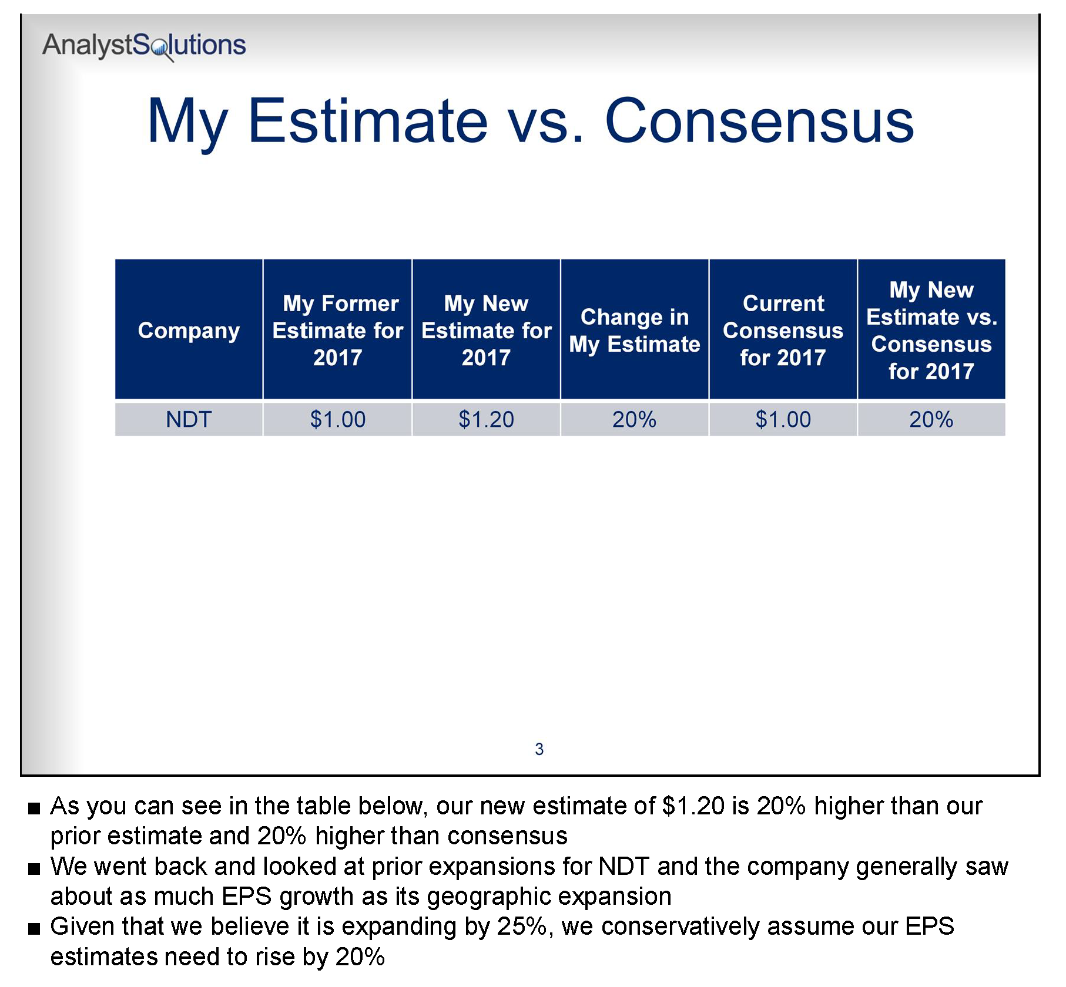
z | Slide 4:  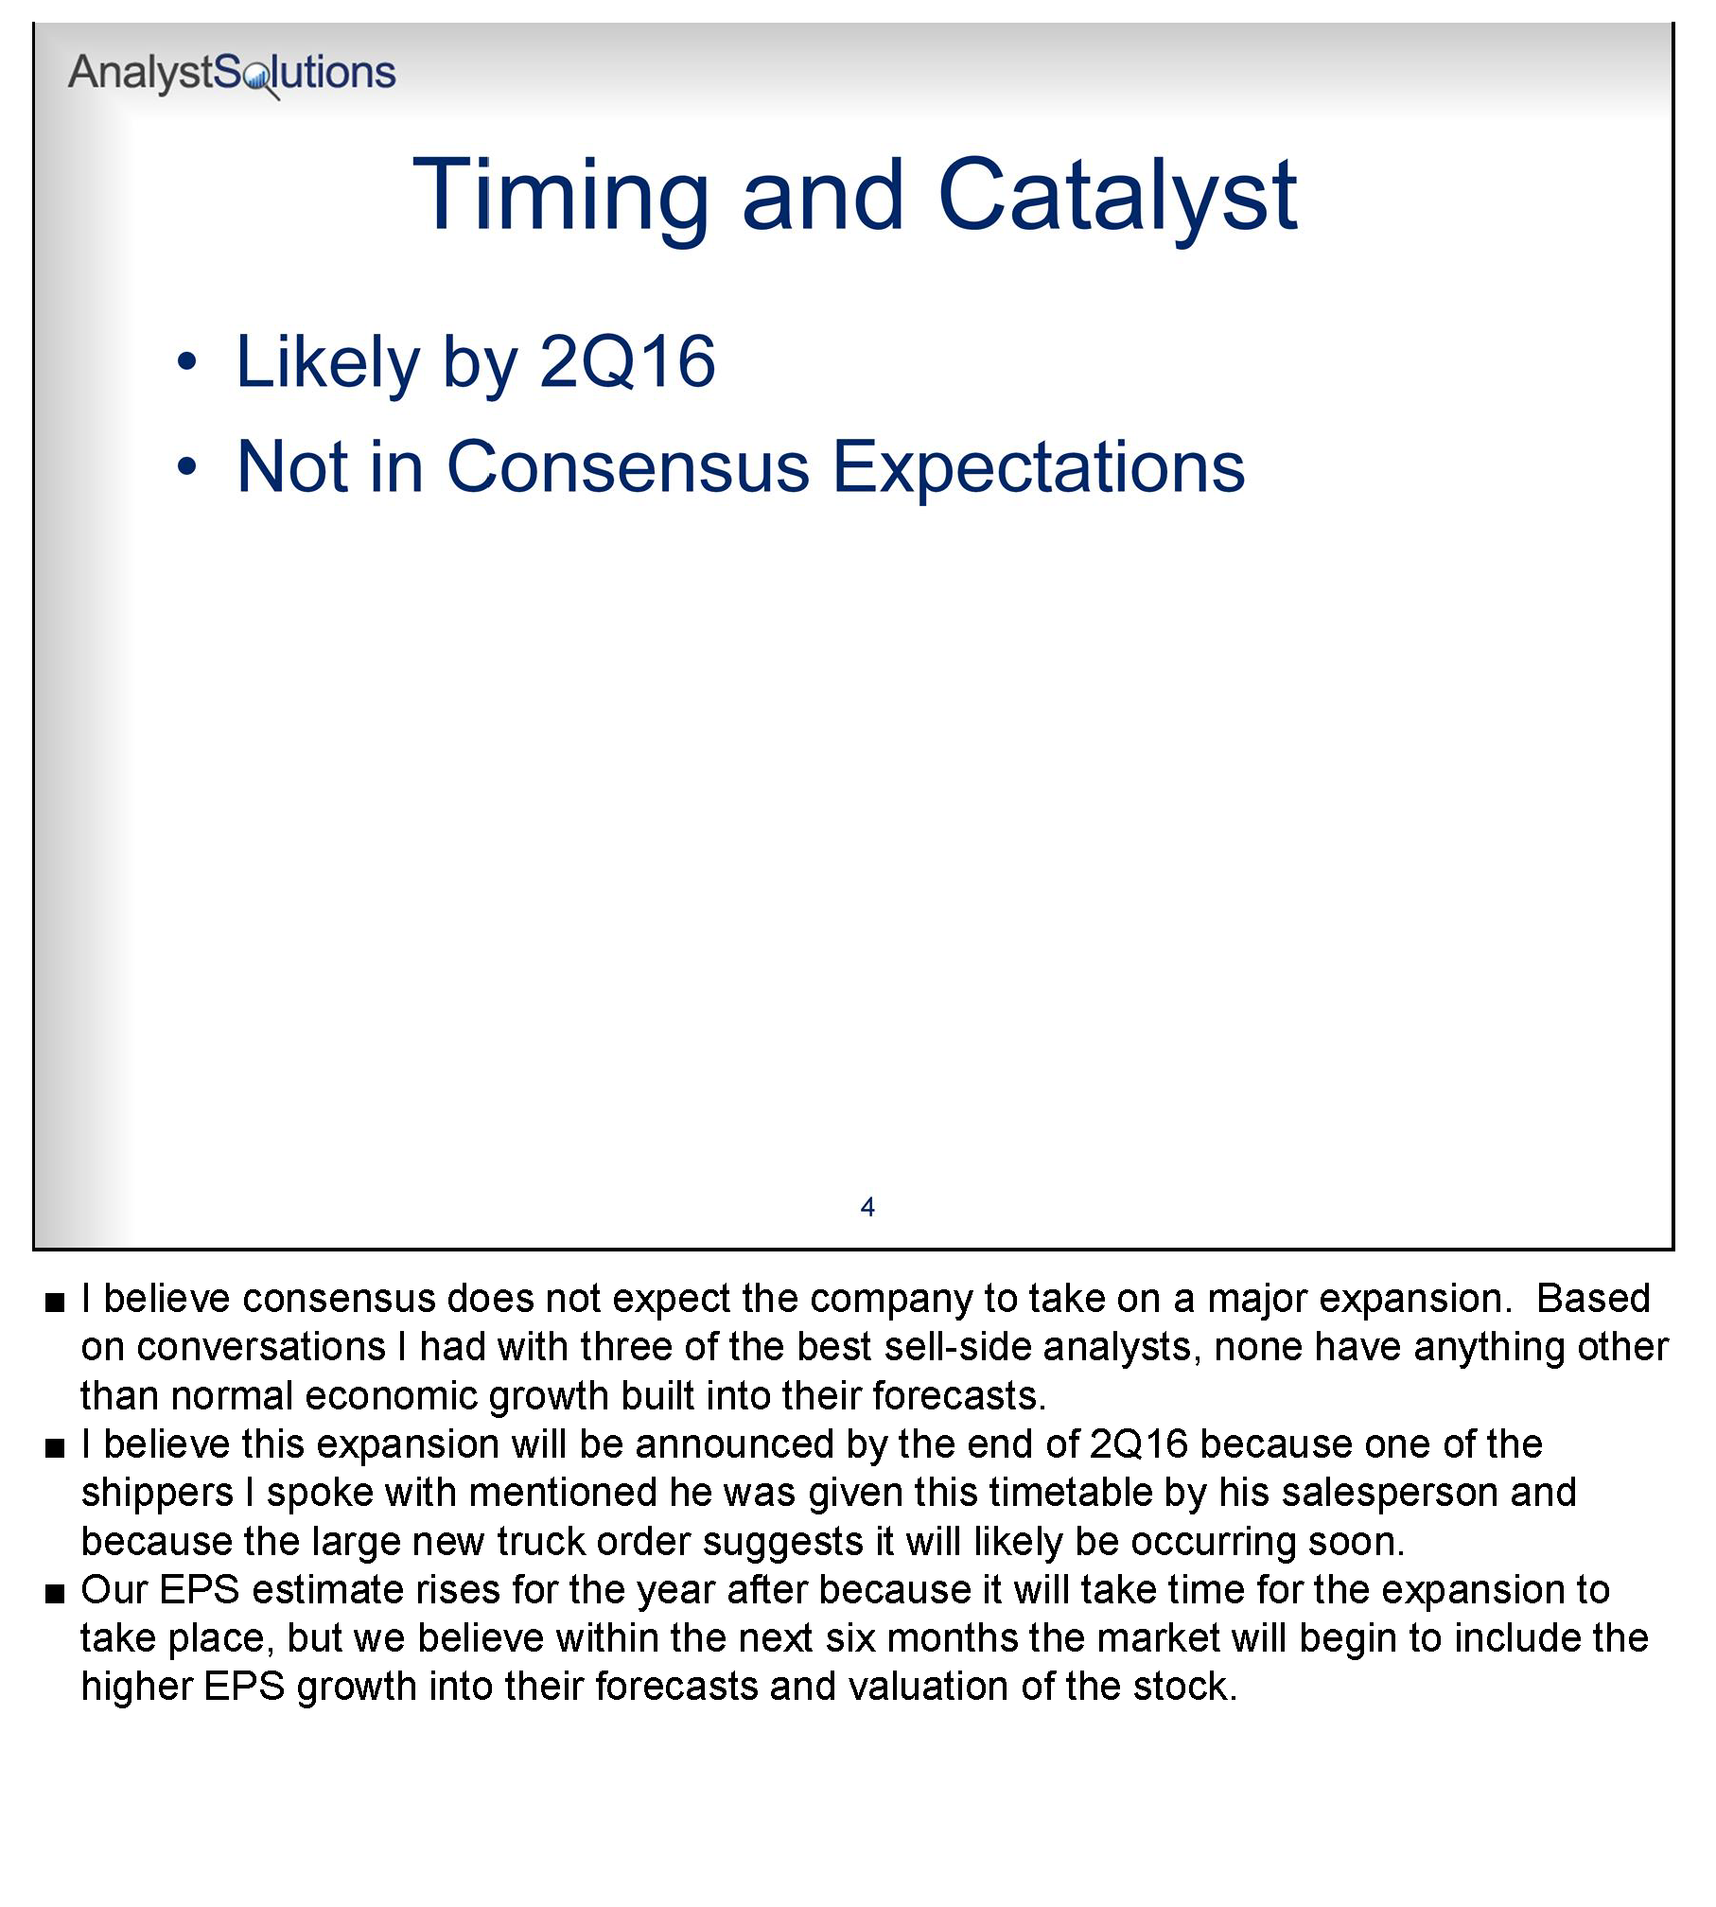
z | Slide 5:  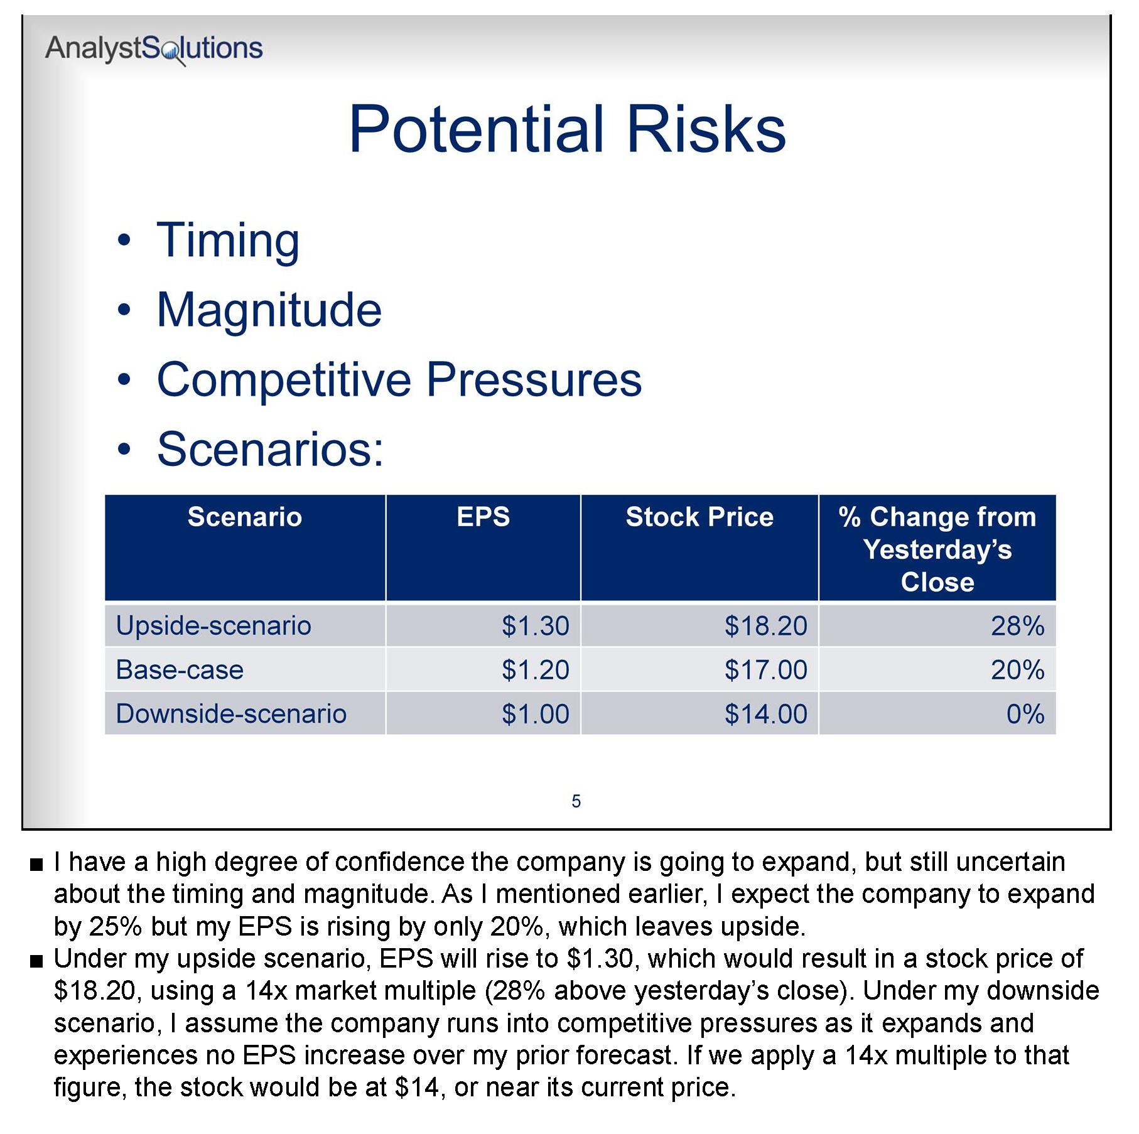

z | Exhibit 20: Answer Key for “Draft Slide Presentation” Exercise Using ADViCE™ Template Format (NSR-Northern & Southern Railroad)  We provide the answer key below in the ADViCE™ template format, followed by a more traditional slide format (
  Element | Wording | Slide Content and Script
  Brief Conclusion | We are/I am…  - recommending the purchase of…  - upgrading/downgrading…  - more bullish/more bearish/concerned towards…  - raising/lowering our estimate/price target for…  - reinforcing/revisiting our positive/negative view towards…  [AND]  …[stock name(s) followed by ticker(s)] because…  - our/my work shows/suggests…  - we/I can now conclude…  - we/I have discovered…  [AND]  …[the critical factor(s)] is/will likely…  - be better/worse than consensus/we/I expected  - not in consensus expectations  - occur sooner/later than consensus/we/I expected | Slide Title: Recommend Purchase of NSR  Bullets for Presentation: (for brevity, we have combined this element and the next two into one slide – we have the script still split up by element)  - Recommending purchase of Northern & Southern Railroad (NSR)  - Customer pricing likely to be much better than consensus expects  - Raising 2024 EPS from $1.02 to $1.20 (consensus is at $1.02)  - $15 one-year price target is 18% above yesterday’s close  Script for This Element:  I am recommending the purchase of Northern & Southern Railroad, ticker NSR, because I believe the company will raise customer pricing much more than consensus expectations.
  Price target math | Applying a X [valuation multiple] multiple on our/my XX.00 [EPS, CFPS, BV] estimate for 20XX [time period], results in a year-end/six-month/one-year price target of XX, which is XX% above yesterday’s close. | Script for this Element:  By applying a 10% discount to the market multiple on my $1.20 EPS estimate for 2024, results in a one-year price target of $15.00, which is 50% above yesterday’s close
  FaVeS™ element that is being changed (be brief) | Our/my view about [critical factor(s)] compels/allows/motivates us/me to…  [here is where you briefly discuss your superior view, as defined by at least one of the following]  - [Superior forecast: when your forecast differs materially from consensus]  - …raise/lower/initiate coverage with our/my EPS/CFPS/growth rate forecast for this year/next year, putting us/me XX% higher/lower than consensus  [AND/OR]  - [Superior valuation: when your valuation assumptions are different from current consensus]  - …justify a valuation multiple of XX, which is XX% above/below its current/historical level.  [AND/OR]  …justify using a [new valuation method not used by consensus] because [explain why this valuation method provides a more accurate price target than the conventional method] | Script for this Element:  My expectation that customer pricing will be much stronger than expected compels me to raise my 2024 EPS estimate from $1.02 to $1.20. I assume the upward earnings momentum and prospects of higher returns will lead the stock’s valuation from its current 21% discount to the market to only a 10% discount.
  Research to support unique FaVeS™ element | [If there is more than one critical factor driving the story, you may want to communicate this element and the one directly below for each critical factor at a time]  Our/my conclusion/above/below-consensus estimate is based on…  - our/my analysis of…  - discussions with…  - data we/I collected from…  - our/my unique modeling of… | Slide Title: Research to Support Thesis  Bullets for Presentation:  - Confirmed through multiple conversations with large railroad shippers at Ship-Con  - Pricing likely to go up 4%-6% while consensus is expecting only 1%-2%  - NSR has the lowest portion of long-term contracts among its peers  Script for this Element:  My conclusion is based on discussions with multiple industry participants whom I met at Ship-Con earlier this week, a large industry conference.  - The industry’s association president stated railroad customer rates are going up 4%-6% which was confirmed by three large shippers I spoke with. This compares to 1%-2% consensus expectations.  - One of the founders of the conference who has been in the industry for 32 years said he’s never seen a better environment for railroads to take up pricing.  - The better pricing is being driven by a shortage of railroad cars and locomotives.  - NSR has the least amount of its revenue under long-term contract, only 25%, compared to its peers and therefore will see the greatest near-term benefit from better customer pricing
  Quantify unique FaVeS™ element | Specifically, we/I believe this results in $XX/XX%…  - higher/lower EPS/CF/BV…  - faster/slower EPS/CF growth rate…  …for 20XX [time period] than…  - current consensus expectations**  - our/my prior estimate  AND/OR  - expansion/contraction of the stock’s relative/absolute valuation multiple from X to Y | Slide Title: My Estimate vs. Consensus  Bullets for Presentation:  - [Provide the table found below this table]  Script for this Element:  - As you can see in the table on this slide, our new estimate of $1.20 is 18% higher than our prior estimate and consensus  - Given that this better pricing trend is likely to continue into 2025 and the company is still in a turnaround phase, I believe its relative valuation multiple will rise from its current 21% discount to the market to only a 10% discount.
  When and why will consensus adopt your view? | We/I believe consensus does not reflect our view because [put your rationale here and avoid repeating your research above (instead focus on why consensus hasn’t come around to your way of thinking yet)]. We believe the consensus/market will adopt/understand our/my view by [specific quarter or time of year] due to [catalyst that will drive the market to your way of thinking]. | Slide Title: Timing and Catalyst  Bullets for Presentation:  - Car and locomotive shortage leading to better pricing is not in consensus expectations  - Will be clearly seen by 4Q17  Script for this Element:  - I differ from consensus because I do not believe consensus understands the car and locomotive shortage is leading to improved pricing initiatives.  - I spoke to 3 sell-side analysts yesterday and they each have only 1%-2% pricing in their models and do not appear to have an accelerating economy in their estimates.  - I believe consensus will adopt my view no later than this time next year when the higher pricing will result in EPS much higher than consensus. It may occur sooner, as railroad management discusses these better pricing initiatives during their quarterly calls and analyst meetings.
  What could go wrong? | We/I have a high/low/modest degree of conviction/confidence in our/my call because [explain why your analysis above is valid or uncertain]. Our/my downside scenario results in a stock price of XX (XX% below yesterday’s close), and our/my upside scenario is XX (XX% above yesterday’s close). | Slide Title: Potential Risks  Bullets for Presentation:  - Speed of pricing (contracts need to roll over)  - Magnitude of pricing  - Locomotive and car shortage could cause customer service problems  - Scenarios [provide a table with scenarios, which comes from Exhibit 14]  Script for this Element:  - I have a high degree of conviction in my call because I spoke to so many individuals who corroborated my thesis. My downside scenario results in a stock price of $6.60 (34% below yesterday’s close) which could occur if pricing is only 1%-2%, the economy weakens, and the stock trades near a trough multiple, which is unlikely in our view. There’s also the possibility the locomotive and car shortage could cause customer defections to trucking.  - My upside scenario calls for a stock price of $20.60 (106% above yesterday’s close), which is driven by pricing at the higher end of my expectations, an accelerating economy and the stock trading at only a 5% discount to the market.
z | Exhibit 21:Summary of My New and Former Estimates Compared to Consensus
  Company | My Former Estimate for 2024 | My New Estimate for 2024 | Change in My Estimate | Current Consensus for 2024 | My New Estimate vs. Consensus for 2024
  NSR | $1.02 | $1.20 | 18% | $1.02 | 18%
z | Answer Key for Draft Slide Presentation Exercise Using Slide Format  This is how the text from the answer key above, might look like as an authentic slide presentation:  Slide 1:  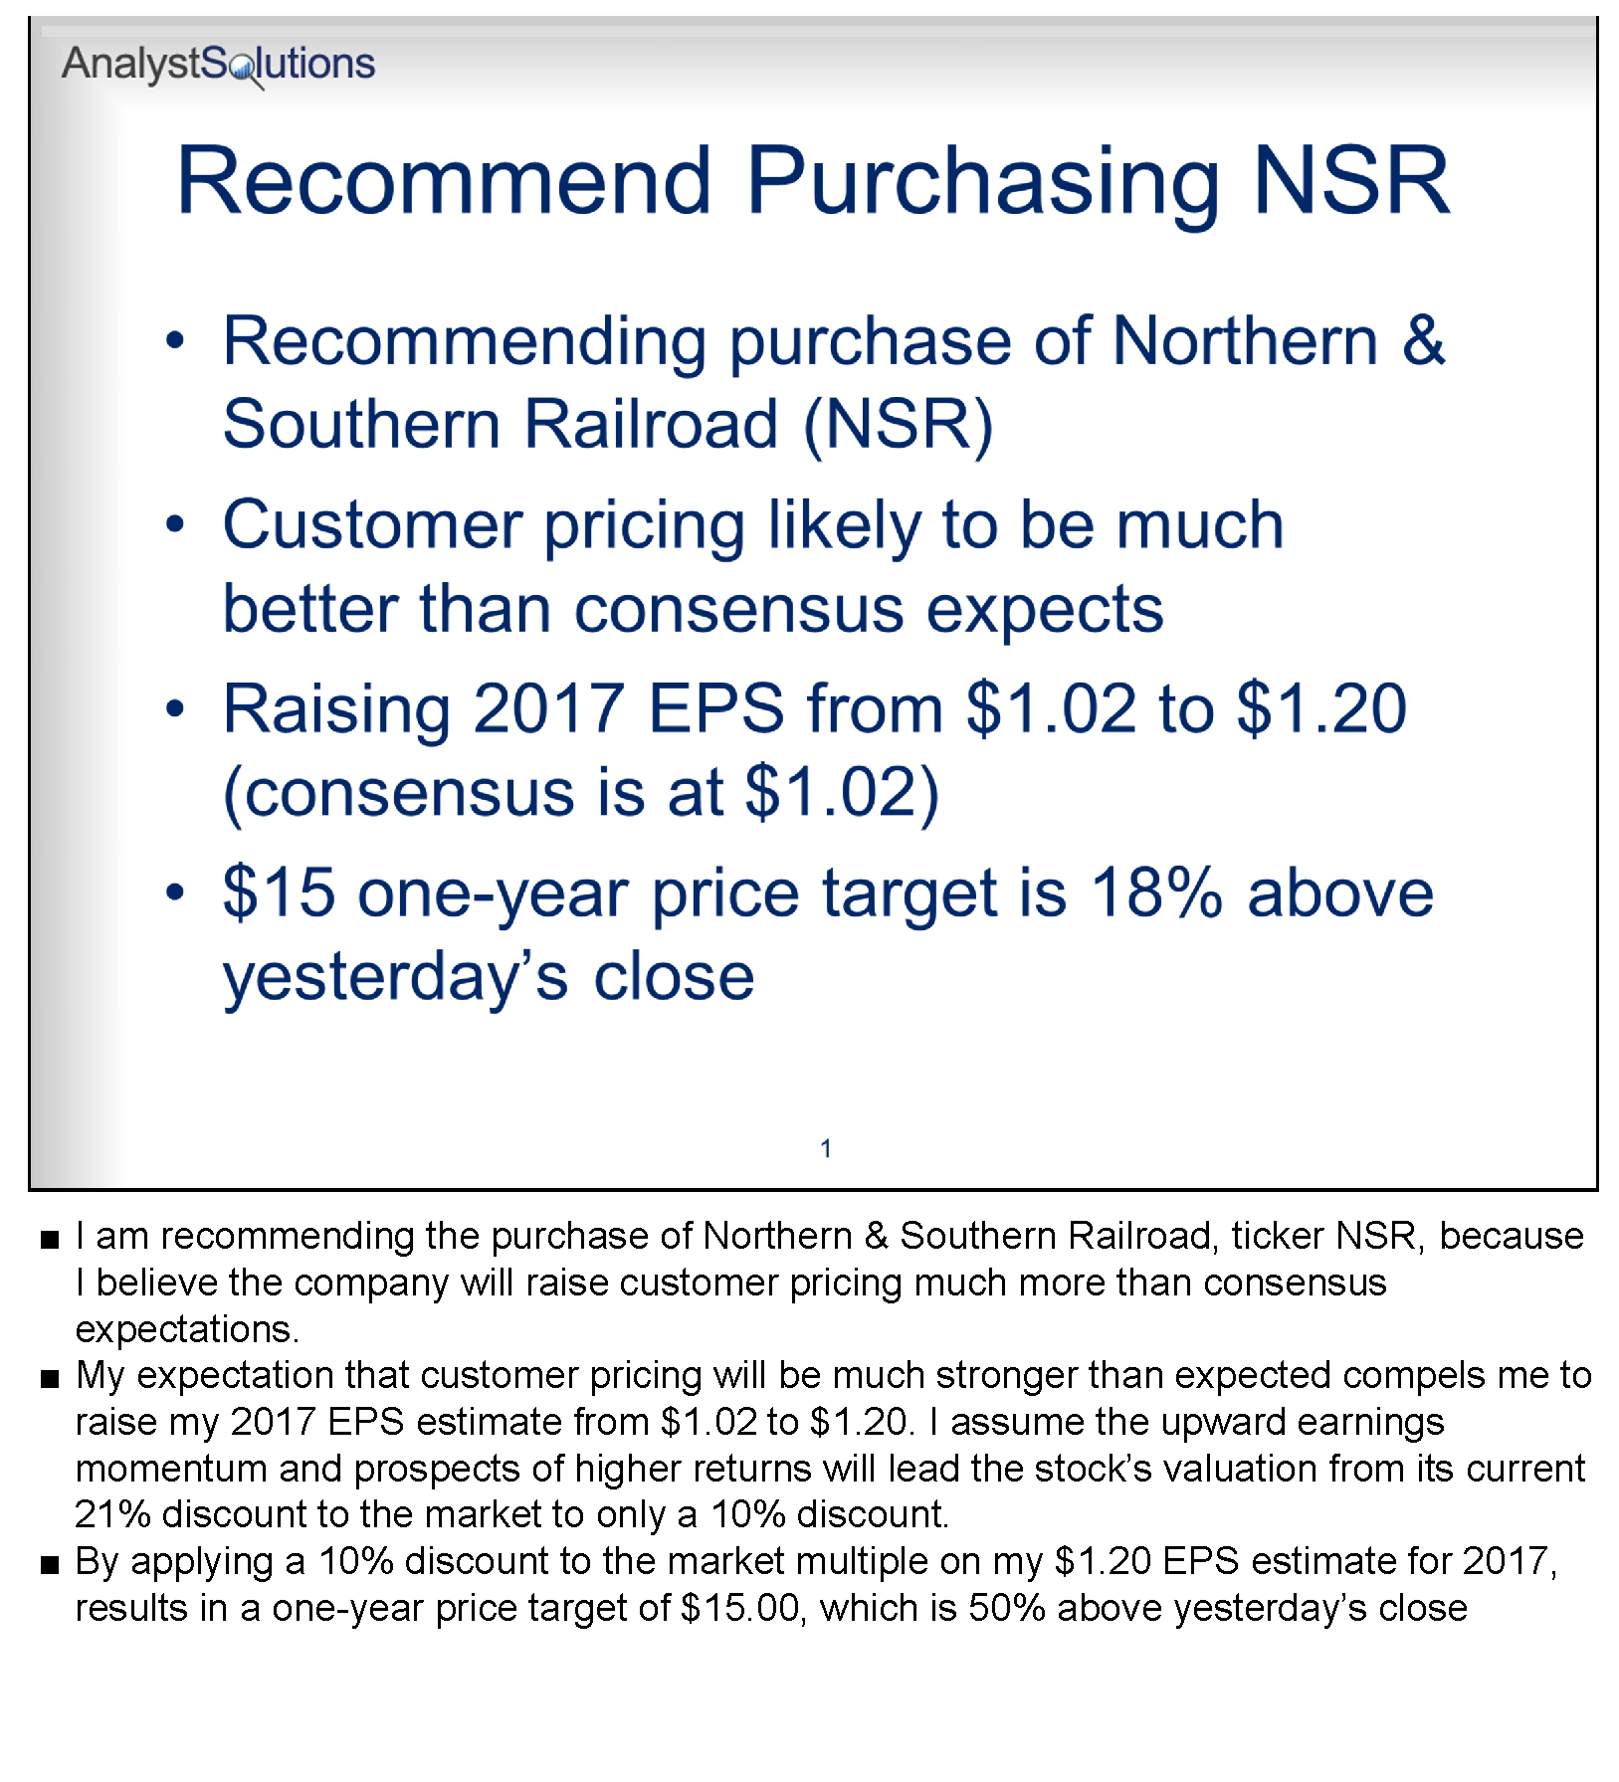
z | Slide 2:  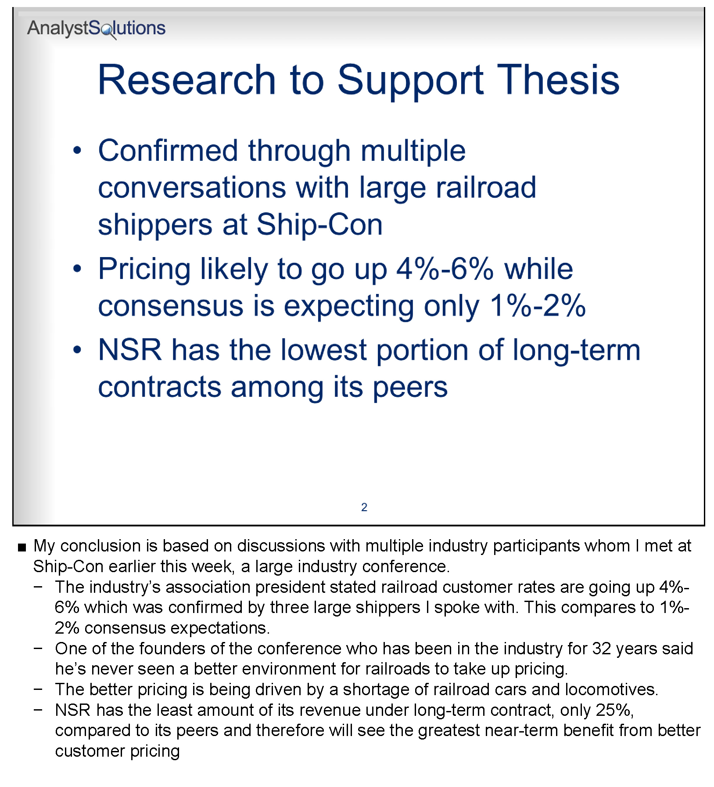
z | Slide 3:  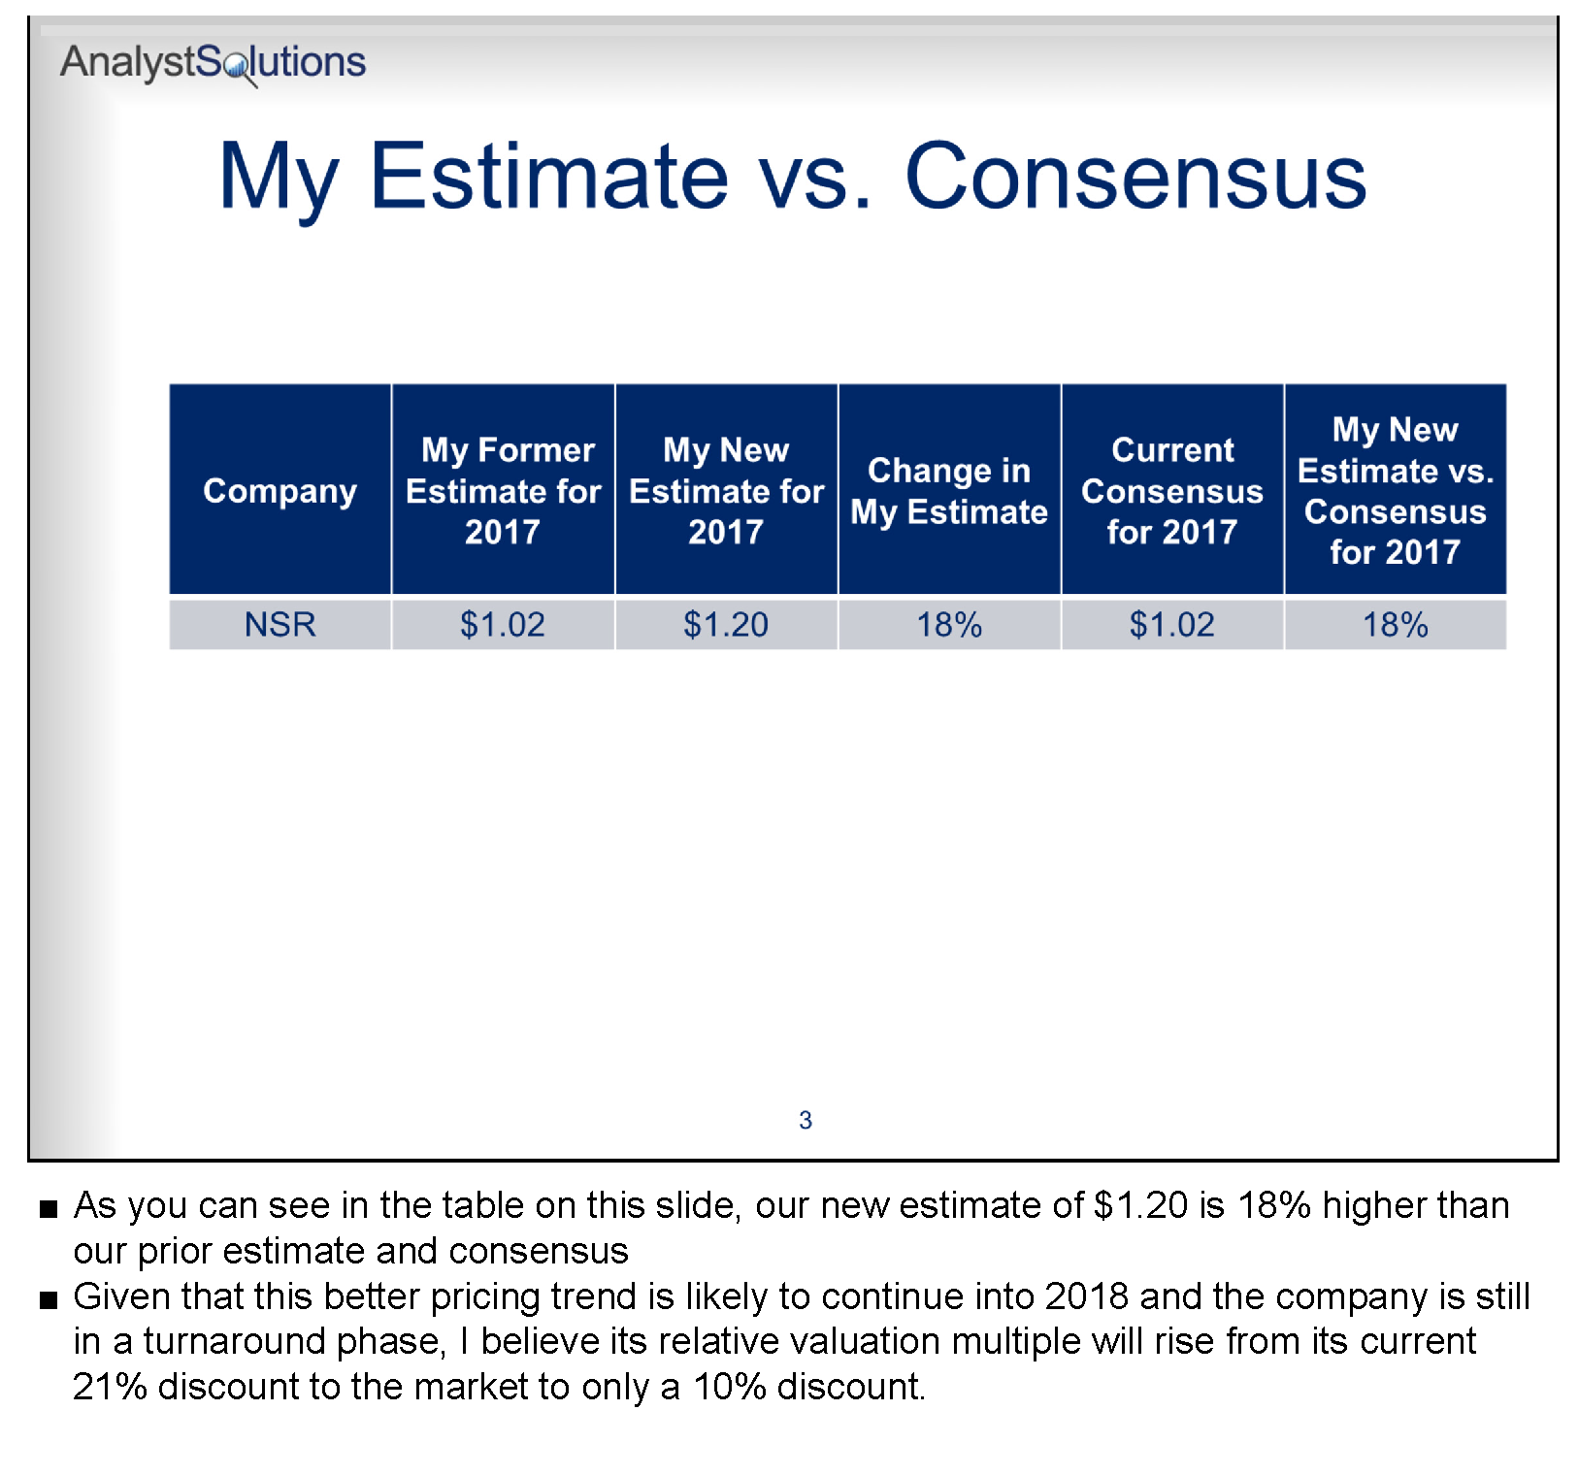
z | Slide 4:  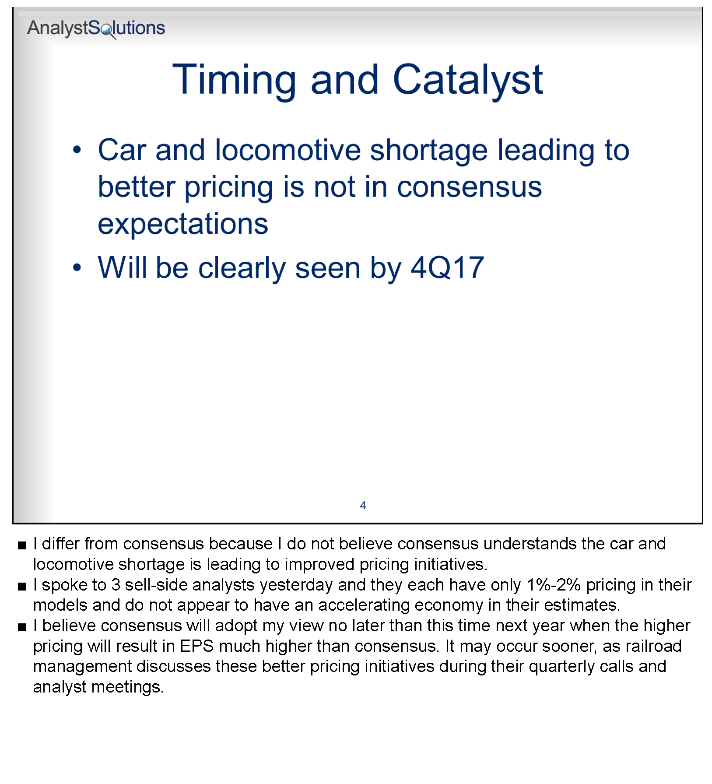
z | Slide 5:  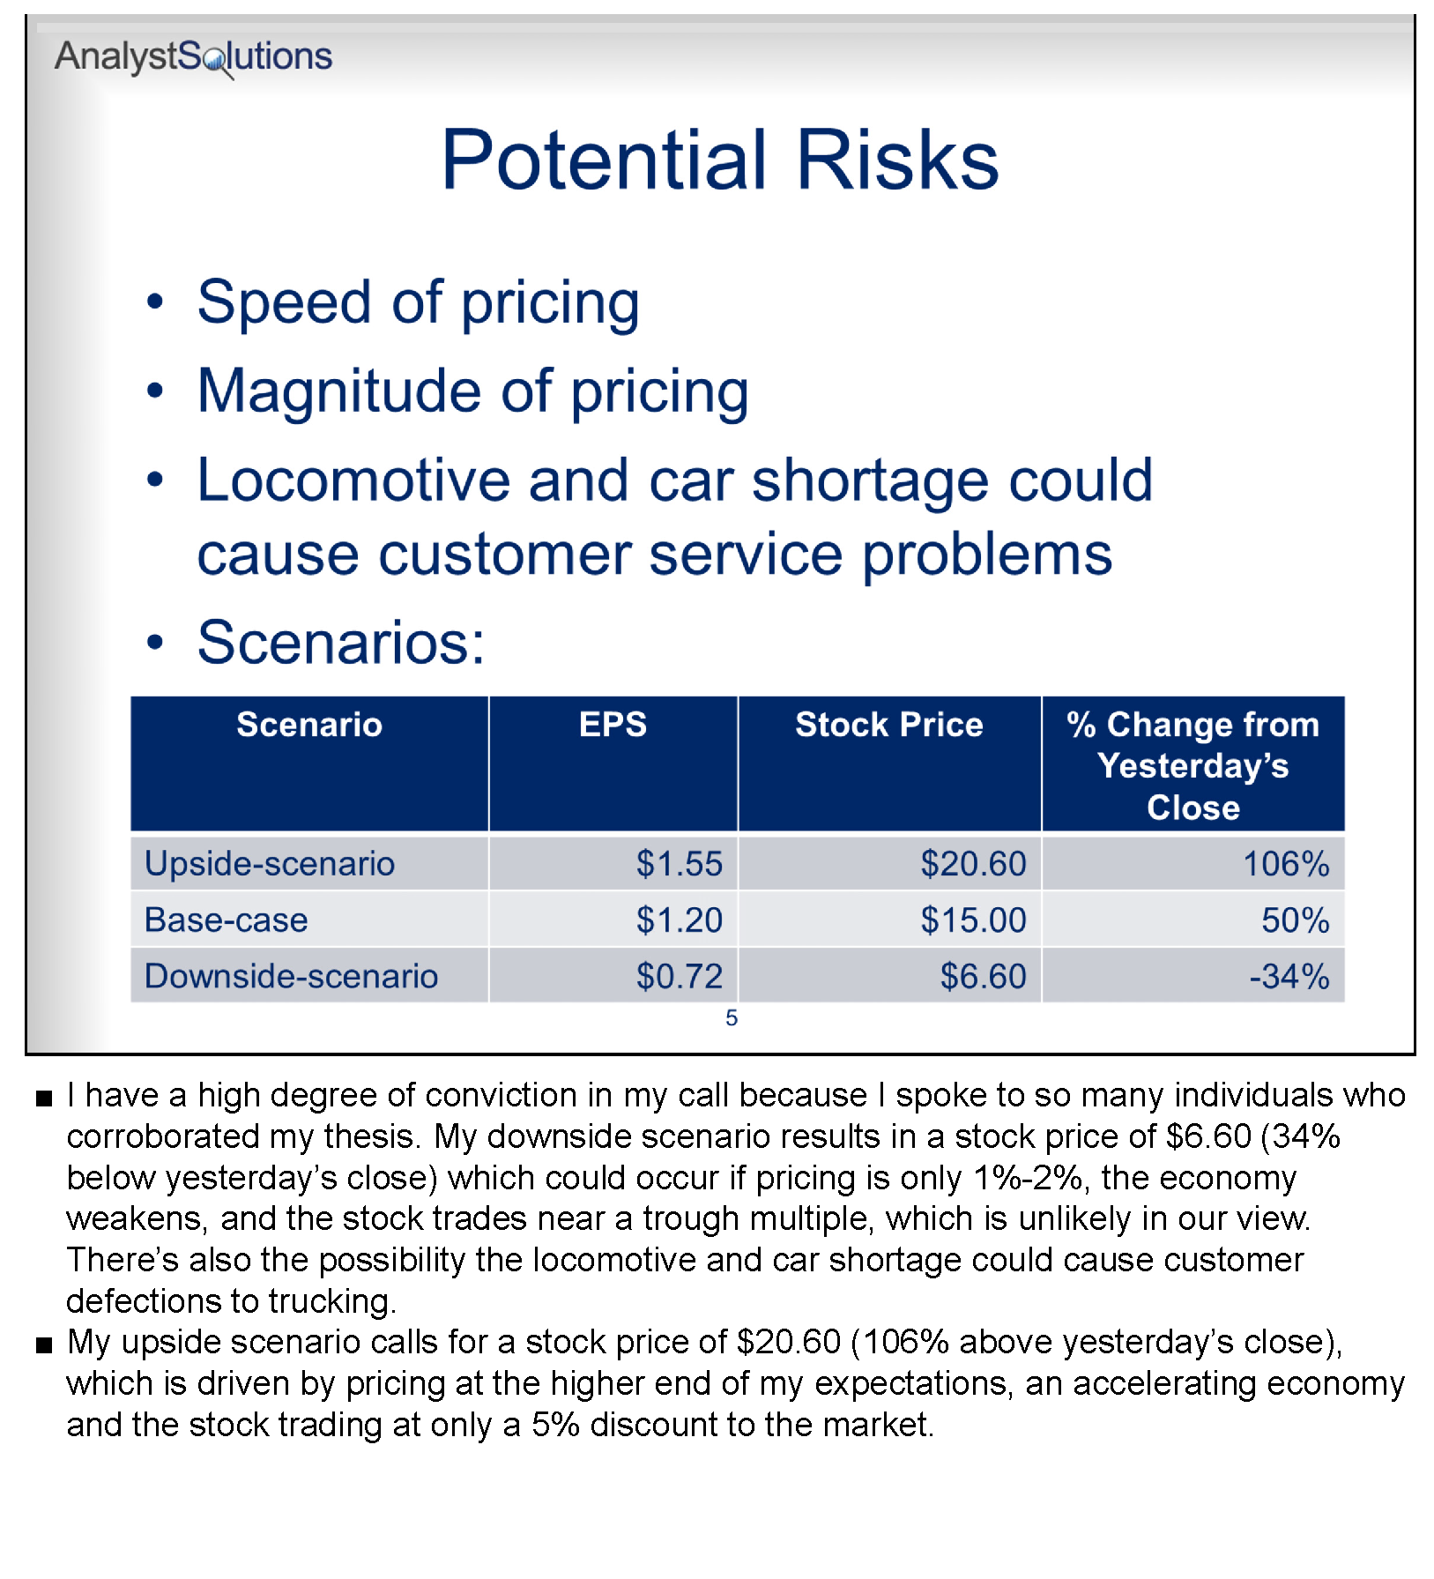

Appendix

Transformation Action Plan (TAP)
Instructions for the Transformation Action Plan (TAP):
- Throughout this workshop complete the TAP below
- Apply the key points after the workshop to help you improve your performance
- This will not be collected and so write in a manner that will help you utilize the concepts being learned
z | Section Ensure Your Content Has Value by Using the ENTER™ Quality Framework  Review the 5 elements of the ENTER™ quality framework below and identify the area(s) where you can make the most improvement to increase the quality of your work. New habits like exercising regularly, eating well or making improvements to our job performance, are very difficult to sustain and therefore also provide at least one tactic you will use to ensure your improved performance continues into the future.
  ENTER™ Component | Steps I Can Take to Improve the Quality of My Research in this Area | Tactic to Ensure My New Behavior Remains Sustainable
  Expectational: Always be thinking about the future, all in an effort to convey how your expectations differ from consensus and resist the temptation to focus on the past. Understanding historical trends is important, but only in helping select stocks in the future.
  Novel: Identify the piece of information you have that’s not in the consensus view, or if responding to news flow, ask yourself, “How is the market misinterpreting the information?”
  Thorough: Ensure that the thoroughness of your research is commensurate with the potential impact on your stock(s) by obtaining insights to accurately forecast critical factors.
  Examinable: Exposing your work to decision makers will raise its quality. It’s not necessary to reveal proprietary sources, but effort should be made to provide enough depth to show others you have done the work.
  Revealing: Identify specific risks not in your base-case scenario, both positive and negative, by determining why the market believes the stock’s current price is more correct than your price target. For an out-of-consensus stock call, assess your conviction level to allow others to gauge the risks to your thesis.
z | Section Utilize the Optimal Channel to Deliver Your Message  Review the following delivery channels and determine if you should be using each one more or less than in the past in order to strike the right balance between the time spent per message recipient and the personal connection required to influence the individuals responsible for rewarding you (i.e. those who influence your pay):
  Channel | I should use this channel more/less/same in the future: | Why?
  In-person conversations
  Live telephone conversations
  Leaving my insights via voicemails
  Presenting, brief (5-10 minutes)
  Presenting, in-depth (10-30 minutes)
  Sending my insights via an email or text message
  Writing a report

Notes

End of Module Section - Do not delete or alter this paragraph and bookmark – Insert all module and lesson content prior to this red non-printing paragraph and bookmark

