

Apply Practical Valuation Techniques For More Accurate Price Targets

Learner Workbook
NOTE: Please ensure you can interact with this document during the workshop in one of these methods:
- With a keyboard (as a Word document); or
- With pen (as a hard copy)

This document has been created for registered participants of AnalystSolutions’ workshops and should not be copied or re-distributed

Apply Practical Valuation Techniques For More Accurate Price Targets

Acknowledgements
Some of the content for this workshop comes from Best Practices for Equity Research Analysts authored by James J. Valentine, CFA and published by McGraw-Hill.

Trademarks & Copyright Acknowledgements
None of the material in this document can be reproduced or distributed without the written consent of:

AnalystSolutions, LLP
20793 W. High Ridge Drive
Kildeer, IL 60047-7937
USA
+1-203-321-9400
AnalystSolutions.com

Table of Contents

Overview 1
Purpose & Learning Objectives 1
Introduction 2
Opening Case 2
Step 1: Select Valuation Method 7
Periods When Valuation Methods Changed 7
Compute Relative P/E Ratios 8
Exercise: "How Is the Valuation Method Likely to Change?" 10
Step 2: Historical & Current Data Review 14
Flowchart 15
Exercise: "Stock or Sector Influences?" 16
Exercise: Cyclically- or Secularly-Moving Valuation? 21
Exercise: Is There a Variable That Explains Valuation Fluctuations? 27
Exercise: Is Relative Valuation Currently On-trend? 30
Sector Correlation Coefficient Matrix 33
Exercise "Is Secularly-Moving Valuation On-trend?" 34
Step 3: Adjust for Future Time Period 39
Stock Correlation Coefficient Matrix 39
Appendix 40
Transformation Action Plan (TAP) 40
Table A: Three Scenarios Answer Key 57
Notes 60

Overview

Purpose & Learning Objectives
 | Why a Apply Practical Valuation Techniques For More Accurate Price Targets program?  When generating price targets, analysts too often spend all of their effort on the financial forecast while leaving the valuation multiple as an afterthought, which can lead to bad stock calls. Analysts sometimes knowingly, and often unknowingly, manipulate valuation multiples and methods to reverse engineer their desired price target. In addition, they miss opportunities to utilize valuation for assessing the all-important market psychology surrounding a stock of interest.  Analysts can derive more reliable price targets by consistently using key practical valuation techniques. Valuation doesn’t need to be overly complicated, but it should employ the best method for the specific stock call and include a thorough review of the past and present to understand the market’s psychology surrounding the stock’s current valuation. As discussed in the best-selling book Best Practices for Equity Research Analysts, valuation is sometimes an afterthought used to help reverse engineer a pre-determined price target. In this workshop, AnalystSolutions provides a highly innovative approach to expose the benefits and limitations of the most widely-used valuation methods as well as our unique SHARE™ framework for generating the most reliable and defendable price targets.
 | Learning Objectives  After completing this program, participants will be able to:  - Recognize the most common causes that lead to unreliable price targets and learn best practices to improve them  - Understand why valuation is not about discovering one flawless number, but rather correctly assessing market psychology surrounding a stock  - Derive the optimal valuation multiple for a future price target by making appropriate adjustments to the stock’s current valuation multiple  - Identify the benefits and limitations to the most commonly-used valuation methods through our tailored decision tree and decision matrix  - Identify if a stock’s current valuation multiple is: 1) on trend compared to the past; and 2) in-line with other stocks that have similar characteristics  - Set a range of upside, downside and base-case price targets using a range of valuation multiples and assumptions towards the stock’s most important 1-3 critical factors  - Identify and monitor the catalysts that would warrant changing the valuation method or future valuation multiple(s)

Introduction

Opening Case
Instructions for the exercise Open Case; “Is the Upgrade Justified?”:
- The purpose of the opening case is to illustrate some of the best and worst practices for selecting the optimal valuation method and multiple. We will refer back to it throughout the workshop.
- Lucas Moretti, who covers the restaurant sector for Golden Bull Securities calls you as a buy-side client, to discuss his upgrade of McDonald’s (MCD)
- It is currently late December 2011 and therefore “next year” is referring to 2012
- Read the entire case
- Then review the case and note any “best practices” (something you would do or advocate other analysts to do) and “bad practices” (those things you would recommend an analyst not do)
  - Use underlining, bolding (if using electronic version) or the right column for notes so that you can keep track of the best and bad practices

z | Upgrade of McDonald’s (MCD) Justified?  - The left column in the table below is Lucas’ dialogue and the center is yours. Read one entire row before proceeding to the next (you will not likely need to put notes in every available box in the “Notes” column)  - Recall it is December 2011 and therefore “next year” is referring to 2012
  Lucas | You | Your Notes
  [Lucas is making a phone call to you]  Hello, this is Lucas Moretti from Golden Bull Securities | Hi Lucas
  I’m upgrading McDonald’s from a neutral to buy. Do you have interest in the stock? | Sure, what do you have?
  I’ve just raised my 2012 estimate from $5.75 to $6.25 and my 2013 estimate from $6.30 to $6.60. | How do your estimates compare to the consensus?
  I think I’m a bit higher | Why is that?
  I’m expecting good volume growth in the U.S. and Europe due to market share gains at the expense of other quick service restaurants. Also, the company should benefit from adding more stores in the U.S. and overseas. I expect the company’s operating margin to expand by 100 basis points each of the next two years, putting it at 32.5% for 2012 and 33.5% for 2013. | But aren’t the company’s margins already near all-time highs?
  Yes, but they can go higher | How high can they go? Put another way, what puts a constraint on its margins expanding?
  MCD’s operating margin has risen from 20% in 2005 to a run rate of 31.5% for full-year 2011, and so there’s no reason they can’t expand further | Let’s assume your financial forecast is correct. Walk me through your valuation.
  When I apply the stock’s current 17.5x multiple on my 2013 estimate, I get a one-year price target in early 2013 of $115 which is 15% higher than yesterday’s close. The stock has averaged a P/E ratio of 17.5 over the past 5 years | How do you come up with an average of 17.5x?
  I get it from our data vendor, BloomSet | I’ve seen this problem in the past…it looks like your 17.5x “historical” average P/E is derived by using the company’s actual trailing earnings as the “E” which inflates the P/E ratio compared to using a forward-looking “E” because trailing earnings tend to be lower than forward earnings.
  I don’t quite follow you | Your price target is based on forward estimates which isn’t how BloomSet computes the historical P/E ratio, which you are using for comparisons. Using the next-12-month forward estimates, the stock’s average P/E ratio for the prior 5 years has only been 15.8x, well below the 17.5x you’re using for your one-year price target.
  I’ll have to look into this. Are you still interested in my thoughts? | Yes, but given that I’m responsible for picking stocks relative to the market, where has MCD traded in the past relative to its peers and the market?
  I’m only looking at absolute P/E ratios and so the level of the S&P’s P/E ratio isn’t a concern. | How do you account for fluctuations in the broader market impacting the movement of the stock? The P/E for the S&P 500 was 14x forward earnings at the beginning of 2011 and is now down to 12x forward earnings. It would be helpful to know how the stock is valued relative to a broad index
  Ok, I’m looking at a screen right now that shows the stock was trading at 160% of the S&P 500 multiple (60% premium) at the end of 2008. If we take the S&P 500’s current forward multiple of 12.3x and apply this 160%, MCD’s P/E ratio would be 19.6x forward earnings. | I appreciate that you’re using a relative P/E ratio, but I have a problem with that math because the stock was trading at 160% of the market in late 2008 because the financial market collapse was driving a huge flight to quality so that all stable high-quality companies were getting excessively high relative valuations. Do you expect a similar collapse to the market to justify a flight to quality in your one-year price target?
  No. | What macro factors have the strongest correlation to MCD?
  I think consumer sentiment. | So as consumer sentiment goes up, so does the stock’s relative P/E ratio?
  I think so. | Has MCD’s relative valuation been moving cyclically over the past 5 to 10 years or has there been a secular movement?
  It’s not a cyclical stock. | I understand that, but is MCD’s relative valuation hitting new highs or lows each year or do they tend to trade in a range over a 5 to 10-year period?
  I’ll have to do some work on this and get back to you. | When I look at a screen I use, the restaurant stocks are currently trading at 146% of the S&P 500’s multiple, which is a 36% premium above their 10-year historical relative average of only 111% of the market multiple. What’s causing this and is it sustainable?
  Aside from Starbucks, MCD is larger than all of the other publicly-traded restaurant stocks combined and so I don’t think it’s useful to compare it to the smaller players in the market | Okay, then how does it compare to large cap stocks in other sectors that have similar financial characteristics?
  I’m not sure it would be a useful exercise to compare a restaurant stock to one in another sector because it would be like comparing apples to oranges | What other valuation methods have you explored?
  My junior associate did some work looking at the stock on a price to sales and EV/EBITDA basis and it looks relatively cheap. | But those methods don’t take into account free cash flow. How do you measure MCD’s ability to generate free cash flow?
  I’m just sticking with P/E ratios because they’re the most commonly used. When a company’s EPS goes up, so does its free cash flows. | Really?  What is the downside to your call?
  I suspect the stock could be dead money from here and trade sideways. | Would that be due to a drop in the valuation multiple or financial forecast?
  Probably a little of both. | So, I know your upside price target is $115. How far would the stock need to drop before you seriously reconsider your rating?
  I haven’t given that much thought because I’m very confident about my calls. As a general rule, I don’t change my price targets from the time I make the call until the stock hits my target or I change the rating. | But over the course of a 6-12-month period shouldn’t you be adjusting for passage of time as the forward-P/E multiple moves further into future forecasts? Also, how do you handle changes that occur to the overall market’s or sector’s valuation level? Shouldn’t that influence the price target you have for a stock?
  That’s more complicated than my clients want me to be. They tell me to keep it simple. | Thanks for the call. Unfortunately, I need to get ready for an upcoming call I have.
  Okay, take care | Thanks…goodbye
- If this workshop is being led by a facilitator, alert him/her after you have noted any “best practices” and “bad practices above, then continue onto the answer key
- If you are taking this workshop without a facilitator, continue to the answer key

z | Answer Key  All of the answers below will be discussed throughout the workshop’s five-step SHARE™ framework and so do not be concerned if you do not have time to read through or fully understand before moving onto the next module.  STEP 1: Select Valuation Method  Lucas…  - Doesn’t understand the shortcomings of each valuation method  - He doesn’t grasp the absolute P/E ratio doesn’t account for fluctuations in the broader market, which is important when selecting stocks relative to the market  - Doesn’t understand that some valuation methods are better proxies for cash flow than others  - He doesn’t appreciate that the P/E ratio, price-to-sales and EV/EBITDA do not measure a company’s ability to generate free cash flow, specifically they do not account for the reinvestment of cash in the business  STEP 2: Historical and Current Data Review  Lucas…  - Doesn’t know these historical: elements for MCD  - Range of MCD’s valuation levels in absolute terms  - Range of MCD’s valuation levels relative to peers and broad index  - Whether MCD’s valuation has been moving cyclically or secularly  - Is using absolute valuation levels rather than relative  - When asked about using relative P/E ratios, he doesn’t understand the importance of using forward-looking estimates for the “e” rather than historical actuals  - Doesn’t know how the stock’s current valuation compares to:  - All of its peers  - Stocks of companies in other sectors with similar characteristics  STEP 3: Adjust for Future Time Period  Lucas…  - In computing a future valuation multiple, he doesn’t account for the current anomalies that will likely disappear:  - Lucas cannot explain why MCD’s current 17.5x P/E multiple (on trailing earnings) is likely to be sustainable when compared to a 15.8x P/E multiple (on forward earnings) the stock has averaged over the past 5 years  - Lucas doesn’t understand there is a negative (not positive) relationship between consumer sentiment and the stock’s relative valuation multiple (this can’t be deciphered from reading the case but we will explore in the workshop)  STEP 4: Range of Multiples and Price Targets  Lucas…  - Doesn’t see the benefit of:  - Creating a range of multiples or price targets (he’s convinced his thought process is the only one he needs to know)  - Developing exit thresholds before making the stock call (nothing can go wrong)  STEP 5: Evaluate as Circumstances Change  Lucas…  - Doesn’t fully appreciate that price targets should be changed when:  - Assumptions change in his earnings or cash flow projections  - Time passes, leading to new forecast periods (e.g. each month that passed will likely cause the next 12-month forward estimate to increase)  - Valuation multiples of comparable companies or the market change

Step 1: Select Valuation Method

Periods When Valuation Methods Changed
z | Periods When Valuation Methods Changed  - Economic Cycles:  - For some cyclical stocks, during periods when the market believes a peak in the economic cycle is near, analysts will value the stocks on “normalized earnings” (which will be lower than the current forward estimates) because they know the next 12-month estimate is not likely sustainable  - The U.S. banks were predominantly valued using P/B pre-2008, and then on their ability to get financing during the financial meltdown of 2008  - During the 2008 downturn, North American telecom analysts were split on valuation methods, with some valuing stocks on EBITDA, while others were defensively using dividend yields. However, the real valuation differentiator should have been focused on their financial forecasts, specifically, each company’s ability to refinance its debt  - Unique Company- and Sector-Specific:  - As Blackberry went from boom to bust, it was valued from P/E to P/S and then to P/tangible book  - Investors shifted from P/E to FCF for Dillard’s, due in part to its strong FCF and possibly due to owning 75% of its own real-estate (which is unusual for a retailer)  - Going back at least 20 years, when airlines have been earning a profit, they are valued on a P/E basis but when they overbuild capacity (which occurs more often than the typical business cycle), they are valued on a P/S basis  - When Liz Claiborne was at $4 it was being valued on price/sales and then as the market realized it could be turned around, valuation shifted to EV/EBITDA and the stock went to $10 (at which point it changed its name to Fifth & Pacific). The company then sold several divisions, and became Kate Spade, where the valuation method shifted to P/E. Because of the substantial ramp up in sales and margins in its new form, valuation changed again, to PEG.  - When a company is being considered as a take-out candidate, the market may shift from a traditional valuation method such as P/E to using EV/EBITDA because the target company’s debt level becomes less important

Compute Relative P/E Ratios
Instructions for “Compute Relative P/E Ratios”
- The purpose of this exercise is to reinforce the method for computing relative P/E ratios and how they are used
- The table that follows is also available in Excel on the page for the bonus material for this workshop
- Complete the table below or the Excel file. We provide instructions for obtaining the information from Bloomberg or the Internet.
- For the S&P 500:
  - If using Bloomberg (“INDEX” is the F10 key):
    - Type SPX INDEX EEO
    - The stock price will be at the top of the page
    - To get the NTM EPS estimate, make sure “Flavor” is set to “F12” = Forward 12 Months to get the NTM estimates
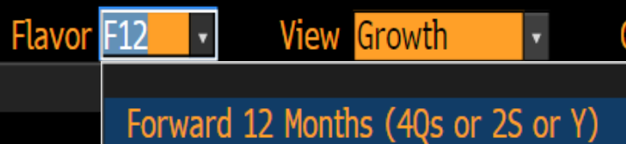
    - Select the first number under “the F12 Est” column
  - If using the Internet, search for “S&P 500 EPS estimates, or go to:
    - https://ycharts.com/indicators/sandp_500_earnings_per_share_forward_estimate and use the next four quarters EPS estimates; or
    - https://www.zacks.com/stock/quote/SPAL/detailed-estimates and weigh the current and next year based on the current month of this year (e.g. if it’s late June, use 50% of this year and 50% of next year)
- For individual stock data, such as MCD:
  - If using Bloomberg (“EQUITY” is the F8 key)
    - Type TICKER EQUITY EEO
    - Note: you may need to scroll to the right to see all four quarters
    - Add up the next 4 quarters to derive a “NTM” estimate (use the amber numbers, not the rust color numbers)
  - If using the Internet, go to the link below on Yahoo! Finance (the example below is for MCD)
    - https://finance.yahoo.com/quote/MCD/analysis?p=MCD
    - Add up the EPS estimates for the next four quarters

 | z | Relative P/E Table
  Ticker | Current Price | Forward (NTM) EPS | P/E | Relative P/E Ratio
  SPX (S&P 500) |  |  |  | N/A
  MCD
  FDX
  NKE
  [Your Stock]

Exercise: "How Is the Valuation Method Likely to Change?"
Instructions for the exercise “How Is the Valuation Method Likely to Change?”:
- Using “change in valuation method” as the primary basis for a stock call is often not successful and so it should be used sparingly. Therefore, the purpose of this exercise is to reinforce those relatively infrequent times when changing the valuation method is justifiable and may allow the analysts to have a unique stock call that generates alpha
- The table that follows contains scenarios when the valuation method is potentially going to change for a sector
- Read Column #1 and then estimate in:
  - Column #2: How is the valuation method likely to change? To help, we have provided the current valuation method
  - Columns #3: How is the market’s overall philosophy towards valuation likely to change?
- You may want to use the flow chart (provided on the next page) to review the most common valuation methods
- The scenarios include sector-specific dynamics and get progressively more difficult and so do not become frustrated if you cannot respond to all of the scenarios
- When you have completed the table, continue to the next page that contains our “ideal” answer key. If you have an answer not in the answer key, check with the workshop facilitator because there may be additional valid answers

 | z |  | Valuation Flow Chart  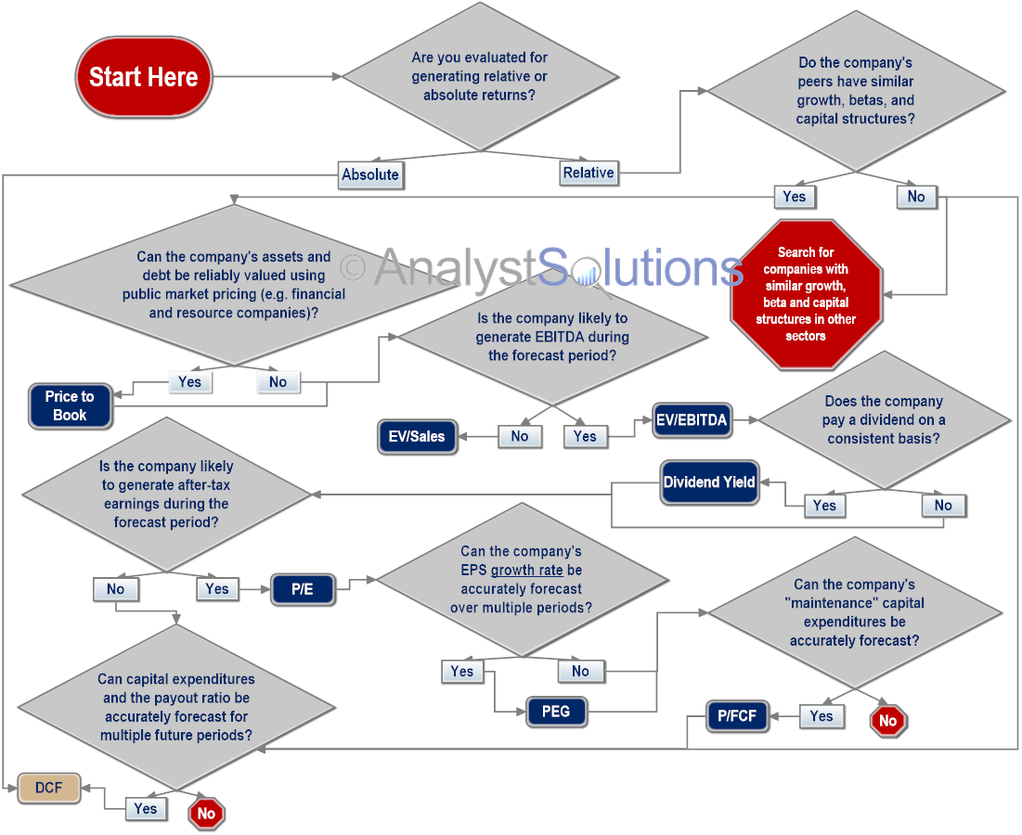
 | z |  | “How Is the Valuation Method Likely to Change?”  After completing the table above, check your answers with the table that follows
  Scenario | How is the valuation method likely to change? | How is the market’s philosophy towards valuation changing or likely to change?
  EXAMPLE:  The auto sector has experienced six years of steady earnings growth | The typical emphasis of applying an average P/E multiple on forward earnings will likely shift to applying the same P/E multiple on “normalized” earnings, which will likely lower than current levels (due to being near the end of a business cycle) | The market is likely becoming concerned that current earnings levels/growth are unsustainable and therefore investors do not want to be paying an average P/E multiple on peak earnings as there is minimal upside from there
  Based on two privately-held food retailer chains merging, some market participants believe a wave of M&A is about to take place | Prior emphasis on forward earnings or cash flows will likely shift to:
  The fate of some technology companies is shifting from growth to maturity based on the potential secular shift away from PCs to tablets | Prior emphasis of using PEG ratios, will likely shift to:
  The government, concerned about lack of safety standards at nuclear plants, is considering revamping regulations that would require large capital outlays by the utilities | Prior emphasis on dividend yields, will likely shift to:
  The shift to reading news online is causing print-based publishers to fail | Prior emphasis on P/E likely to shift to:
  Energy companies are not replenishing their oil and gas reserves at historical levels | Prior emphasis on free cash flow will likely shift to:
z |  | “Ideal” Answer Key to “How Is the Valuation Method Likely to Change?” (there may be other valid answers not included below)
  Scenario | How is the valuation method likely to change? | How is the market’s philosophy towards valuation changing or likely to change?
  Based on two privately-held food retailer chains merging, some market participants believe a wave of M&A is about to take place | Prior emphasis on forward earnings or cash flows will likely shift to take-out multiples for target companies. | Traditionally looking at stocks relative to one another or their past will likely shift to one that includes control premiums. Also, industry consolidation could lead to better returns and cash flows.
  The fate of some technology companies is shifting from growth to maturity based on the potential secular shift away from PCs to tablets | Prior emphasis of using PEG ratios, will likely shift to normalized P/E or FCF | Slower growth rates likely shift focus from growth to identify the company’s free cash flow available for shareholders
  The government, concerned about lack of safety standards at nuclear plants, is considering revamping regulations that would require large capital outlays by the utilities | Prior emphasis on dividend yields, will likely shift to free cash flows, especially if capital expenditures rise enough to cause the companies to cut their dividends (or reduce their payout ratio) | Larger uses of cash to comply with regulations will likely hurt dividends
  The shift to reading news online is causing print-based publishers to fail | Prior emphasis on P/E likely to shift to company’s ability to repay interest such as a minimum coverage ratio | A concern about insolvency is going to shift the focus from P/E to a company’s ability to get financing or merge
  Energy companies are not replenishing their oil and gas reserves at historical levels | Prior emphasis on free cash flow will likely shift to NAV (net asset value) | The market will likely become more concerned with the companies’ ability to generate future free cash flows (beyond the current or next period) based on the net asset value of their reserves

Step 2: Historical & Current Data Review

Flowchart
z | 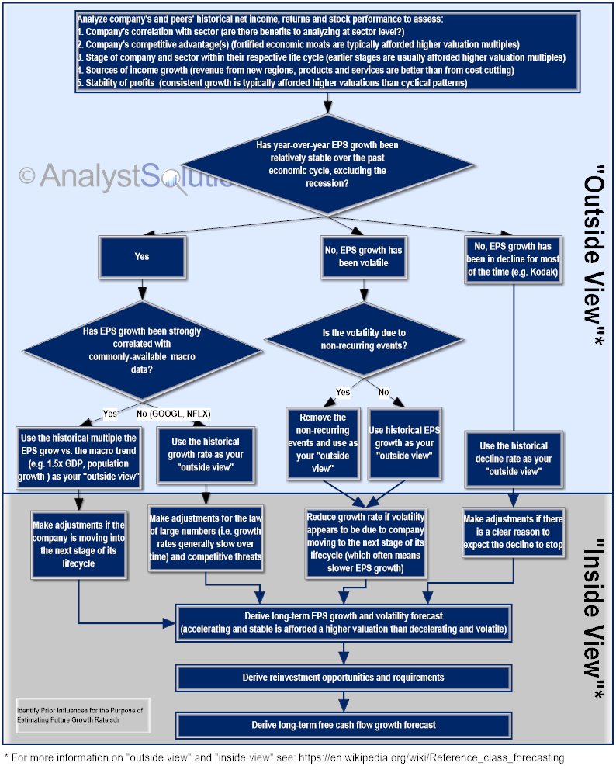

Exercise: "Stock or Sector Influences?"
Instructions for the exercise “Stock or Sector Influences?”:
- For this exercise, recall this equation:
Stock’s P/E relative to index | = | Stock’s P/E relative to sector’s | x | Sector’s P/E relative to index’s
- The purpose of this exercise is to determine if a stock’s relative valuation to an index (e.g. S&P 500) is being more heavily influenced by:
  - The stock’s relative valuation to its sector; or
  - The sector’s relative valuation to a broad index
- In the charts that follow, each will have:
  - The stock’s P/E ratio relative to a broad index (S&P 500) as a tan line, (this is the variable that needs to be analyzed)
  - The stock’s P/E ratio relative to its sector’s P/E ratio as a light blue area chart
  - The sector’s P/E ratio relative to the broad indexes’ as a dark blue area chart
- Answer the question below each chart
  - There will not be an answer that holds true over the entire time period and so look for the broader trends to answer the question
  - The goal is to identify periods when the stock or sector are clearly driving the stock’s P/E ratio relative to an index

z | Oracle (ORCL)  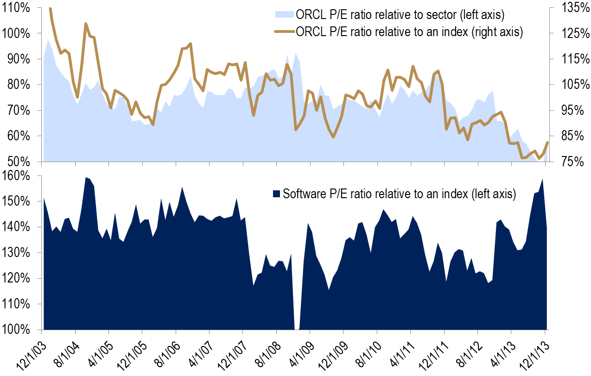  During most of the time period above, which is the greater influence on ORCL’s P/E relative to the index (circle or bold one of the right terms below):
  ORCL’s P/E relative to index  (tan line) | = | Stock’s P/E relative to sector’s  (light blue area chart) | x | Sector’s P/E relative to index’s  (dark blue area chart)
z | Pfizer (PFE)  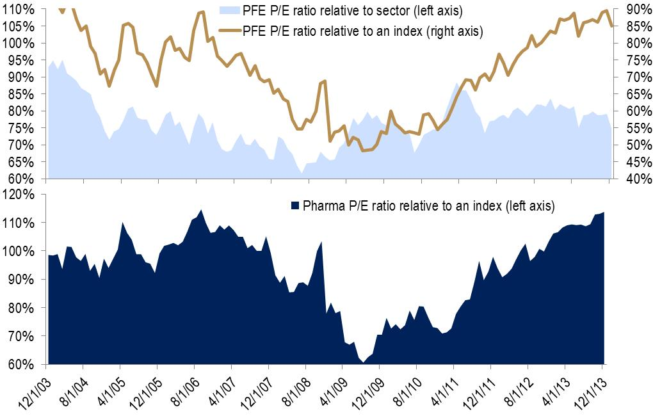  During most of the time period above, which is the greater influence on PFE’s P/E relative to the index (circle or bold one of the right terms below):
  PFE’s P/E relative to index  (tan line) | = | Stock’s P/E relative to sector’s  (light blue area chart) | x | Sector’s P/E relative to index’s  (dark blue area chart)
z | Bed Bath & Beyond (BBBY)  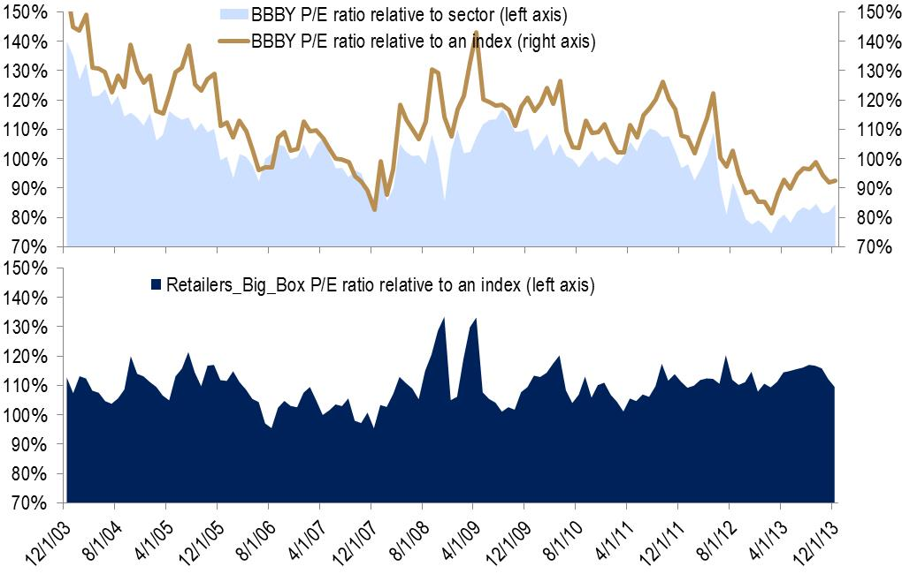  During most of the time period above, which is the greater influence on BBBY’s P/E relative to the index (circle or bold one of the right terms below):
  BBBY’s P/E relative to index  (tan line) | = | Stock’s P/E relative to sector’s  (light blue area chart) | x | Sector’s P/E relative to index’s  (dark blue area chart)
z | Walmart (WMT)  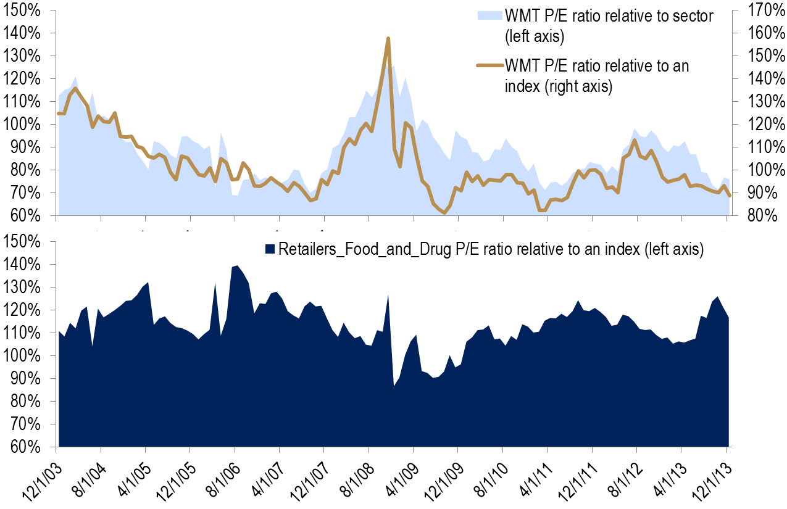  During most of the time period above, which is the greater influence on WMT’s P/E relative to the index (circle or bold one of the right terms below):
  WMT’s P/E relative to index  (tan line) | = | Stock’s P/E relative to sector’s  (light blue area chart) | x | Sector’s P/E relative to index’s  (dark blue area chart)
z |  | Answer Key to “Stock or Sector Influences?”  Yes you made it past the answer key, but we still have one important question to ask:  - How would the answers above influence how you approach researching valuation for PFE vs. the other stocks?
  Stock | Which Is the Influencer of the stock vs. Index (tan line)
  ORCL | Stock vs. sector is bigger component
  PFE | Sector vs. index is bigger component
  BBBY | Stock vs. sector is bigger component
  WMT | Stock vs. sector is bigger component

Exercise: Cyclically- or Secularly-Moving Valuation?
Instructions for the exercise Cyclically- or Secularly-Moving Valuation?
- The purpose of this exercise is to determine if a stock’s or sector’s relative valuation is moving on a secular basis, because the type of movement impacts the manner in which the historical and future multiples are evaluated
- In the charts that follow:
  - There will be the relative P/E ratio for a stock or sector depicted as a light blue bar chart using the left axis
  - For this exercise, ignore the variable depicted as a tan line as it will be used in a later exercise
- Using the table immediately below, determine if the chart shows the stock as having a secularly-moving valuation:
  - Be mindful that just because a stock’s relative valuation has been expanding since the 2008 recession does not necessarily mean it’s moving on a secular basis because it may just be due to economic expansion. For a trend to be secular, it typically is not impacted by the economic cycle.
  - If a stock’s or sector’s valuation appears to be moving on a secular basis, it means something other than economic cycles is likely a factor to the new highs or lows
  - If you discover a period when the stock’s valuation has been moving on a secular basis, identify the wrong conclusion that would be reached if an analyst computed a future price target by simply taking the “historical average” of the multiple during the secular trend
  - Remember to ignore the tan lines for this exercise as they should have no influence on your answers for this exercise
- For this exercise and the others that follow, be mindful they are not intended to test your knowledge on a specific stock or sector or to help you become an expert on a specific stock or sector. Instead, they are intended to help you learn a process so that you can apply it to your stocks and sectors (so all you overachievers, please try to resist getting frustrated if you don’t have all of the stock- or sector-specific answers).

z | Cyclically- or Secularly-Moving Valuation?  - Complete the table below by reviewing the charts that follow  - If you are using an electronic version in Word, split your screen so this table is in the top panel and the charts you will review are on the bottom panel  After completing the table above, review the answer key, which can be found after the last chart below
  Stock or Sector Chart | Cyclical, Secular or Unclear | For charts with secular trends, if a future price target were derived by taking the “historical average” of the multiple over the entire secular trend period, would it be: TOO HIGH or TOO LOW
  EXAMPLE:  1. Internet sector | Y | Too high
  2. Pharmaceutical sector
  3. CVS
  4. Railroad sector
  5. Restaurant sector
  6. Air Freight
  7. Campbell Soup
z | Internet Sector  “EPS growth FY2 vs. FY1” is the growth between the consensus EPS estimate for the next fiscal year compared to the consensus EPS estimate for this year
z | Pharmaceutical Sector
z | CVS  “NTM EPS vs. Avg. of Prior 12 Months” is the next-twelve-month consensus EPS at that point in time divided by the average consensus EPS estimate over the prior 12 months
z | Railroad Sector
z | Restaurant Sector
z | Air Freight Sector  Note We have reversed right axis (the lowest number on the top and the highest number on the bottom), which can be helpful in identifying negative correlations/relationships between two data series.
z | Campbell Soup  Stop here because this is the last chart for the exercise. After you have provided your answer in your version of the table, review the corresponding answer key
z |  | Answer Key to “Cyclically- or Secularly-Moving Valuation?”
  Stock or Sector | Cyclical, Secular or Unclear | For charts with secular trends, if a future price target were derived by taking the “historical average” of the multiple over the entire secular trend period, would it be: TOO HIGH or TOO LOW
  1. Internet sector | Secular (decline) | Too high
  2. Pharmaceutical sector | Cyclical
  3. CVS | Secular (decline) | Too high
  4. Railroad sector | Unclear but may be secular increase
  5. Restaurant sector | Unclear but may be secular increase | Too low
  6. Air Freight | Cyclilcal
  7. Campbell Soup | Cyclical | Too high

Exercise: Is There a Variable That Explains Valuation Fluctuations?
Instructions for the exercise “Is There a Variable That Explains Valuation Fluctuations?”:
- The purpose of this exercise is to identify if there is a variable that can explain the market’s psychology in terms of fluctuations of a sector’s or stock’s relative valuation multiple (relative P/E ratio in our examples)
- You will be using the charts from the prior exercise, but for this exercise you will be also reviewing an independent variable depicted as a tan line, using the right axis
    - The definition of the variable will be below the chart if not a conventional industry term
    - A variable that begins with “MACRO” is a macroeconomic factor
- In the table below, rate the variable (tan line) in each chart in terms of its relationship to the relative P/E bar chart (blue bars using left axis), by using one of the following:
  - 1 = Appears to have strong relationship (denote positive or negative)
  - 2 = Appears to have good relationship at times
  - 3 = Appears to be a weak or no relationship

 | z | Table for Exercise: “Is There a Variable That Explains Valuation Fluctuations?”  After you have completed the table above, go to the next page to see the answer key
  Stock or Sector | Variable (tan line) | Relationship between relative P/E ratio and tan line variable:  1=Strong  2=Good  3=Weak/None | If strong relationship exists, Positive or Negative? (P or N)
  EXAMPLE:  1. Internet sector | Sector’s EPS growth rate FY2 vs. FY1 | 1 or 2 would be acceptable answers | P
  2. Pharmaceutical sector | Sector’s payout ratio
  3. CVS | Stock’s EPS growth vs. prior 12 month average
  4. Railroad sector | ROE
  5. Restaurant sector | Gasoline prices
  6. Air Freight | Industrial production
  7. Campbell Soup | Stock’s EPS growth rate FY2 vs. FY1
 | z | Answer Key for Exercise: “Is There a Variable That Explains Valuation Fluctuations?”  - We’ve provided the correlation coefficients in the table below, which were purposely not in the content above, but allow you to see precisely how strong of a relationship exists
  Stock or Sector | Variable (tan line) | Relationship between relative P/E ratio and tan line variable:  1=Strong  2=Good  3=Weak/None | If strong relationship exists, Positive or Negative? (P or N)
  1. Internet sector | Sector’s EPS growth rate FY2 vs. FY1 | 1 or 2 would be acceptable answers  Corr. Coefficient: 65% | P
  2. Pharmaceutical sector | Sector’s payout ratio | 1 or 2  Corr. Coefficient: 71% | P
  3. CVS | Stock’s EPS growth vs. prior 12 month average | 1 or 2  Corr. Coefficient: 71% | P
  4. Railroad sector | ROE | 1 or 2  Corr. Coefficient: 76% | P
  5. Restaurant sector | Gasoline prices | 1 or 2  Corr. Coefficient: 72% | P
  6. Air Freight | Industrial production | 1 or 2  Corr. Coefficient: -72% | N
  7. Campbell Soup | Stock’s EPS growth rate FY2 vs. FY1 | 3  Corr. Coefficient: 12%

Exercise: Is Relative Valuation Currently On-trend?
Instructions for the exercise “Is Relative Valuation Currently On-trend?”:
- The purpose of this exercise is to determine if a stock’s or sector’s current relative valuation appears to be currently on-trend with the past
- Review the charts used in the prior two exercises and then in the table below record if the relative P/E ratio is currently on-trend (assume the right-most point on the chart is “current” day)
- If the relative P/E ratio does not appear to be on-trend, determine if it is high or low compared to the trend you see
- Note we have removed Campbell Soup from this exercise because no relationship existed between the variable (tan line) and valuation (blue bars)
z |  | Table for “Is Relative Valuation Currently On-trend?”  After you have completed the table above, go to the next page to see the answer key
  Stock or Sector | Variable | Currently on-trend? (Y or N) | If “No”, does the stock or sector appear over-(“O”) or under-valued (“U”)?
  1. Internet sector | Sector’s EPS growth rate FY2 vs. FY1
  2. Pharmaceutical sector | Sector’s payout ratio
  3. CVS | Stock’s EPS growth vs. prior 12 month average
  4. Railroad sector | ROE
  5. Restaurant sector | Gasoline prices
  6. Air Freight | Industrial production
  7. Campbell Soup | Stock’s EPS growth rate FY2 vs. FY1 | Not evaluated due to weak relationship
 | z | Answer Key for “Is Relative Valuation Currently On-trend?”  NOTE: When you are done, read the text below titled:  “Regression Analysis Helps Fend Off Guesswork”
  Stock or Sector | Variable | Currently on-trend? (Y or N) | If “No”, does the stock or sector appear over-(“O”) or under-valued (“U”)?
  1. Internet sector | Sector’s EPS growth rate FY2 vs. FY1 | Y
  2. Pharmaceutical sector | Sector’s payout ratio | N | O
  3. CVS | Stock’s EPS growth vs. prior 12 month average | Y
  4. Railroad sector | ROE | N | U
  5. Restaurant sector | Gasoline prices | Y
  6. Air Freight | Industrial production | N | O
  7. Campbell Soup | Stock’s EPS growth rate FY2 vs. FY1 | Not evaluated due to weak relationship
z |  |  | Regression Analysis Helps Fend Off Guesswork  Why conduct regression analysis to see if company or macro trends are linked to a company’s relative P/E ratio?  “A firm may have a P/E ratio of 22 in a sector where the average P/E is only 15, but the analyst may conclude that this difference can be justified because the firm has higher growth potential than the average firm in the industry.  If, in the judgment of the analyst, the difference on the multiple cannot be explained by the fundamentals, the firm will be viewed as overvalued (if its multiple is higher than the average) or undervalued (if its multiple is lower than the average).  The weakness in this approach is not that analysts are called upon to make subjective judgments, but that the judgments are often based on little more than guesswork. All too often, these judgments confirm analysts' biases about companies.”  -- Aswath Damodaran  Damodaran on Valuation: Security Analysis for Investment and Corporate Finance. Hoboken, NJ: John Wiley & Sons, 2006. 248. Print.

Sector Correlation Coefficient Matrix
z | Sector Correlation Coefficient Matrix  December 2003 to December 2013

Exercise "Is Secularly-Moving Valuation On-trend?"
Instructions for the exercise “Is Secularly-Moving Valuation On-trend?”:
Part 1 of 4:
- Baidu (BIDU) is an internet search service company offering a Chinese language search platform that went public in 2005 and is traded on NASDAQ.
- Using only the waterfall chart below, answer the questions below:
  - Is the internet sector’s relative P/E ratio trading at a premium, discount or on-trend with ten-year averages?
  - Is BIDU’s relative P/E ratio trading at a premium, discount or on-trend with ten-year averages?
- After answering the questions above, continue to Part 2 of this exercise

z | Baidu (BIDU)  Historical averages from December 31, 2005 to June 30, 2013:
Part 2 of 4:
- Review the two charts below that show P/E ratios relative to the S&P 500 for:
  - The Internet sector
  - BIDU
- What additional dimension(s) do these charts show not found in the prior waterfall chart? Does the sector or stock appear to be as far off historical trends as the conclusion from the waterfall chart?
- After answering the question above, continue to Part 3 of this exercise

z | Chart 1: Internet Sector
z | Chart 2: Baidu
Part 3 of 4:
- Directly below is the regression output from Excel when comparing:
  - BIDU’s P/E ratio relative to the S&P 500 index (which we want to predict); and
  - Two predictor variables (those we use for predicting):
    - Growth in BIDU’s future EPS (consensus FY2 vs. FY1)
    - BIDU’s beta
  - Using the regression output, create the regression equation that will show if BIDU’s relative valuation is currently on-trend

z | Baidu Regression Output  - Derive the regression equation for predicting BIDU’s relative P/E ratio based on output above  - Use the terms “BIDU EPS growth” and “BIDU Beta” to create the formula below – we will provide the actual numbers for these in the next step  - If you’re not sure how to build the regression equation, which you will need for the next step, look at the answer key that follows Part 4 of the exercise
  BIDU' s relative PE Ratio | = | __________ | + | ____________ x ____________ | + | ____________ x ____________
Part 4 of 4:
- In June 2013, the consensus EPS growth rate for BIDU over the next 12 months was 23.9% and its beta was 1.59. To use the formula derived from the Excel output above, the growth rate must first be converted to a decimal by moving the decimal two places to the left (e.g. 23.9% = 0.239).
- Based on this information and your regression equation above, what is the predicted relative P/E ratio for BIDU’s stock as of June 2013?
- The stock’s P/E ratio at the time was 121% of the S&P 500. Based on your analysis directly above, was BIDU’s stock on-trend?

z | Answer Key for Exercise “Is Secularly-Moving Valuation On-trend?”  Part 1:  Based on the waterfall chart alone, the internet sector and BIDU both appear to be trading at significant discounts to their historical average (internet sector at 61% discount and BIDU at 186% discount)  Part 2:  These two charts shows the internet sector and BIDU have been experiencing contracting (declining) P/E ratios relative to the S&P 500. Mathematically, the current relative P/E ratios appear low by historical standards but this does not make them “off trend” when considering they are declining on a secular basis.  Part 3:  Based on the Excel output, the regression equation is  $$BIDU^{'}s relative PE Ratio= -1.41+\left(7.47*{BIDU}^{'}s EPS Growth\right)+\left(0.53*{BIDU}^{'}s Beta\right)$$  Part 4:  Based on the regression equation and BIDU”s variables in June 2013, its predicted relative P/E ratio is 122% which compares to its actual relative P/E ratio at the time of 121%. Therefore BIDU’s relative valuation was on-trend.

Step 3: Adjust for Future Time Period

Stock Correlation Coefficient Matrix
z | Stock Correlation Coefficient Matrix*  *Correlation with the stock’s monthly relative P/E ratio between December 2001 to June 2014

Appendix
 | Transformation Action Plan (TAP)
Instructions for the Transformation Action Plan (TAP):
- Throughout this workshop complete the TAP below
- Apply the key points after the workshop to help you improve your performance
- This will not be collected and so write in a manner that will help you utilize the concepts being learned

TAP Section Reflect on “S” in SHARE™ Framework (Select valuation method)
- Review these reference cards:
  - Considerations for Identifying the Optimal Valuation Method (flowchart)
  - Benefits and Limitations of Popular Valuation Methods
- Rank the questions in the table below in terms of how well these best practices are part of your process for identifying and using valuation methods (1=strongly disagree and 5=strongly agree):
For my universe of stocks, | 1= disagree  5= agree
I include a valuation method that includes an element of free cash flows (i.e. going as far as possible through the flow chart)?
I am aware of all the limitations to the valuation method(s) I currently use

- If you responded to either question above with a 1, 2, or 3 put in the box below, steps you intend to take to adopt best practices to improve the valuation method(s) you use:
In intend to do the following:

TAP Section Part 1A & 1B of MCD Simulation
- In order to ensure you have mastered the best practices covered in this workshop, you will work through the primary steps of the SHARE™ framework in order to forecast the future valuation multiple for a stock, specifically, McDonald’s (MCD).
- In this section of your TAP, you will:
  - Classify if MCD’s historical relative valuation has been primarily moving cyclically or secularly
  - Identify the cause of the historical premium or discount in MCD’s P/E ratio relative to peers and a broad index
- Use the data below to answer the questions, as though it is currently late December 2011

z |  | Part 1A of MCD Simulation: Cyclical, Secular or Both  Reviewing the light blue area in the first chart below, determine if MCD’s P/E ratio relative to the sector over this 8-year time period was primarily cyclically-moving or secularly-moving (ignore the tan line and dark blue area chart for this question):  Reviewing the dark blue area chart below, determine if the restaurant sector’s valuation relative to the index (S&P 500) over this 8-year time period was primarily cyclically-moving or secularly-moving (ignore the tan line and light blue area chart for this question):  After answering the questions above, continue to the next page to complete Part 1 of the MCD simulation  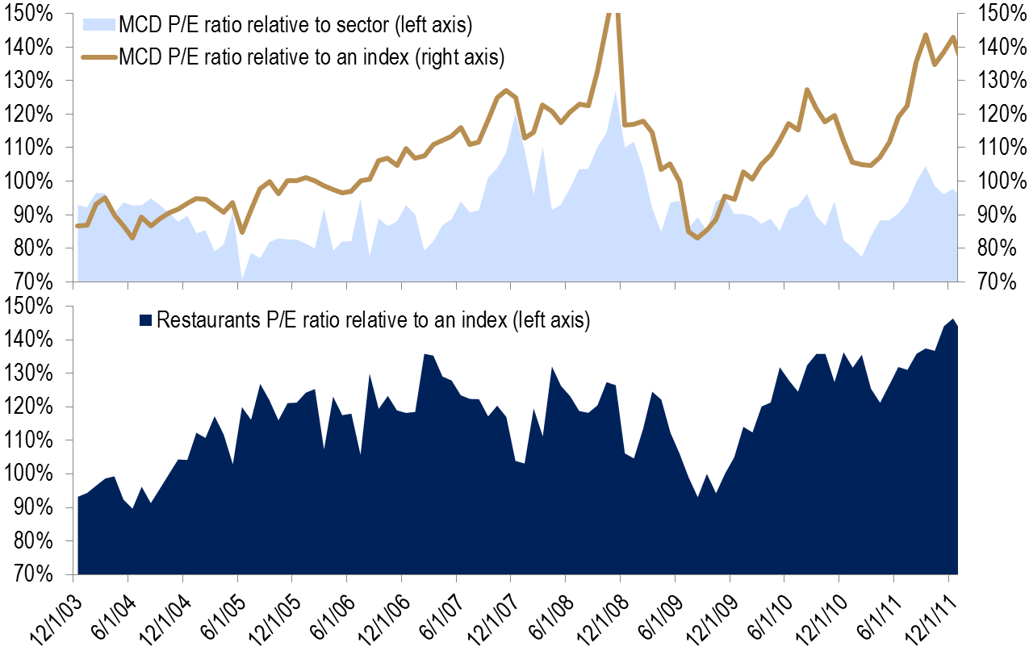
  Answer:
  Answer:
z |  | Part 1B of MCD Simulation: Cause of the Premium or Discount  Review each of the charts below and evaluate the variable (tan line) in terms of being:  - Helpful in evaluating the level of the sector’s or stock’s relative P/E ratio  - Not helpful in evaluating the level of the sector’s or stock’s relative P/E ratio  Note the light blue bars are measuring one of these two elements in each chart:  - The restaurant sector’s P/E ratio relative to a broad index (S&P 500); or  - MCD’s P/E ratio relative to the restaurant sector  Chart 1: Restaurant Sector  Circle or bold your answer below regarding the chart above:
  Appears Helpful | Does Not Appear Helpful
z |  | Chart 2: Restaurant Sector  Circle or bold your answer below regarding the chart above:
  Appears Helpful | Does Not Appear Helpful
z |  | Chart 3: McDonald’s Stock Specific  Circle or bold your answer below regarding the chart above:
  Appears Helpful | Does Not Appear Helpful
z |  | Chart 4: McDonald’s Stock Specific  Circle or bold your answer below regarding the chart above:
  Appears Helpful | Does Not Appear Helpful
z |  | Answer Key for the MCD Simulation Part 1A: “Cyclical, Secular or Both”  - MCD’s P/E ratio relative to the restaurant sector appears to be cyclical because it’s not reaching new highs or new lows over more than one economic cycle  - The restaurant sector’s P/E ratio relative to the index appears to be predominantly cyclical, but given that it achieves an all-time high in late 2011, higher than any point of the prior economic cycle suggests there may be a slight secular element at work here as well  Answer Key for the MCD Simulation Part 1B: “Cause of the Premium or Discount”  The answer is all four charts help explain some of the fluctuation of MCD’s P/E relative to the index, explained in part by sector issues as well as stock-specific issues. In the table below, the right-most column shows the correlation coefficient between each of the two data series. The ones with the highest correlation presumably would be the most helpful.  Hopefully it’s becoming clear that there is value in finding a strong correlation between data and a sector’s or stock’s relative P/E ratio. Because:  - If the current figure is not on-trend, it forces the all-important research to better understand why, specifically why has the market psychology towards this stock changed from the past trends; and  - By accurately forecasting the company-specific data and having an understanding of the macro data trend, provides the foundation for a much more accurate future price target than simply using today’s valuation levels
  Chart # | Variable Being Predicted | Variable explaining relative valuation | “Helpful” | Correlation Coefficient
  1 | Restaurant Sector P/E Relative to Index | Restaurant Sector’s Change in NTM EPS FY2 vs FY1 | Yes, see correlation coefficient | (47%)
  2 | Restaurant Sector P/E Relative to Index | Restaurant Sector’s ROE | Yes, see correlation coefficient | (58%)
  3 | MCD’s P/E Relative to Restaurant Sector | MCD’s NTM EPS vs. 12 Month Average | Yes, see correlation coefficient | (40%)
  4 | MCD’s P/E Relative to Restaurant Sector | MCD’s NTM EPS vs. Private Construction Spending | Yes, see correlation coefficient | (56%)

TAP Section Reinforce Best Practices of Step 2 of SHARE™ Framework
- Recall Step 2 of the SHARE™ framework is to determine if a stock’s current relative valuation is on-trend with the past, which was divided into a process for stocks with cyclically-moving valuations and another for stocks with secularly-moving valuations
- To ensure you can utilize this step in your role, take a minute and reflect on the key elements you will use from this best practice in the future (including data you’ll need to gather, time specified for this type of analysis, etc.). You may want to review the TAP section above where you were using elements of Step 2 (in the space below tell yourself what you need to do to replicate these best practices when you get back to your daily routine).

z |  |  | Variable #2: MCD’s ROE  - Your forecast is for MCD’s ROE to drop to 36% for 2013  - Use the data from the chart and regression output above to complete the table below (which will be used later to derive a future price target for MCD).
  Regression Statistics
  Multiple R | 0.63
   | Coefficients | P-value
  Intercept | 0.65 | 0.00
  ROE | 1.51 | 0.00
  Variable #2: ROE
  Current/recent levels (tan line) | 37.5%
  Your forecast at time when price target should be achieved (1 yr from now) | 36.0%
  Correlation coefficient
  Regression coefficient (multiplier from regression output)
  Point change (not %) to current relative valuation | -2.3%
z |  |  | Variable #3: Consumer Sentiment (RIGHT AXIS REVERSED)  - The consensus forecast is for consumer sentiment to rise from 70 in December 2011 to 82 in 2013  - Recall if the coefficient (in first column, last row in table below) is negative, when the variable increases (e.g. consumer sentiment), the relative valuation will decline (similarly, the axis for the tan line above is reversed so the negative relationship is more visible)  - Use the data from the chart and regression output above to complete the table below (which will be used later to derive a future price target for MCD).
  Regression Statistics
  Multiple R | 0.63
   | Coefficients | P-value
  Intercept | 1.77 | 0.00
  UMCSENT | -0.00933 | 0.00
  Variable #3: Consumer Sentiment
  Current/recent levels (tan line) | 70.0
  Your forecast at time when price target should be achieved | 82.0
  Correlation coefficient
  Regression coefficient (multiplier from regression output)
  Point change (not %) to current relative valuation
z |  |  | Variable #4: Existing Home Sales (RIGHT AXIS REVERSED)  - The consensus forecast is for existing home sales to increase from their current rate of 4.4 million to 5.3 million for 2013  - Recall if the coefficient (in first column, last row in table below) is negative, when the variable increases (e.g. consumer sentiment), the relative valuation will decline (similarly, the axis for the tan line above is reversed so the negative relationship is more visible)  - Use the data from the chart and regression output above to complete the table below (which will be used later to derive a future price target for MCD).  THE ANSWERS CAN BE FOUND NEAR THE END OF YOUR LEARNER WORKBOOK IN A SECTION TITLED  “TABLE A: Three Scenarios Answer Key”  Go to the second table (Part 2 of 3) and look at the “Base” column for the answer key
  Regression Statistics
  Multiple R | 0.59
   | Coefficients | P-value
  Intercept | 1.53 | 0.00
  Existing home sales | -0.09640 | 0.00
  Variable #4: Existing Home Sales
  Current/recent levels (millions) (tan line)
  Your forecast at time when price target should be achieved
  Correlation coefficient
  Regression coefficient (multiplier from regression output)
  Point change (not %) to current relative valuation

TAP Section EPS Impact from Changes to Critical Factor Assumptions
- Every price target needs an accurate financial forecast and realistic valuation multiple. Due to the scope of this workshop (focusing on the valuation multiple) we will not have time to cover the all-important step of generating an accurate forecast
- But we need a forecast to generate our price target. Therefore, in the material below, we provide the three critical factors that the analyst (not Lucas in this case) believes will drive MCD’s performance over the next year, including the impact on EPS
- Read the information below and review the table that follows in order to become familiar with the process of creating financial scenarios. Answer the questions below the table on the next page simply to ensure you are familiar with this process

z |  |  | Analyst’s Critical Factors that Drive the EPS Forecast  It is January 1, 2012 and the analyst draws the following conclusions about MCD from data he has collected, including proprietary work he has conducted:  - Critical Factor #1: International growth slowing  - European sales (37% of profits) were up 6.5% in 3Q11 (the most recently-reported quarter), which appears due to easy comps and the analyst forecasts those comparisons will become much tougher in 2012  - There has been excitement in the financial media about MCD growing +14% in China during 3Q11, but the analyst notes it’s only 3% of MCD’s profits and so market psychology is probably getting too far ahead of reality  - The strengthening U.S. dollar is hurting non-U.S. profits and unless it weakens, the company will have difficult year-over-year comparisons in 2012  - Critical Factor #2: Margins  - For the most recent quarter, operating margins were at all-time highs and the analyst believes they can grow no more because the company has no new cost-cutting initiatives. He confirmed this with two industry consultants who are very familiar with MCD’s margins.  - Making matters worse, the company is likely to incur a higher tax rate and interest expense in 2012 vs. 2011.  - Critical Factor #3: Food inflation  - Food inflation has begun to accelerate and based on the analyst’s work, it will be difficult to pass along all of it to the consumer in the current environment  The analyst is especially concerned about the consensus estimate for 2012 which has gone from $5.60 only a few months ago to $5.72 at present.  Review how the information above has been incorporated into the base-case, downside and upside scenario table below and then answer the questions that follow.
z |  |  | Table for “EPS Impact from Changes to Critical Factor Assumptions”
   | Downside | Base | Upside
  Part 1: EPS Impact from Changes to Critical Factors
  Critical Factor #1. Impact from slowing international growth | Non-U.S. growth of -1% | Non-U.S. growth of 2% | Non-U.S. growth of 5%
  EPS Impact vs. Base-case | -$0.25 | $0.00 | $0.25
  Probability (must equal 100%) | 20% | 60% | 20%
  EPS Impact, Weighted for Probability | -$0.05 | $0.00 | $0.05
  Critical Factor #2. Operating margins stop improving | O.M. decline 200 bps | O.M. decline 100 bps | O.M. rise 50 bps
  EPS Impact vs. Base-case | -$0.18 | $0.00 | $0.27
  Probability (must equal 100%) | 35% | 50% | 15%
  Weighted probability | -$0.06 | $0.00 | $0.04
  Critical Factor #3. Food inflation (not passed along to customer) | 6% inflation | 3.5% inflation | 1% inflation
  EPS Impact vs. Base-case | -$0.10 | $0.00 | $0.10
  Probability (must equal 100%) | 15% | 75% | 10%
  Weighted probability | -$0.02 | $0.00 | $0.01
  EPS Impact Summary of Critical Factors Above
  Total Impact of 3 factors above (un-weighted) | -$0.53 | $0.00 | $0.62
  EPS forecast for next 12 months ("NTM") | $4.87 | $5.40 | $6.02
  Analyst's expected growth of EPS between NTM and following 12-month period | -8% | 3% | 10%
  Analyst's EPS forecast for months #13-#24 (i.e. NTM one year from now) | $4.48 | $5.55 | $6.62
  Analyst's Estimates vs. Consensus
  Current consensus EPS for NTM | N/A | $5.72 | N/A
  Analyst's estimate vs. consensus | -15% | -6% | 5%
  Current consensus EPS for NTM One Year From Now | N/A | $6.32 | N/A
  Analyst's estimates vs. consensus | -29% | -12% | 5%
 | z |  | Questions for “EPS Impact from Changes to Critical Factor Assumptions”  - Which critical factor has the greatest EPS impact in the downside scenario (un-weighted)?  - Which critical factor has the greatest probability of occurring under the base-case?  - How much are EPS expected to grow for the analyst’s base-case estimates between the upcoming year (2012) and next (2013)?  - How much does the analyst’s 2013 downside EPS estimate differ from the consensus 2013 EPS estimate?
 | z |  | Answer Key for “EPS Impact from Changes to Critical Factor Assumptions”
  Question | Answer
  Which critical factor has the greatest EPS impact in the downside scenario (un-weighted)? | #1 (-$0.25)
  Which critical factor has the greatest probability of occurring under the base-case? | #3 (75%)
  How much are EPS expected to grow for the analyst’s base-case estimates between the upcoming year (2012) and next (2013)? | 3% ($5.55 divided by $5.40)
  How much does the analyst’s 2013 downside EPS estimate differ from the consensus 2013 EPS estimate? | -29% ($4.48 divided by $6.32)

TAP Section Review of Step 4 of SHARE™ (Range of Multiples And Price Targets)
- Reflecting on the final product of your work found in Table A, respond to the questions below in terms of how well these best practices are currently part of your process for setting price targets (1=strongly disagree and 5=strongly agree):
 | z |  | Review of Step 4 of SHARE™ (Range of Multiples And Price Targets)  - If you rated any item above as a 1, 2 or 3, what are you committed to do to adopt best practices? (start with the item you rated with the lowest score)
  For stocks I’m recommending… | 1=strongly disagree  5=strongly agree
  I forecast multiple EPS (or cash flow) scenarios based on changes to assumptions for my critical factors
  I analyze the stock’s historical valuation trends and current levels in order to create an accurate range of likely valuation multiples that I expect the stock to command at the time my price target should be achieved
  I know which of my stocks trade on peak multiples on peak earnings (or cash flow) and those that trade on peak multiples on trough earnings (or cash flow)
  I apply my multiple valuation scenarios to my multiple EPS (or cash flow) forecasts to derive a range of price targets, which helps me think outside my comfort zone
  In intend to do the following:
z |  | Postscript  The first waterfall chart below is from December 2011, at the time of the exercises involving MCD in this workshop, while the second is from a year later. Notice the sector’s relative P/E ratio declined only slightly (from 146% to 143%) while MCD’s relative P/E ratio dropped significantly, from 143% to 116%.  Ten-year Averages Waterfall Chart at Time One-Year Price Target is Set (December 2011)  Ten-year Averages Waterfall Chart at Time One-Year Price Target is To Be Achieved (December 2012)

Table A: Three Scenarios Answer Key
z | Three Scenarios Answer Key, Part 1 of 3 (financial forecast scenarios)
  Part 1: EPS Impact from Changes to Critical Factors | Downside | Base | Upside
  Critical Factor #1. Impact from slowing international growth | Non-U.S. growth of -1% | Non-U.S. growth of 2% | Non-U.S. growth of 5%
  EPS Impact vs. Base-case | -$0.25 | $0.00 | $0.25
  Probability (must equal 100%) | 20% | 60% | 20%
  EPS Impact, Weighted for Probability | -$0.05 | $0.00 | $0.05
  Critical Factor #2. Operating margins stop improving | O.M. decline 200 bps | O.M. decline 100 bps | O.M. rise 50 bps
  EPS Impact vs. Base-case | -$0.18 | $0.00 | $0.27
  Probability (must equal 100%) | 35% | 50% | 15%
  Weighted probability | -$0.06 | $0.00 | $0.04
  Critical Factor #3. Food inflation (not passed along to customer) | 6% inflation | 3.5% inflation | 1% inflation
  EPS Impact vs. Base-case | -$0.10 | $0.00 | $0.10
  Probability (must equal 100%) | 15% | 75% | 10%
  Weighted probability | -$0.02 | $0.00 | $0.01
  EPS Impact Summary of Critical Factors Above
  Total Impact of 3 factors above (un-weighted) | -$0.53 | $0.00 | $0.62
  EPS forecast for next 12 months ("NTM") | $4.87 | $5.40 | $6.02
  Analyst's expected growth of EPS between NTM and following 12-month period | -8% | 3% | 10%
  Analyst's EPS forecast for months #13-#24 (i.e. NTM one year from now) | $4.48 | $5.55 | $6.62
  Analyst's Estimates vs. Consensus
  Current consensus EPS for NTM | N/A | $5.72 | N/A
  Analyst's estimate vs. consensus | -15% | -6% | 5%
  Current consensus EPS for NTM One Year From Now | N/A | $6.32 | N/A
  Analyst's estimates vs. consensus | -29% | -12% | 5%
z | Three Scenarios Answer Key, Part 2 of 3 (valuation scenarios)
  Part 2: Relative Valuation Multiple Adjustments | Downside | Base | Upside
  Current relative valuation multiple | N/A | 143% | N/A
  Variable #1: EPS Growth rate (NTM EPS vs. avg. of past 12 months)
  Current/recent levels | N/A | 7.0% | N/A
  Your forecast at time when price target should be achieved (2013 to 2014) | 0.0% | 5.0% | 10.0%
  Correlation coefficient of regression | N/A | 55% | N/A
  Regression coefficient (multiplier from regression output) | N/A | 1.55 | N/A
  Point change (not %) to current relative valuation | -10.9% | -3.1% | 4.7%
  Variable #2: ROE
  Current/recent levels | N/A | 37.5% | N/A
  Your forecast at time when price target should be achieved (Jan 2013) | 34.0% | 36.0% | 38.0%
  Correlation coefficient | N/A | 63% | N/A
  Regression coefficient (multiplier from regression output) | N/A | 1.51 | N/A
  Point change (not %) to current relative valuation | -5.3% | -2.3% | 0.8%
  Variable #3: Consumer Sentiment
  Current/recent levels | N/A | 70.0 | N/A
  Your forecast at time when price target should be achieved (Jan 2013) | 85.0 | 82.0 | 70.0
  Correlation coefficient | N/A | 63% | N/A
  Regression coefficient (multiplier from regression output) | N/A | -0.00933 | N/A
  Point change (not %) to current relative valuation | -14.0% | -11.2% | 0.0%
  Variable #4: Existing Home Sales
  Current/recent levels (millions) | N/A | 4.4 | N/A
  Your forecast at time when price target should be achieved | 6.0 | 5.3 | 4.4
  Correlation coefficient | N/A | 59% | N/A
  Regression coefficient (multiplier from regression output) | N/A | -0.09640 | N/A
  Point change (not %) to current relative valuation | -15.4% | -8.7% | 0.0%
  "Shotgun" (regression) comparison to stocks in other sectors
  Correlation coefficient | N/A | 79% | N/A
  Standard error | N/A | 17% | N/A
  Forecast relative valuation using regression formula | N/A | 82% | N/A
  Relative valuation using standard error | 68% | 82% | 96%
  Point change (not %) to current relative valuation | -75% | -61% | -47%
  "Rifle" (screening) comparison to stocks in other sectors
  Standard deviation | N/A | 25% | N/A
  Average relative valuation of screened stocks | N/A | 107% | N/A
  Relative valuation using standard deviation | 80% | 107% | 134%
  Point change (not %) to current relative valuation | -63% | -36% | -9%
z | Three Scenarios Answer Key, Part 3 of 3 (price targets)
  Part 3: Computation of Price Targets (Part 1 x Part 2) | Downside | Base | Upside
  Option #1: Applying trough valuation multiple to downside scenario and peak valuation multiple to upside scenario | Trough Multiple | Average Multiple | Peak Multiple
  Stock’s current P/E ratio (using consensus EPS) relative to index | N/A | 143% | N/A
  Adjustment to multiple for the future price target | -0.30 | -0.15 | 0.00
  Stock’s relative P/E multiple one year from now | 113% | 128% | 143%
  Analyst's forecast of market (or sector) multiple one year from now | 12.3 | 12.3 | 12.3
  Analyst's forecast of stock’s P/E multiple one year from now | 13.9 | 15.7 | 17.6
  Price Target | $62.27 | $87.40 | $116.47
  Current stock price | $100.00 | $100.00 | $100.00
  One Year Change | -38% | -13% | 16%
  Option #2: Applying peak valuation multiple to downside scenario and trough valuation multiple to upside scenario | Peak Multiple | Average Multiple | Trough Multiple
  Stock’s current P/E ratio (using consensus EPS) relative to index | N/A | 143% | N/A
  Adjustment to multiple for the future price target (from above) | 0.00 | -0.15 | -0.30
  Stock’s relative P/E multiple one year from now | 143% | 128% | 113%
  Analyst's forecast of market (or sector) multiple one year from now | 12.3 | 12.3 | 12.3
  Analyst's forecast of stock’s P/E multiple one year from now | 17.6 | 15.7 | 13.9
  Price Target | $78.81 | $87.40 | $92.04
  Current stock price | $100.00 | $100.00 | $100.00
  One Year Change | -21% | -13% | -8%

Notes

End of Module Section - Do not delete or alter this paragraph and bookmark – Insert all module and lesson content prior to this red non-printing paragraph and bookmark

