

Identify & Monitor a Stock’s Critical Factors
Learner Workbook
NOTE: Please ensure you can interact with this document during the workshop in one of these methods:
- With a keyboard (as a Word document); or
- With pen (as a hard copy)

This document has been created for registered participants of AnalystSolutions’ workshops and should not be copied or re-distributed

Identify & Monitor a Stock’s Critical Factors

Acknowledgements
Much of the content for this workshop comes from Best Practices for Equity Research Analysts authored by James J. Valentine, CFA and published by McGraw-Hill.

Trademarks & Copyright Acknowledgements
None of the material in this document can be reproduced or distributed without the written consent of:

AnalystSolutions, LLP
20793 W. High Ridge Drive
Kildeer, IL 60047-7937
USA
+1-203-321-9400
AnalystSolutions.com

Table of Contents

Contents
Table of Contents i
Overview 1
Purpose & Learning Objectives 1
Module: Introduction 2
How Does This Skill Help Me Succeed? 2
Example Critical Factors 3
Module: EPIC™ Framework 4
EPIC™ Framework 4
What’s “Material” to You? 6
“Is It Worth Your Time?” Exercise 7
Materiality vs. Probability 9
Module: HELP™ Framework 10
Food Chain Example 11
Example Historical Information 12
Self-Assess Your Historical Tool Kit 14
Example for FDX 15
Module: Monitoring Critical Factors 16
Flow Chart 16
Module 6: Appendix 19
Transformation Action Plan (TAP) 19
TAP Section 1. List Everything (PART 1) 19
TAP Section 2. Initiatives to Better Understand the Historical Drivers of My Stocks 22
TAP Section 3. Validate/Refute Assumptions with Live Sources 23
TAP Section 4. Create Critical Factors Worthy of Further Research 24
TAP Section 5. Create Your Monitoring Matrix 26
TAP Section 6. Steps to Avoid Wasting Time on Non-factors 27
Notes 28

Do not delete this section break

Overview

Purpose & Learning Objectives
 | Why an Identify & Monitor a Stock’s Critical Factors program?  Information overload is one of the biggest contributors to missing great stock calls. Analysts are typically inundated with excessive “noise” about their universe of stocks: hundreds of pieces of information each week from company management, the media and sell-side (for buy-side analysts), much of which has no influence on stock prices. When a stock materially outperforms its peers or the market, it’s usually due to only one key factor that often gets buried among all of this noise. Until an analyst can identify and monitor these few key factors, there’s a good chance great stocks calls will be missed.  Analysts use our process to identify and then monitor the most critical factors that deserve their time and attention. As discussed in the best-selling book Best Practices for Equity Research Analysts, the top performing buy-side and sell-side analysts use this winning formula for their success, by investing time to identify the 1 to 4 critical factors most likely to move their stocks during their investment time horizon. Then they spend a disproportionate amount of their time proactively researching these critical factors to determine where consensus could be wrong, which becomes the basis for great stock calls. Mastering this skill of identifying just the few critical factors per stock helps analysts in generating informed insights, forecasting, making stock calls, communicating their calls, and for sell-side analysts, maximizing their client votes.
 | Learning Objectives  After completing this program, you will be able to:  - Improve time management, forecasting, stock picking and communications by focusing only on a stock’s 1-4 critical factors  - Identify the financial statement impact zone for a potential critical factor  - Quickly compute materiality to determine how much a factor may impact a stock’s price  - Evaluate historical and current investment controversies to determine if they are likely to evolve into new critical factors  - Use our EPIC™ framework to quickly process inbound information to separate potential critical factors from noise

Module: Introduction

How Does This Skill Help Me Succeed?
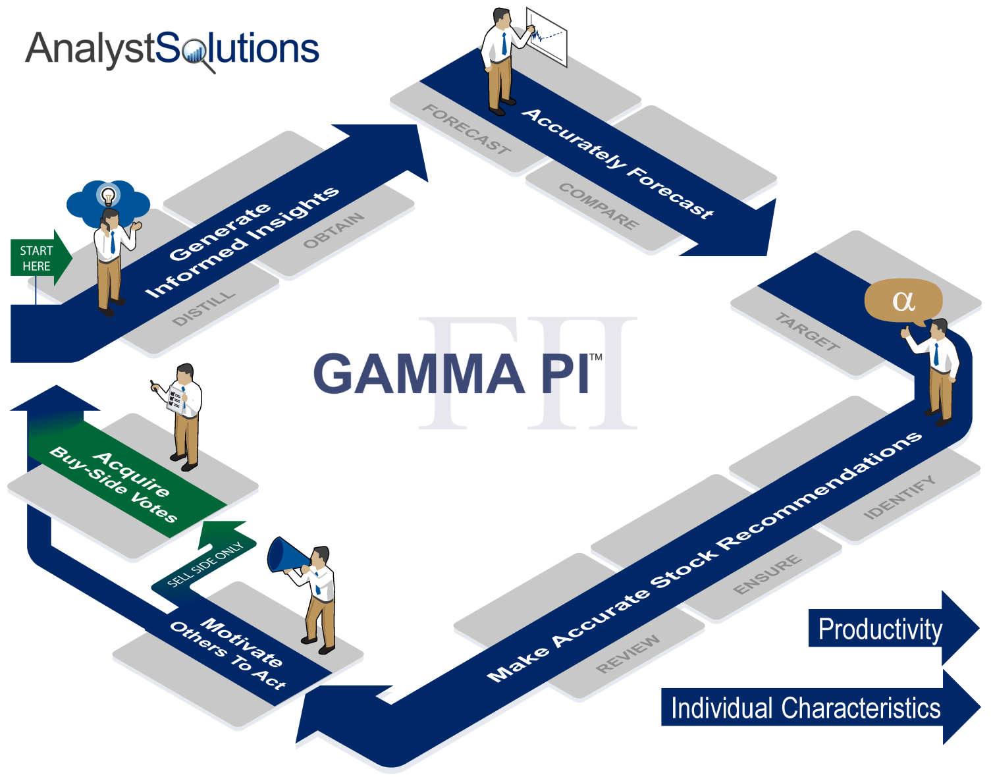

Example Critical Factors
z | Example Critical Factors and Key Assumptions*  * These critical factors may become out of date over time and should be viewed as examples
  Sector or Stock | Critical Factor | Assumption #1 | Assumption #2
  Airbnb (online travel agency) | Growth of online travel agencies | Rate of market share gains from traditional hotel channels | Cost advantage of online travel agency vs. traditional channels
  Amazon.com | Market share shift from traditional retailers | Adoption rate of e-commerce within emerging markets | Adoption rate of mobile apps for retail purchases
  IBM | Migration to cloud-based solutions | Rate of growth of cloud-based enterprise applications | Level of security offered in the cloud vs. in-house options
  Nike | Top line growth rate keeping up with historical trends | Changes in demand from international markets | Changes in broad athletic activities
  NVIDIA | Growth of virtual reality as mainstream product | Adoption of virtual reality by mass markets | Cost to produce high quality virtual reality devices that can be used in the home
  The Gap | Apparel pricing deflation | Adoption of off-price and low-price fashion | Use of mobile devices for price discovery
  T-Mobile | Competitive pricing among the wireless carriers | Timing when domestic smartphone becomes saturated | Changing regulations
  VMware (software) | Growth of open source software vs. traditional vendors | Open source providers going public | IT leaders selling services that rely on Open Source solutions
  Walgreens (drug retailer) | Generic drug price inflation | Changes in FDA regulation of non-generic drug manufacturers | Distribution channel consolidation
  Wal-Mart | Wage inflation | Level at which other competitors raise minimum wage | Efficiency gains by reducing employee turnover

Module: EPIC™ Framework

EPIC™ Framework
z | 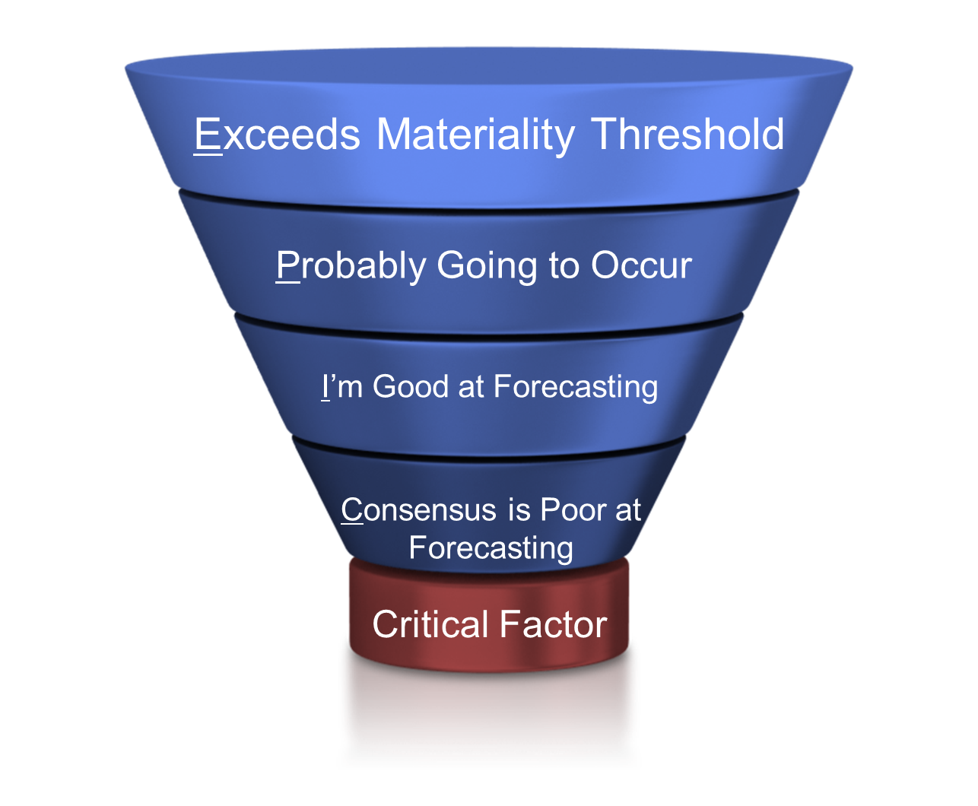

What’s “Material” to You?
 |  |  | Instructions for What’s “Material” to You?:  - Answer the question below, found above the table  - For the table, list three stocks in the first column that you are familiar with, making sure to include the one that is the subject of any materials you may have prepared for this workshop  - Ignore the other columns until you receive further instructions from the facilitator
 | Approximately how much does a stock need to move relative to a benchmark or in absolute terms for you to consider recommending it as a buy at your firm?: _______%
z
  Ticker | Revenue from Volume | Revenue from Pricing | Expenses

 | “Is It Worth Your Time?” Exercise
Instructions for “Is It Worth Your Time?” Exercise:
- From your research, you have come across the following scenarios. Using the basic income statement data below, determine if each is material, assuming “materiality” is defined as a 10% change to EPS.
  - FDX has invoiced customers a 4% fuel surcharge for the past year but only collected half (2%) (some customers refuse to pay it). You believe the company has instructed its salespeople to get more aggressive in collecting the surcharge, likely resulting in the company collecting 3%. Is this 1 percentage point increase material? To keep the math simple, assume the surcharge covers all of FDX’s revenue (in reality some of its revenue is not subject to a fuel surcharge).
  - Your research concludes FDX will likely need to change a pension assumption that will raise its overall costs by $150 million per year
  - Your research concludes there is a high likelihood FDX will win a new agreement with the U.S. Postal service to haul Priority Mail, which will likely result in $1 billion of additional annual revenue for FDX. You assume this new contract will be priced to achieve the overall company’s existing margins.

z
  Data Below is Actual for Fiscal Year Ending: | 2016
  Total Revenue (as reported) | $50,365
  Total Expenses | $45,350
  EBIT (adjusted) | $5,015
  EBIT margin (adjusted) | 10.0%
  Interest Expense | $336
  Other | $16
  Pre-tax Income (adjusted) | $4,695
  Tax Expense | $920
  Effective Tax Rate | 19.6%
  Net Income (adjusted) | $3,016
  EPS (adjusted) | $10.81
  Fully Diluted Share Count | 279

z | Answer Key  ¹ Assuming pricing drops directly to EBIT  ² Assuming expenses change with no change in volumes or sales  ³ Assuming all incremental revenue is at average EBIT margins
  Scenario | EPS Impact | Change to EPS
  1% higher pricing from better fuel surcharge collection | $1.45 | 13%
  $150 million higher pension costs | $0.43 | 4%
  $1 billion of USPS revenue | $0.29 | 3%
  Computing Materiality Thresholds
  Ticker: | FDX | IBM | SBUX | WMT
  Period (year) | 2016 | 2016 | 2016 | 2016
  Amount EPS needs to change to be "material": | 10% | 10% | 10% | 10%
  Step 1: Compute 10% of net income
  10% change to EPS | 1.08 | 1.37 | 0.19 | 0.44
  Materiality threshold as measured in net income | $302 | $1,317 | $286 | $1,414
  Step 2: Convert to pre-tax EBIT (MAGIC NUMBER)
  Materiality threshold as measured in pre-tax EBIT | $375 | $1,359 | $424 | $2,036
  Step 3: Compute threshold for changes from pricing and expenses
  Materiality threshold as measured in changes to pricing¹ | 0.7% | 1.7% | 2.0% | 0.4%
  Materiality threshold as measured in changes in expenses² | 0.8% | 2.0% | 2.5% | 0.4%
  Step 4: Compute threshold for change in revenue from sales/volume
  Materiality threshold as measured in changes from sales/volume³ | $3,767 | $8,117 | $2,135 | $40,980
  As a percent of revenue | 7.5% | 10.2% | 10.0% | 8.5%
  Data Below is for Fiscal Year Ending: | 2016 | 2016 | 2016 | 2016
  Total Revenue (as reported) | $50,365 | $79,919 | $21,316 | $482,130
  Total Expenses | $45,350 | $66,534 | $17,087 | $458,179
  EBIT (adjusted) | $5,015 | $13,385 | $4,229 | $23,951
  EBIT margin (adjusted) | 10.0% | 16.7% | 19.8% | 5.0%
  Interest Expense | $336 | $630 | $81 | $2,548
  Other | $16 | $1,516 | $108 | $81
  Pre-tax Income (adjusted) | $4,695 | $14,271 | $4,256 | $21,484
  Tax Expense | $920 | $449 | $1,380 | $6,558
  Effective Tax Rate | 19.6% | 3.1% | 32.4% | 30.5%
  Net Income (adjusted) | $3,016 | $13,166 | $2,862 | $14,144
  EPS (adjusted) | $10.81 | $13.73 | $1.93 | $4.40
  Fully Diluted Share Count | 279 | 959 | 1,487 | 3,217

Materiality vs. Probability
z | 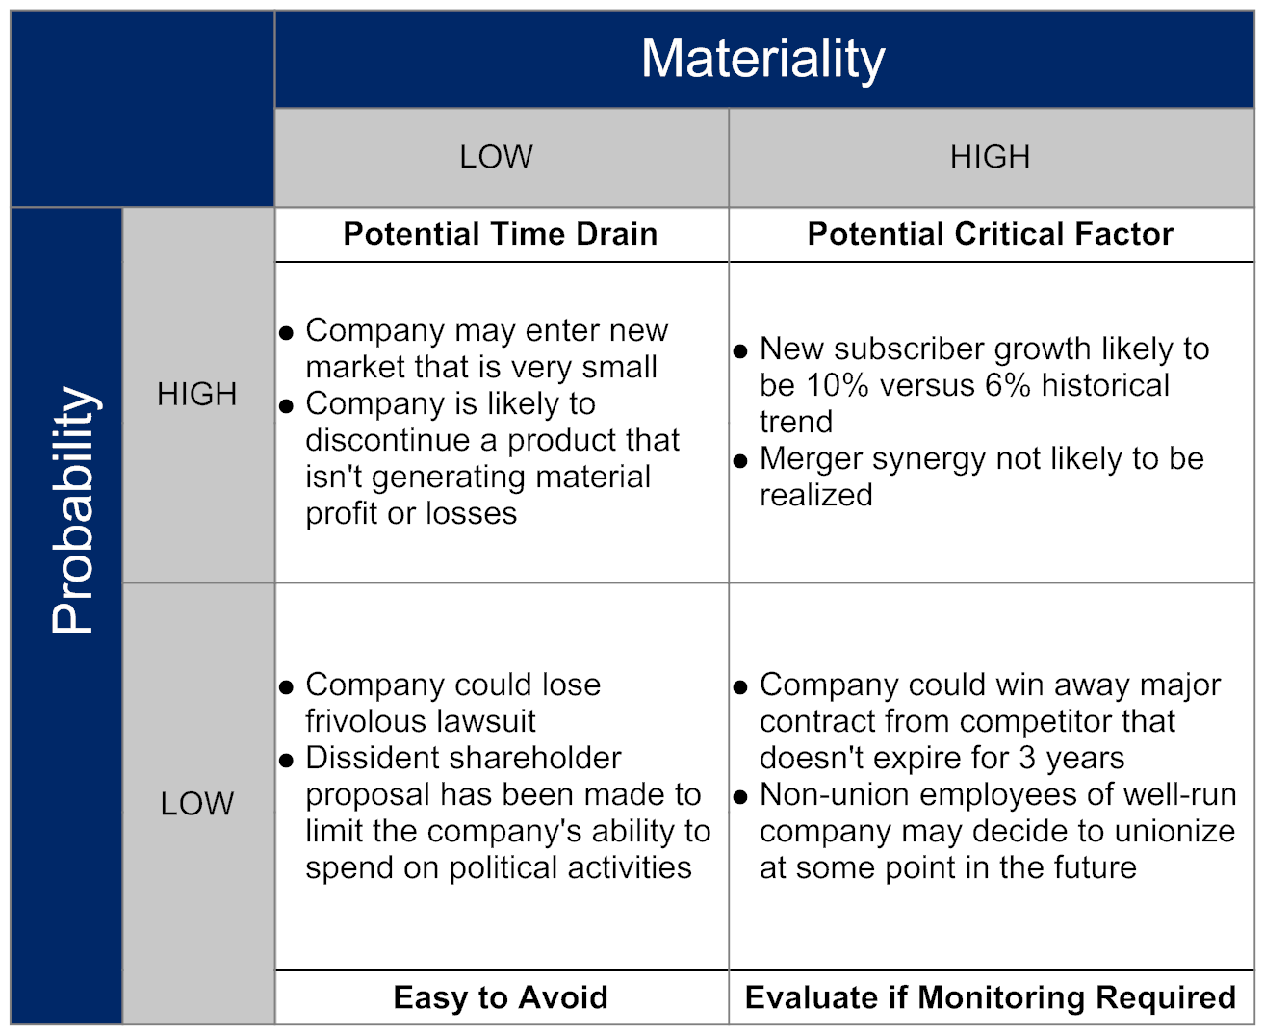

Module: HELP™ Framework
z | 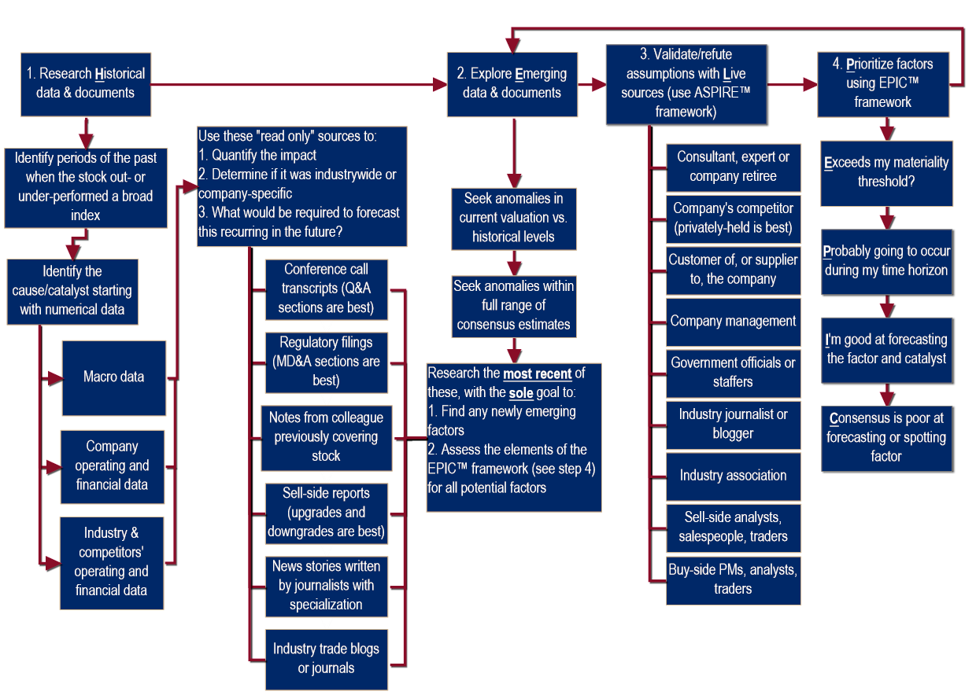

Food Chain Example
z | 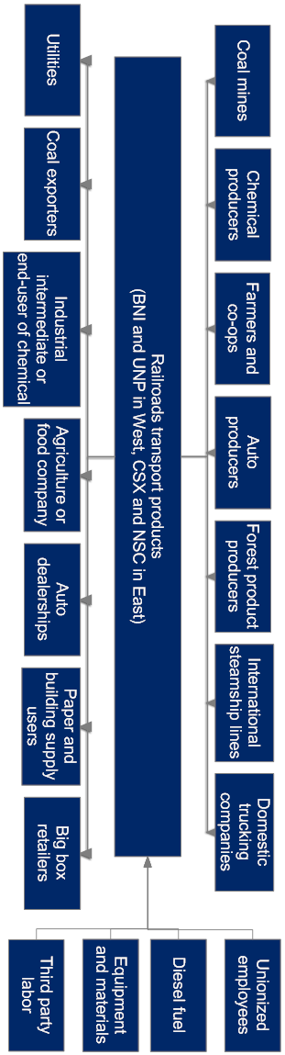

Example Historical Information
 |  | - The excerpts below are examples of how to highlight potential factors in historical documents (we don’t know yet if they are “critical” and so don’t be too selective)
z | FDX 10-K For the fiscal year ended May 31, 2006  Management’s Discussion and Analysis  Operating income increased during 2006 primarily due to revenue growth and improved margins across all our transportation segments. Yield and cost management activities, combined with productivity gains across all transportation segments, contributed to our margin growth. Operating income improvement was partially offset by higher costs at FedEx Express to support international volume growth, expansion costs at FedEx Ground and reduced operating profit at FedEx Kinko’s.  While fuel costs increased substantially in 2006, fuel surcharges more than offset the effect of higher fuel costs on our operating results.  Revenue growth during 2005 was attributable to volume and yield improvements across all transportation segments and the inclusion of FedEx Kinko’s for the full year. Combined volume growth in our package businesses increased 8%. Yields improved during 2005 primarily due to incremental fuel surcharges and base rate increases.  During 2005, operating income increased primarily due to revenue growth in all transportation segments and improved margins at FedEx Express and FedEx Freight. FedEx Express benefited from the realization of a full year of savings from our 2004 business realignment programs (versus a half year in 2004), which reduced the growth in salaries, wages and benefits.
z | FDX Press Release for the Quarter Ending May 31, 2006  Portion Discussing Segment Details  FedEx Express [the company’s overnight express division] achieved a double-digit operating margin in the seasonally strong fourth quarter, driven by revenue growth, yield management and effective cost controls. International Priority (IP) package revenue grew 15% for the quarter, as IP revenue per package grew 9%, primarily due to fuel surcharges, a higher rate per pound and an increase in package weights. IP average daily package volume grew 6%. U.S. domestic express package revenue increased more than 5%, as yield increased 8% and U.S. domestic average daily package volume declined 2%. The yield increase was driven by the January 2006 rate increases, higher fuel surcharges and yield management actions. U.S. deferred express services continue to show higher yields and lower volumes due to the continuing impact of previous yield management action  FedEx Ground average daily package volume grew 11% year over year in the fourth quarter. Yield improved 3% primarily due to higher extra-services revenue, increased fuel surcharges and the January 2006 general rate increase. Operating margin improved due to revenue growth, higher productivity and effective cost controls, offset in part by investments in new technology and the company’s capacity expansion program.

Self-Assess Your Historical Tool Kit
 |  | Instructions for Assessing Your Historical Knowledge  - Evaluate each item on a scale of 1 to 5 with 5 as “strongly agree”  - If you are covering a sector that has not been in existence for at least 10 years, reduce the time period to when the sector formally developed  - If you are new to covering stocks, read the assessment as background but do not rate yourself
z
  - I possess the data that shows the primary factor(s) that caused return on invested capital to change for my sector over at least the past 10 years.
  - I know the factor(s) that caused each of my stocks to substantially out- or under-perform their peers over the past 10 years.
  - I know the factor(s) that caused each of my sectors to substantially out- or under-perform my broader benchmark over the past 10 years.
  - I have industry-level data that provides a good gauge of supply/capacity and demand/units/revenue going back at least 10 years.
  - I have built, or could quickly build, a comprehensive food chain analysis for my sector, showing the upstream and downstream players for the companies in my universe.
  - When forecasting revenue for my individual companies, I ensure their combined revenue growth is within a realistic industry growth rate based on historical trends.
  - I know the high, low and mid-point of longer-term historical valuation ranges for each of my stocks for at least the past 10 years.
  Total

 | Example for FDX
z |  | Factors for: FedEx in the 2005-2006 time period, ranked by “Total” column
  Factor to Potentially Be Researched | If this factor were to occur or change from trend, it would cause changes in consensus’ expectations to Exceed my materiality threshold | This factor will Probably deviate materially from consensus expectations during my investment time horizon | Based on my research on the factor, I'm good at forecasting this factor and its catalyst (it’s not just a guess) | The overall Consensus will be poor at accurately forecasting or spotting an anomaly for this factor | Total
  Cost management/productivity/Improved network efficiency | 5 | 4 | 4 | 5 | 18
  Level of fuel surcharge collected | 5 | 4 | 4 | 4 | 17
  Acquisition(s) | 5 | 3 | 2 | 5 | 15
  Ground package volume growth | 3 | 4 | 4 | 4 | 15
  Domestic Express package pricing/yield | 4 | 3 | 4 | 3 | 14
  Ground package pricing/yield | 4 | 3 | 3 | 4 | 14
  International Priority package pricing/yield | 3 | 4 | 3 | 4 | 14
  International Priority package volume growth | 2 | 4 | 4 | 4 | 14
  Service levels other than during the holiday season | 3 | 2 | 4 | 5 | 14
  Change in senior management | 5 | 2 | 2 | 4 | 13
  Electronic documents reducing need for overnight envelopes | 2 | 4 | 3 | 4 | 13
  GDP growth | 5 | 3 | 2 | 3 | 13
  Labor cost trends | 3 | 3 | 3 | 4 | 13
  Domestic Express package volume growth | 2 | 3 | 4 | 3 | 12
  Service levels at holiday season | 2 | 2 | 3 | 5 | 12
  Asia-Pacific volume growth | 2 | 3 | 4 | 2 | 11
  Change in level of tech shippers vs. non-tech shippers | 4 | 2 | 3 | 2 | 11
  Purchase of new aircraft | 1 | 3 | 3 | 4 | 11
  Level of major weather disruptions | 1 | 3 | 1 | 5 | 10
  Depreciation rate | 1 | 2 | 2 | 4 | 9

Module: Monitoring Critical Factors

Flow Chart
z | Flow Chart for “Monitor” Process (see next 2 pages for enlarged details)
z | Flow Chart for “Monitor” Process (left side expanded)
z | Flow Chart for “Monitor” Process (right side expanded)

Module 6: Appendix
 |  | Transformation Action Plan (TAP)
Instructions for the Transformation Action Plan (TAP):
- Throughout this workshop complete the TAP below
- Apply the key points after the workshop to help you improve your performance.
- This will not be collected and so write in a manner that will help you utilize the concepts being learned.
 | z |  | TAP Section List Everything (PART 1)  Instructions, Part 1:  - The initial purpose of this exercise is to create a list 5 to 10 factors that will generate investor interest over the next year by using the most-read stories for that stock over the past 6 to 12 months (for a single stock)  - This list will be used for multiple exercises throughout the workshop  - Begin by selecting a stock:  - Among a list we provide at this URL: AnalystSolutions.com/LE (please browse quickly in making your decision because there will not be time to review every headline for every stock listed); OR  - If you were encouraged to compile a list before the workshop, please retrieve the list now  - Once you have selected a stock and reviewed the top headlines, go to the table on the next page (labeled “List Everything” Exercise) and put the ticker at the top of the table  - Using the list of headlines referenced above go to the “List Everything” table on the next page and create a list of 5 to 10 factors that could receive the media’s attention in the future.  - If the subject of the prior headline occurred in the past (e.g. Apple debuted a new iPhone last month), restate the factor as though this event or a similar-type event may re-occur in the future (e.g. Apple will debut a new iPhone in the next 3 months)  - For this step, please complete only the first column (you will be instructed on how to use the other columns at a later stage)
 | z |  | Exercise: “List Everything”  Ticker: ______________________  (ONLY COMPLETE EACH COLUMN WHEN INSTRUCTED)  (Scale of 1 to 5 with 5=strongly agree)  Please do not continue until told to do so
  Company-specific “newsworthy” issues | E | Zones | P | K, U-R, U-I | Source | I | C | T
  EXAMPLE: Company is trying to improve its network efficiency | 5 | OC | 4 | U-R | - Industry consultant  - Private competitor | 4 | 4 | 17
 | Z |  | Instructions for “List Everything” (PART 2)  Instructions, Part 2:  - The purpose of Part 2 is to evaluate the list of newsworthy issues using the EPIC™ framework to determine if a “factor” is a “critical factor.”  - Using the directions below, complete the “List Everything” table, but only the specific line items when instructed:  - In the column labeled “E”, do your best at ranking each item on an “Exceed my materiality threshold” scale, if it were to occur or recur (use a 1 to 5 scale with 5 as strongly agree). Don’t get frustrated for not having the company’s financial details (which you will likely need to provide a definitive answer), but instead focus on the process.  - In the column labeled “Zone” list the impact zone(s) for the factor (good or bad), by using:  - “V” for “Volumes” (revenue from additional transactions)  - “P” for “Pricing” (revenue from better pricing)  - “OC” for “Operating costs”  - “O” for “Other” (such as a stock buy-back or lower tax rate)  - “N” “None” (because it’s not likely to impact earnings)  - Using the column labeled “P”, try to rank each issue on “there a high Probability this factor will become much more certain to occur (or deviate materially from the expected trend) during my investment time horizon” (using a 1 to 5 scale with 5 as strongly agree). If the newsworthy issue is focused on something that already occurred, rank the likelihood that a similar event will recur during your investment time horizon.  - In the column labeled “K, U-R, U-I” include one of these letters:  - “K” for “Knowable”: Your prior research provides the insight you need to forecast this factor if it should occur or recur  - “U-R”: “Unknowable, Research Required”: You need to conduct research to accurately forecast this factor  - “U-I”: “Unknowable, Impossible to Forecast”: Nobody can forecast with accuracy even if more research is conducted (e.g. direction of interest rates or oil prices)  - In the column labeled “Source” for those factors you labeled “K” or “U-R” try to explain where you already received or could get information to better assess if this is a critical factor (e.g. industry consultant, private competitor, company source, sell-side analyst, etc.).  - Based on your response to the two items above, in the column labeled “I”, do your best at ranking the statement “I could forecast this factor and its catalyst accurately with a moderate amount of research” using a 1 to 5 scale with 5 as strongly agree. If the issue already occurred, rate the likelihood of forecasting this issue recurring.  - In the column labeled “C”, do your best at ranking each item on “the general Consensus will be poor at accurately forecasting/spotting this factor (or a change from trend).” Remember, “5” is strongly agree which means consensus will be POOR at forecasting if you put a high number.  - In the last column (labeled “T”), add up the four numbers within that row

TAP Section Initiatives to Better Understand the Historical Drivers of My Stocks
- “Those who cannot remember the past are condemned to repeat it”
  - George Santayana, philosopher, novelist, and poet, 1863–1952
- With this in mind, it’s important to know the factors that have caused your stocks to out- or under-perform in the past
- In the area below, provide steps you can take to improve your knowledge of this area
 | z
  Steps I’ll take to understand the factors that caused my stocks to out- or under-perform in the past:

TAP Section Validate/Refute Assumptions with Live Sources
- The purpose of this section of the TAP is to identify sources you can contact to accurately forecast your top-ranked factors (e.g. speak to industry source or sell-side analyst, conduct a survey, etc.)
- Refer back to your “List Everything” list and identify the factors that have the highest ranked “E” and “P” scores. Put these line numbers in the three blank column headings below.
- For these 3 factors, rate each source in the table in terms of its potential ability to help you forecast the critical factor (5 = highly likely).

 | z |  |  | Potential Critical Factors Worth Further Research
  Top #3 ranked line items from “List Everything” list----> | # | # | #
  Company’s competitor (publicly-traded or privately-held)
  Company’s executives (including investor relations)
  Conference speaker or author of book/academic paper
  Consultant, expert, or company retiree
  Customer of, or supplier to, the company (publicly-traded or privately-held)
  Government officials or staffers
  Industry association or forecasting service representative
  Industry journalist/blogger
  Sell-side analyst (for the buy-side) considered among top 3 in sector
  Sell-side salesperson (with deep knowledge of specific stock)
  Trader of stock (with deep knowledge of specific stock)

TAP Section Create Critical Factors Worthy of Further Research
- To help “prime the pump” for this exercise, read the list of potential critical factors below from a variety of North American sectors
- Below the table, record three potential critical factors for stocks of interest that you intend to research further after this workshop (you may have already been thinking about this research before this workshop)
- Determine if your critical factors meet all elements of the EPIC™ framework
 | z |  |  | Potential Critical Factors Worth Further Research  * Created in early 2015 and therefore some of the examples will become outdated over time
  Sector | Critical Factor?*
  Automobile Manufacturers | Will deflation of new car pricing cause unexpected downward pressure on used car pricing, beyond current consensus thinking?
  Cable Providers | Will growth of non-cable content providers such as Netflix, Amazon and HBO deteriorate the cable bundle faster than consensus expectations?
  Drug Retailers | Will drug retailers be hurt by unexpectedly strong inflation in generic drug pricing?
  Media | Will the growth of advertising on mobile devices take more spending away from traditional channels (e.g. TV) than current consensus expectations?
  Oil Services | Will the decline in oil prices drive consolidation and if so, who will be the winners and losers?
  Railroads | Will railroad customer pricing accelerate higher than expected due to tight trucking capacity?
  Renewable Energy | Will energy storage costs decline faster than consensus expectations, leading more users away from traditional utilities?
  Retail, Apparel | Will apparel pricing grow slower on a secular basis, given the consumer’s newfound appetite for discounting brought about during the 2008 recession?
  Software | Will newfound growth of the distribution channels for Open Source software have a negative impact on traditional software companies?
  Telecom | Will saturation of the domestic smartphone market lead to price wars among the wireless carriers that causes consensus expectations to drop?
  Wireless Equipment | Will a more competitive wireless phone market and greater emphasis by the carriers to improve efficiency (rather than their historical emphasis on upgrading networks) cause a bigger-than-expected drop in capital spending?
 | z
  These are potential critical factors for stocks in my sector that I intend to research further:
 | z
  These are factors that waste my time but are clearly not critical factors (I’ll stop spending time on them):
z |  |  | TAP Section Create Your Monitoring Matrix  Complete the following table for one factor you provided in the prior section
  Critical Factor | Issue to Explore | Potential Catalysts | Contact Source | Frequency

TAP Section Steps to Avoid Wasting Time on Non-factors
- A basic, but often misunderstood concept of time management is you can’t add something to your day (e.g. going to the gym more regularly) unless you’re committed to taking something away (e.g. surfing the web less)
- With this in mind, in the table below, write yourself the steps you intend to take to reduce research time wasted on non-critical factors
 | z
  Steps I’ll take to avoid focusing on non-critical factors:

Notes

z
z
z
z
z
z
z
z
z
z
z
z
z
z
z
z
z
z
z
z
z
z
z
z

End of Module Section - Do not delete or alter this paragraph and bookmark – Insert all module and lesson content prior to this red non-printing paragraph and bookmark

