

Master the Stock Call Techniques of Highly Experienced Analysts

Learner Workbook
NOTE: Please ensure you can interact with this document during the workshop in one of these methods:
- With a keyboard (as a Word document); or
- With pen (as a hard copy)

This document has been created for registered participants of AnalystSolutions’ workshops and should not be copied or re-distributed

Master the Stock Call Techniques of Highly Experienced Analysts

Acknowledgments
Some of the content for this workshop comes from Best Practices for Equity Research Analysts authored by James J. Valentine, CFA and published by McGraw-Hill.

Trademarks & Copyright Acknowledgements
None of the material in this document can be reproduced or distributed without the written consent of:

AnalystSolutions, LLP
20793 W. High Ridge Drive
Kildeer, IL 60047-7937
USA
+1-203-321-9400
AnalystSolutions.com

Table of Contents

Overview 1
Purpose & Learning Objectives 1
Introduction 2
Opening Case: Lucas Proposes to Upgrade Starbucks 2
"ENTER™ Quality Checklist" Exercise 7
Module 1: Target Realistic Price(s) (Step 1 of TIER™) 9
"Stress Test Your Forecast" Exercise 9
TIER™ & SHARE™ Frameworks 12
Module 2: Identify and Forecast Catalyst(s) (Step 2 of TIER™) 13
"Identify the Catalyst" Exercise 13
Module 3: Ensure Ideal Entry Point (Step 3 of TIER™) 17
“Find the ‘F’s’” Exercise 17
Four Scenarios Table 18
"How Do You Differ?" Exercise 19
“Rank Your Ability” Exercise 28
“How Does Your Future Look?” Exercise 29
Assess and Influence the Market’s View 30
“Circle the Symbols” Exercise 33
Module 4: Review Performance and Thesis 34
"Ski Vacation" Exercise 34
Appendix 35
Transformation Action Plan (TAP) 35
Notes 40

Overview

Purpose & Learning Objectives
 | Why a Master the Stock Call Techniques of Highly Experienced Analysts program?  Many analysts, especially those early in their career, make the mistake of assuming stock picking is primarily about creating a detailed financial model and conducting a thorough valuation. While these are critical, there are many other key elements to making great stock calls, which are more difficult to master and often underappreciated. Mastery requires creating a forecast more accurate than consensus, selecting an optimal valuation multiple, setting a realistic price target, identifying a catalyst, ensuring the ideal entry point and objectively reviewing your performance and thesis.  Less experienced analysts can increase their odds of generating alpha by understanding the behind-the-scenes methods employed by successful analysts. Successful stock picking is unquestionably the most important element of a buy-side analyst’s job, as well as one of the key elements for sell-side analysts, and yet until now, formal training in this area has been scarce. As discussed in the best-selling book Best Practices for Equity Research Analysts, interviews with successful buy-side and sell-side analysts reveal they follow a process before upgrading or downgrading a stock. Through its TIER™ system, AnalystSolutions has deconstructed their “art” to provide analysts the “science” behind making high quality stock calls. While there’s no foolproof method to ensure every stock call generates alpha, there are lessons to be learned that will increase an analyst’s odds for success.
 | Learning Objectives  - Assess if enough research has been conducted to justify a stock call  - Identify the key challenges to successful stock picking and apply lessons from experienced stock pickers  - Make accurate stock recommendations by mastering these steps:  - Identifying the catalyst most likely to move a stock  - Identifying the ideal entry point for recommending a stock  - Reviewing stock picking performance to improve future stock picking  - Ensure stock calls are differentiated  - Avoid the most common mind traps (e.g. sunk cost fallacy, loss-aversion) and biases (such as familiarity, recency, confirmation, self-attribution momentum and overreaction)  - Review a universe of stocks in an unbiased manner to ensure those being recommended offer the best return compared to their level of risk

Introduction
 | Opening Case: Lucas Proposes to Upgrade Starbucks
Instructions for the case “Lucas Proposes to Upgrade Starbucks”
- As you’re reviewing the case, keep track of “best practices” (something you would do or advocate other analysts to do) and “bad practices” (those things you would recommend an analyst not do). We encourage you to use underlining, bolding (if using electronic version) or the right column for notes so that you can keep track of the best and bad practices.
z |  | Script  Lucas Gallo, a buy-side analyst who covers the restaurant sector, has had trouble with some of his stock picks in the past. In fact, during his mid-year review his boss said if his stock picking doesn’t improve, he’ll likely not receive a bonus this year and be put on probation, which is the first step to having his employment terminated from the firm. Lucas would like to upgrade Starbucks, ticker SBUX, and decides he should discuss it first with a more senior member of the firm, Robert, who has been a successful analyst for 10 years.
  Lucas’ Dialogue | Robert’s Dialogue | Your Notes:
  Hi Robert. I was hoping you could give me some feedback about a stock call I’d like to make. | I’d be happy to help. What’s the stock?
  I’ve wanted to upgrade Starbucks for years and now I have my opportunity because it’s launching new breakfast sandwiches and a new cold drink. | Interesting…what’s your price target?
  Putting a price target on it is difficult because there’s a lot of uncertainty about the company’s long-term earnings power…I suspect there’s at least 20%-30% upside. I’m not sure why, but some analysts in the market are valuing using a PEG ratio while others are using a P/E ratio. | How are you valuing the stock?
  I’m using $0.87 of earnings for the upcoming year and $1.00 for the year after. | That’s 15% growth. Where’s consensus in terms of estimates?
  Very close to my numbers. | If you see 25% upside in the stock and the company is growing EPS only 15%, you must be assuming the P/E multiple expands.
  I’m not sure I follow your logic. The stock is trading at a 28x multiple, but it was trading as high as a 42x multiple just 3 months ago. | Has the multiple expanded in the past?
  I’m not sure -- when I pulled up the historical valuation metrics for the past two years, it showed a historical peak of 48x forward earnings. | What about the trough?
  I’m not sure, but the stock is up 18% for this year – I don’t want to miss a further move. | But the market is up about that much.
  …And SBUX has climbed along with it, despite nothing really new to the story. They’re poised for a break-out. One sell-side analyst I speak with said if you buy SBUX late in the year, you always see upside by the end of February. | Do you know when the new breakfast sandwiches and cold drink will be released?
  Not entirely, but I just read in The Financial Journal that a supplier to SBUX said they’ve been asked to build equipment to make the frozen drink. I’ve wanted to upgrade this stock for a while and this now gives me the opportunity. | How does the risk-return trade-off for SBUX compare to the other stocks in your universe?
  SBUX has the most upside. | What about risk?
  I don’t follow your point. | What’s the downside in the stock?
  Why would it go down from here? | Could something go wrong?
  Not likely because the new products haven’t been debuted yet. | Didn’t the company struggle with its same-store-sales comps in the recent quarter?
  Yes, they grew only 4%, but that was due to a slower morning throughput caused by the increased popularity of Frappuccinos. The company still plans to generate 20%-25% EPS growth for the next 3-5 years and recently raised its long-term global unit target to 40,000 stores, up from 30,000. | Have you looked into how much stock management owns?
  I’m not sure, but it’s a young company and so management must own a big chunk. | What are your thoughts about the current quarter?
  Last time I looked, consensus was at 18 cents, but I think everyone knows the near-term numbers need to come down by a penny or two. | Lucas, I want to help you avoid making a call similar to the two problematic ones earlier this year.
  Thanks, but those calls weren’t my fault – consensus dropped for both of those companies, showing that everyone was surprised. | Maybe, but I recall short-interest in those stocks were very high at the time. And wasn’t Golden Bull Securities recommending shorting one of those names before the drop?
  True, but even a blind squirrel finds a nut every once in a while. | I think we need to discuss this potential upgrade a bit further.
- If this workshop is being led by a facilitator, alert him/her after you have noted “best practices” and “bad practices above, then continue onto the answer key
- If you are taking this workshop without a facilitator, continue to the answer key
z |  |  | This page intentionally left blank
Answer Key for “Potential Upgrade of SBUX”
All of the answers below will be discussed throughout the workshop’s four-step TIER™ framework and so do not be concerned if you do not have time to read through or fully understand before moving onto the next module.
Best Practices by Robert and Lucas:
- Lucas is aware of how his estimate compares to consensus
- Robert breaks down the potential upside into the two key components: the forecast or valuation
- Robert correctly notes that most of the upside in the stock over the past year has been in line with the market’s move
- Robert is trying to ascertain the catalyst that will move the stock (i.e., the date of the new products being released)
- Robert wants to explore what could go wrong
- Robert is looking for imminent risks such as a potential disappointment in the current quarter
- Robert is questioning if Lucas has selective memory, where he revises history to meet his needs
Bad Practices by Lucas:
- Says he’s been wanting to “upgrade SBUX for years” suggesting he has a pre-existing bias that could be clouding his view (aka “confirmation” bias)
- Doesn’t have a price target or range of targets
- Doesn’t know if the stock has seen an expanding P/E in the past
- Is impressed the stock has moved 18% this year even though this is likely due to the overall market move
- Is relying on a basic rule of thumb (heuristic) in terms of buying the stock late in the year to get upside by February, which he doesn’t appear to have validated
- Doesn’t know when the new products will be released, which is the catalyst for his stock call
- When asked to compare SBUX to other stocks in his universe, he’s only looking at returns and appears to have excluded an assessment of risk
- Hasn’t considered what could go wrong with his call
- Doesn’t seem to be concerned with the company having poor same-store-sales comps or the amount of stock owned by management
- Doesn’t seem to be concerned by the company’s potential for falling short of the current quarterly consensus estimates
- Dismisses prior bad calls to things that were a surprise to everyone even though a sell-side firm had correctly made an accurate call on one of the stocks

Postscript:
The passage above was inspired by actual events occurring from 2006 to 2008. (The EPS were slightly modified so the math would be easy to compute without a calculator.) Here are some actual events that occurred after Lucas’ proposed upgrade:
- In late 2006, Howard Schultz, the company’s founder and chairman at the time, wrote a memo (leaked to the press) that identified challenges caused by the company’s excessive growth. In addition to specific concerns, he closed the letter with, “I have said for 20 years that our success is not an entitlement and now it's proving to be a reality. Let's be smarter about how we are spending our time, money and resources.”
- Due to weaker-than-expected growth and margins, the stock dropped 42% in 2007, while the S&P 500 was up 3%
- In January 2008, Howard Schultz took back the CEO role
- Breakfast sandwiches were discontinued in 2008
- The frozen drink “Sorbetto” was discontinued after a debut to 300 stores

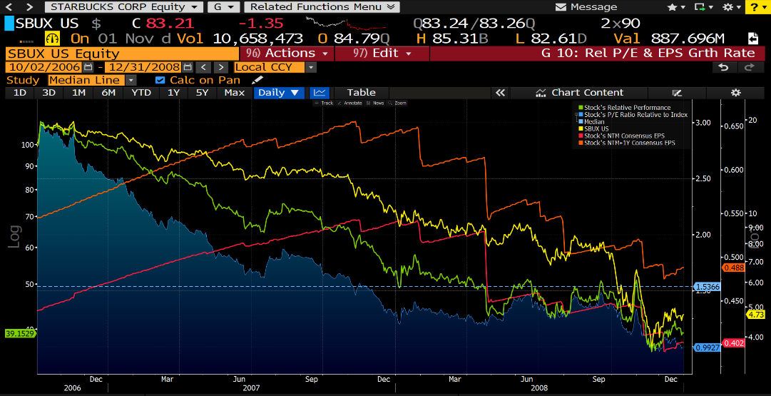

"ENTER™ Quality Checklist" Exercise
Instructions for the “ENTER™ Quality Checklist” exercise:
- The majority of portfolio managers have under-performed their benchmarks as far back as the records have been kept on this topic. Our work suggests some of the problem is the research they are using is low quality, which prevents them from making the right decisions
- The ENTER™ quality checklist below has been designed to help analysts review their research efforts to ensure they meet or exceed a quality threshold
- For each item in the checklist, in the right column, provide a value for how regularly you follow this practice before making a stock recommendation
- This will not be collected and so respond in a manner that will help you assess your performance

 | z | ENTER™ Quality Checklist
  ENTER™ Quality Checklist (to be used before starting the communication of a stock recommendation) | 1=Never  5=Always
  Expectational
  I have a forward-looking view in terms of the stock and the critical factor(s) likely to move the stock
  I have identified the catalyst(s) likely to move my stock and important dates when the catalyst is most likely to cause the stock to move to my price target
  When I believe the company management’s forecast is relevant, I frame it in terms of my independent financial forecast (rather than just repeat management)
  When I review historical information or events, it in the context of considering the future implications to my investment thesis. (I don’t dwell on the past for other reasons.)
  Novel
  I have a piece of information or insight that is new and not widely understood within the financial markets
  I know where my unique view falls within the FaVeS™ framework (unique Financial forecast, Valuation method/multiple, or unique view about market Sentiment)
  I know why the market does not have my view
  Thorough
  For critical factors that are key to the stock call, I research more than one source or confirm the insight with an independent source
  If the stock call is based on a unique financial forecast, I conduct detailed modeling in the area surrounding the critical factor(s)
  I do not use management guidance as the sole justification for the call
  Examinable
  If asked, I can provide the following details of my analysis to a trusted colleague(s):
  - Data or insights about the critical factor(s)
  - Detailed financial forecast or valuation analysis, if key to the investment thesis
  I clearly separate:
  - Opinion or forecast from…
  - Views of others from…
  - Undisputable facts
  Revealing
  I create upside, downside, and base-case scenarios to identify where the investment thesis could have flaws
  I identify specific risks beyond the macro
  I provide my conviction level to others, even if it is not strong

Module 1: Target Realistic Price(s) (Step 1 of TIER™)

"Stress Test Your Forecast" Exercise
Instructions for the “Stress Test Your Forecast” exercise:
- For one stock of interest, in Table 1 below:
  - In the column labeled “Factor”, list the critical factors you believe will potentially have the greatest impact on the stock price movement over the next 12 months
  - In the next three columns, provide the assumptions for your base-case, upside, and downside scenarios for each critical factor
  - Weigh the probability of each scenario (the three boxes for each critical factor should add up to 100%)
  - If possible, quantify the EPS impact for at least one of the critical factors by using the company’s earnings model, if you brought with you (you probably won’t have time to quantify all three factors during the time for this exercise)
- In Table 2, evaluate the quality of each critical factor by the using the EPIC™ framework
- Complete the entire process in Tables 1 and 2 for your first critical factor and if time allows, do the same for your critical factors #2 and #3.

z | Your stock of interest: _________________________  In the table below, first complete the “Factor” and “Base Case” columns and then complete the “Downside” and “Upside” scenario columns  Table 1: Identify 3 Critical Factors
  Factor | Base Case | Downside Scenario | Upside Scenario
  Examples for FedEx: Change in ability to collect fuel surcharge | BASE CASE: Based on the current environment, FDX continues to pass through 75% of its fuel inflation to its customers  WEIGH PROBABILITY: 65% | CAUSE: A weaker economy creates excess capacity in the express parcel sector, causing FDX to be less disciplined in implementing its fuel surcharge, causing it to pass through only 25% of its fuel inflation  WEIGH PROBABILITY: 15%  QUANTIFY: Drops EPS by 12% from base case | CAUSE: Stronger demand causes FDX and its competitors to be more disciplined on implementing fuel surcharges so that FDX is successful in passing through 95% of its fuel inflation  WEIGH PROBABILITY: 20%  QUANTIFY: Increases EPS by 8% compared to base case
  1. | BASE CASE:  WEIGH PROBABILITY:  % | CAUSE:  WEIGH PROBABILITY:  %  QUANTIFY (if you have data with you): | CAUSE:  WEIGH PROBABILITY:  %  QUANTIFY (if you have data with you):
  2. | BASE CASE:  WEIGH PROBABILITY:  % | CAUSE:  WEIGH PROBABILITY:  %  QUANTIFY (if you have data with you): | CAUSE:  WEIGH PROBABILITY:  %  QUANTIFY (if you have data with you):
  3. | BASE CASE:  WEIGH PROBABILITY:  % | CAUSE:  WEIGH PROBABILITY:  %  QUANTIFY (if you have data with you): | CAUSE:  WEIGH PROBABILITY:  %  QUANTIFY (if you have data with you):
z | In Table 2 below, rank your factors from above on a scale of 1 to 5, with 5 as “strongly agree”, using the EPIC™ framework in the column headings below:  Table 2: Evaluate the Quality of the Critical Factors
  Critical Factor from Table 1 | If this factor were to occur or change from trend, it would cause changes in consensus’ expectations to Exceed my materiality threshold | This factor will Probably deviate materially from consensus expectations during my investment time horizon | Based on my research on the factor, I'm good at forecasting this factor and its catalyst (it’s not just a guess) | The overall Consensus will be poor at accurately forecasting or spotting an anomaly for this factor | Total
  1.
  2.
  3.

TIER™ & SHARE™ Frameworks
z | 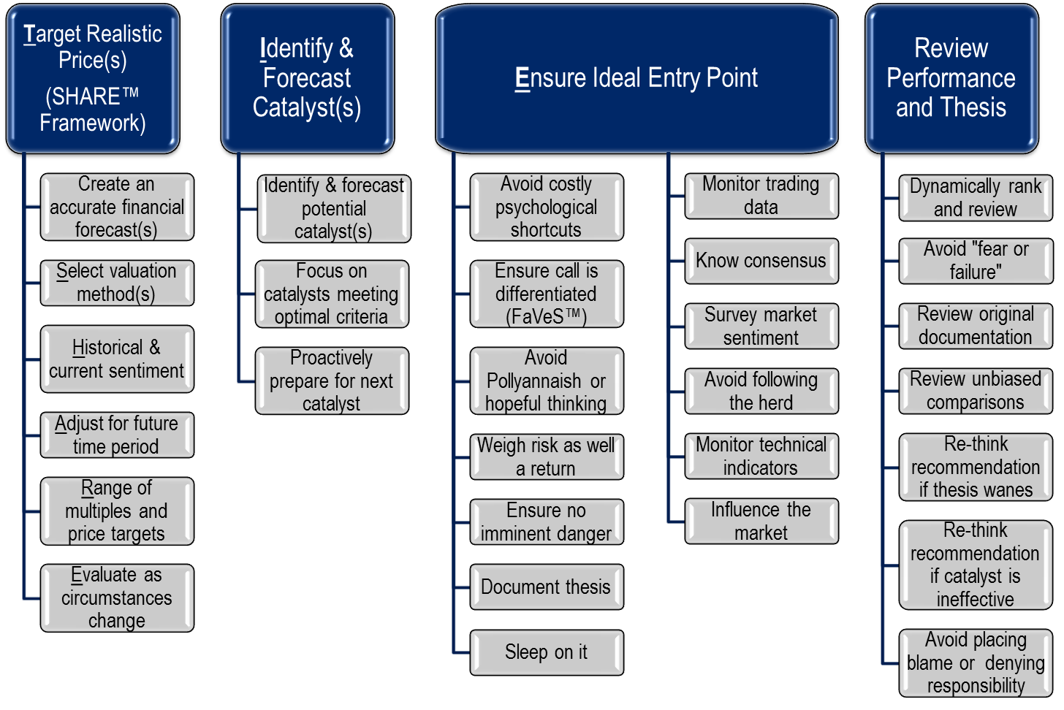

Module 2: Identify and Forecast Catalyst(s) (Step 2 of TIER™)

"Identify the Catalyst" Exercise
Instructions for the “Identify the Catalyst” exercise, PART 1:
- There are two parts to this exercise, labeled “PART 1” and “PART 2” which both pertain to identifying catalysts but are not related to each other
- In PART 1, read the first scenario and follow the prompts in the column headings to determine:
  - The catalyst
  - Quality of the catalyst
  - Timing of when the catalyst will be noticeable enough for the stock to begin to react (the timing may be unknown, which is an acceptable answer, but shows the catalyst is low quality)
- After completing the first scenario in PART 1, review the answer key that follows
- After completing the first scenario in PART 1 move to the first catalyst in PART 2
- If you would like to reinforce this concept, go back and complete PART 1 and PART 2 for the other scenarios

z | Table 1 for “Identify the Catalyst” Exercise
   | Stock Call | Catalyst | Quality of Catalyst:  High, Medium, or Low | Timing of when the catalyst will be noticeable enough for the stock to begin to react
  1. | We are recommending purchasing McDonald’s Corp (MCD) and have a one-year price target of $116 (up 21% from its current $96). We believe accelerated growth from remodeled stores and expansion in China will allow the company to beat this year’s consensus of $5.80 by $0.20 (most noticeable in 3Q and 4Q) which will be even more apparent next year, causing next year’s consensus of $6.20 to rise to our $7.00.
  2. | We are no longer recommending purchasing SBUX because we believe the consensus expectation for the next fiscal year is 11% too high. Using our EPS forecast for next year of $2.85 (while consensus is at $3.20), we arrive at a base-case scenario price target of $68, which would be a 9%-10% drop from the stock’s close of $75. Our proprietary work (survey and interview with industry sources) suggests by 3Q of this year the company will be unable to pass through the upward labor cost pressure driven by increases in minimum wages. By early next year, the company will see higher cost inflation or, if it raises prices, slower unit sales, either of which will slow EPS growth.
  3. | We are upgrading Alaska Air Group (ALK) because we believe it will be taken out at a premium as part of the North American airline industry consolidation trend. The stock is currently trading approximately 15% above its historical relative P/E ratio on forward earnings, which we believe could expand further as part of a takeout.
z | Note: the following table is the answer key to Table 1 above  ANSWER KEY for Table 1 for “Identify the Catalyst” Exercise
   | Stock Call | Catalyst | Quality of Catalyst:  High, Medium, or Low | Timing of when the catalyst will be noticeable enough for the stock to begin to react
  1. | We are recommending purchasing McDonald’s Corp (MCD) and have a one-year price target of $116 (up 21% from its current $96). We believe accelerated growth from remodeled stores and expansion in China will allow the company to beat this year’s consensus of $5.80 by $0.20 (most noticeable in 3Q and 4Q) which will be even more apparent next year, causing next year’s consensus of $6.20 to rise to our $7.00. | Store remodeling and growth in China | Moderate quality because these are factors the analyst may not be able to forecast with a high degree of accuracy | Earnings during the second half of this year and all of next year
  2. | We are no longer recommending purchasing SBUX because we believe the consensus expectation for the next fiscal year is 11% too high. Using our EPS forecast for next year of $2.85 (while consensus is at $3.20), we arrive at a base-case scenario price target of $68, which would be a 9%-10% drop from the stock’s close of $75. Our proprietary work (survey and interview with industry sources) suggests by 3Q of this year the company will be unable to pass through the upward labor cost pressure driven by increases in minimum wages. By early next year, the company will see higher cost inflation or, if it raises prices, slower unit sales, either of which will slow EPS growth. | Inability to pass through wage inflation to customers | Medium to high quality because it’s plausible, with effort, the analyst can determine if wage inflation is being passed through to customers | Third-quarter results should see some of the impact and will become more pronounced going into the following year
  3. | We are upgrading Alaska Air Group (ALK) because we believe it will be taken out at a premium as part of the North American airline industry consolidation trend. The stock is currently trading approximately 15% above its historical relative P/E ratio on forward earnings, which we believe could expand further as part of a takeout. | Industry consolidation | Low because it is almost impossible to forecast the timing. Also, the market may already be anticipating as shown in the stock’s current premium. | Unknown
z | Instructions for the “Identify the Catalyst” exercise, PART 2:  - Go to Table 2 below (which is not related to Table 1 above), and refer back to the earlier exercise where you identified 3 critical factors for a stock of interest (“Stress Test Your Forecast” exercise). In Table 2 below, identify the catalyst for each of your 3 critical factors and then rank on a scale of 1 to 5, with 5 as “strongly agree”, using the table column headings
z | Table 2 for “Identify the Catalyst” Exercise  (Rank on a scale of 1 to 5, with 5 as “strongly agree”, using the table column headings)
  Catalyst for Your Critical Factor Identified in Earlier Exercise | Catalyst pertains to a critical factor that is material enough to move the stock | Catalyst likely to occur during the investment time horizon | Catalyst not currently understood by the market | Catalyst can be forecast with some level of certainty | Total
  Your Critical Factor #1 Catalyst(s):
  Your Critical Factor #2 Catalyst(s):
  Your Critical Factor #3 Catalyst(s):

Module 3: Ensure Ideal Entry Point (Step 3 of TIER™)

“Find the ‘F’s’” Exercise
Instructions for the “Find the F’s” exercise:
- Step 1: Count the number of “f's" you see in the sentence below and put here: _______

Two of the most powerful and effective of all human fears are the fear of failure and the fear of success.

Four Scenarios Table
 | z | This table is also found in your Slide Booklet  * NTM = next twelve months
   | Scenario
   | A | B | C | D
  1. Current data
  Current stock price | $50.00 | $50.00 | $50.00 | $50.00
  Next 12-month (“NTM”) consensus EPS forecast at present (we call this "Year 1") | $5.00 | $5.00 | $5.00 | $5.00
  Stock's current valuation multiple based on Year 1 EPS | 10.0 | 10.0 | 10.0 | 10.0
  Current market multiple | 15.0 | 15.0 | 15.0 | 15.0
  Stock's current premium or discount to the market multiple | -33% | -33% | -33% | -33%
  2. Change from consensus EPS between Year 1 and Year 2
  NTM consensus in Year 2 (i.e., forecast at beginning of Year 2 for Year 2) | $5.60 | $5.60 | $5.60 | $5.60
  Difference between Year 2 and Year 1 consensus forecasts | 12% | 12% | 12% | 12%
  Item #2 above is due to passage of time while #3 and #4 below are influenced by the analyst
  3. Change due to analyst's financial forecast differing from consensus
  Analyst's NTM EPS forecast in one year (i.e., forecast for Year 2) | $5.60 | $6.00 | $6.00 | $6.60
  Premium or discount of analyst's EPS estimate in Year 2 compared to consensus' | 0% | 7% | 7% | 18%
  4. Change due to analyst's future valuation multiple differing from current multiple
  Analyst's estimate of market multiple at beginning of Year 2 (typically keep same as present) | 15.0 | 15.0 | 15.0 | 15.0
  Analyst's estimate of stock's premium or discount to market multiple at beginning of Year 2 | -33% | -33% | -27% | -20%
  Valuation multiple used for price target at beginning of Year 2 | 10.0 | 10.0 | 11.0 | 12.0
  Difference between analyst's future multiple and stock's current multiple
  5. Price target | $56.00 | $60.00 | $65.70 | $79.20
  Change from current price | 12% | 20% | 31% | 58%

"How Do You Differ?" Exercise
Instructions for the “How Do You Differ?” exercise:
- This exercise helps to reinforce the critically-important concept that all great stock calls must differ from consensus. You will do this using the FaVeS framework, specifically, looking for an out-of-consensus view in one of these areas:
  - Financial forecast; or
  - Valuation multiple or method; or
  - Sentiment towards the stock (void of impending changes to the financial forecast or valuation multiple/method above, which is rare, but does occur)
- If you brought or can quickly access example research reports that contain recommendation/ratings changes that include price targets (if not, go to the next square bullet below):
  - Review page 1 of each report to identify where the author (which could be you) differs from consensus using the FaVeS framework.
  - If you would like to use a standard format to lay out your answers, feel free to use the blank columns under “Your Answer” in the 3 scenario worksheets that follow. (If you brought your own reports, you will not need the upcoming pages for any other purpose)
- If you do not have access to recommendation/ratings change reports that contain price targets:
  - Review the 3 scenarios below, noting they are occurring at the start of calendar Year 1 (Y1) and so one-year price targets are based on forecast earnings for Y2. The term “NTM” is “next 12 months.”
  - To ensure you arrive at the same answer as our answer key, we assume the market’s multiple is 15x NTM earnings (not the stock’s multiple)
  - Before reading the scenario, cover up or minimize your window so that you do not see the two right-most columns until after you have tried to complete the scenario
  - After reading the passage, complete the column titled “Your Answer” and then check the right-most columns to see if you were correct
  - After reviewing the answer key, answer the question “Did the analyst have a unique call” which can be found below each answer key
- Note the answer key may differ slightly from your answer due to rounding issues
- Using a calculator or pasting the tables into Excel will likely speed up the exercise

 |  | z |  |  | Scenario 1: McDonald’s  (Reminder: cover up or minimize your window so that you do not see the two right-most columns below until after you have attempted to complete the scenario.)  “We are recommending purchasing McDonald’s Corp (MCD) and have a one-year price target of $116 (up 21% from its current $96). We believe a recovering Europe and growing emerging markets will allow the company to beat Y2 consensus EPS of $6.20 (we are at $7.00). Our price target assumes the stock continues to trade at its current 10.3% premium to the market’s 15x multiple (putting MCD at a 16.6x forward multiple).”  * NTM = next twelve months
   | Your Answer | Row # | Answer Key | Effect on Stock Price
  1. Current data
  Current stock price | $96.00 | A | $96.00
  Next 12-month (“NTM”) consensus EPS forecast for STOCK at present (we call this "Year 1") | $5.80 | B | $5.80
  Stock's current valuation multiple based on Year 1 EPS (divide row A by row B) | 16.6x | C | 16.6x
  Current market multiple on NTM consensus (for the broad market such as S&P 500) | 15.0x | D | 15.0x
  Stock's current premium or discount to the market multiple (divide row C by row D minus 1, expressed as a percentage above or below 100%: a “discount” should be shown as a negative number) |  | E | 10.3%
  2. Change from consensus EPS between Year 1 and Year 2
  NTM consensus in Year 2 (i.e., forecast at beginning of Year 2 for Year 2) |  | F | $6.20
  Difference between Year 2 and Year 1 consensus EPS forecasts (divide row F by row B) |  |  | 6.9% | $6.62
  3. Change due to analyst's financial forecast differing from consensus
  Analyst's NTM EPS forecast in one year (i.e., forecast for Year 2) |  | G | $7.00
  Difference between analyst's estimate in Year 2 and that of consensus (divide row G by row F) |  | H | 12.9% | $13.24
  4. Change due to analyst's future valuation multiple differing from current multiple
  Analyst's estimate of market multiple at beginning of Year 2 | 15.0x | J | 15.0x
  Analyst's estimate of stock's premium or discount to market multiple at beginning of Year 2 |  | K | 10.3%
  Valuation multiple used for price target at beginning of Year 2 (multiply row J x (1+row K)) |  | L | 16.6x
  Difference between analyst's future multiple and stock's current multiple (divide row L by row C minus 1) |  | M | 0% | $0.00
  5. Price target (multiply row G x row L) | $115.86 | N | $115.86 | $19.86
  Change from current price (divide row N by row A) | 20.7% |  | 20.7%
 |  | z |  |  | Breakdown of Analyst’s Price Target vs. Current Price  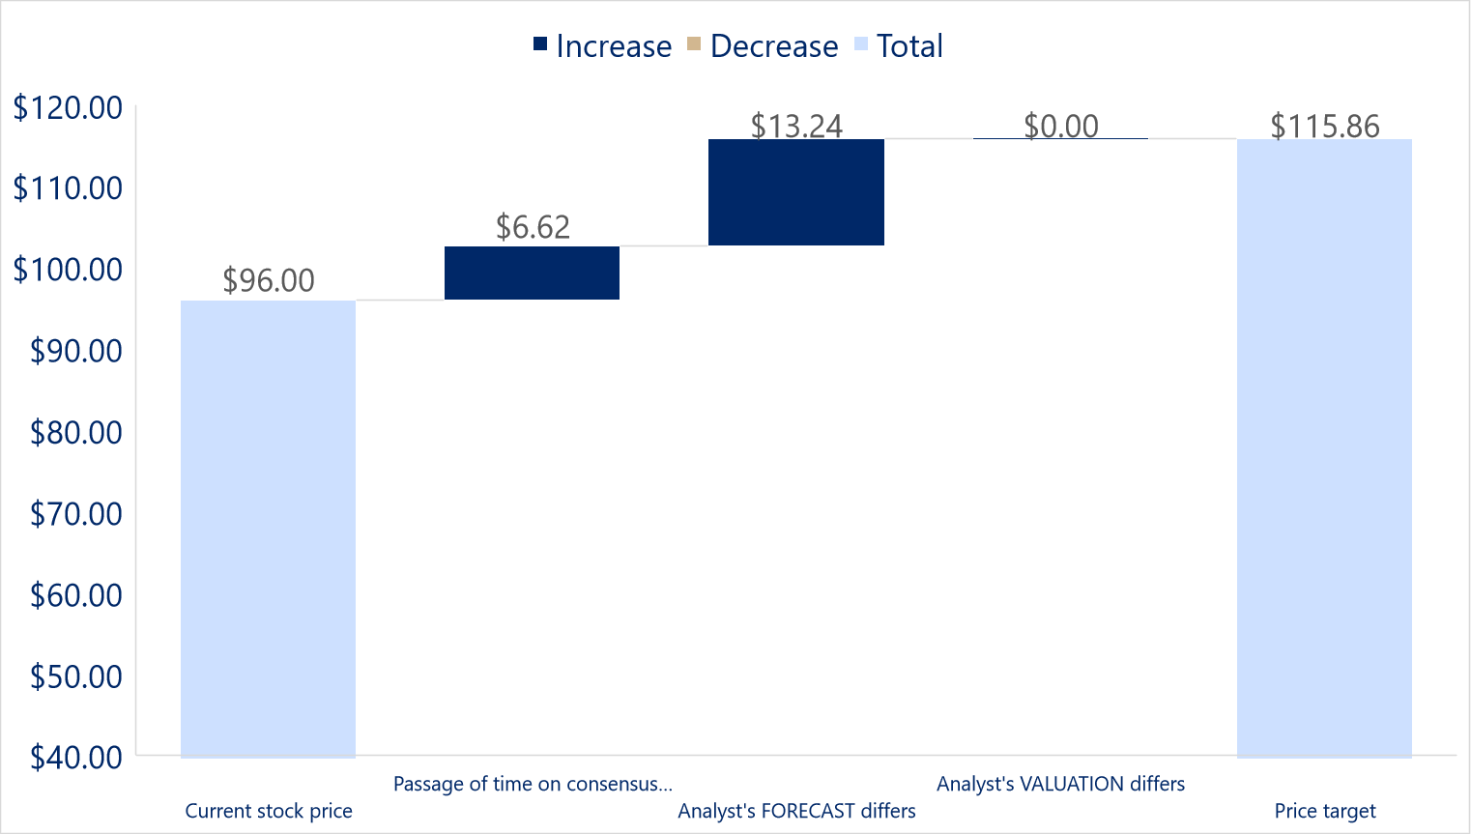  Did the analyst have a unique call?
 |  | z
 |  | z |  |  | Scenario 2: Starbucks (SBUX)  (Reminder: cover up or minimize your window so that you do not see the two right-most columns below until after you have attempted to complete the scenario.)  “We are no longer recommending purchasing SBUX because we believe the consensus expectations for the next fiscal year (Y2) are 11% too high. Using our EPS forecast for next year (our Y2 estimate is $2.85, while consensus is at $3.20); we arrive at a base-case scenario price target of $68, which would be a 9% drop from the stock’s close of $75. Our proprietary work (survey and interview with industry sources) suggests the company will be unable to pass through the upward labor cost pressure driven by increases in minimum wages. The company will see higher cost inflation or, if it raises prices, slower unit sales, either of which will slow EPS growth. Given the company’s current above-average valuation multiple of 28x current consensus Y1 earnings (which is an 85% premium to the market multiple of 15x), we believe this multiple will contract to 24x when the market realizes next year’s consensus earnings are too high, putting it at only a 60% premium to the market.”
z |  |  |  |  |  | Scenario 2: Starbucks (SBUX)  * NTM = next twelve months  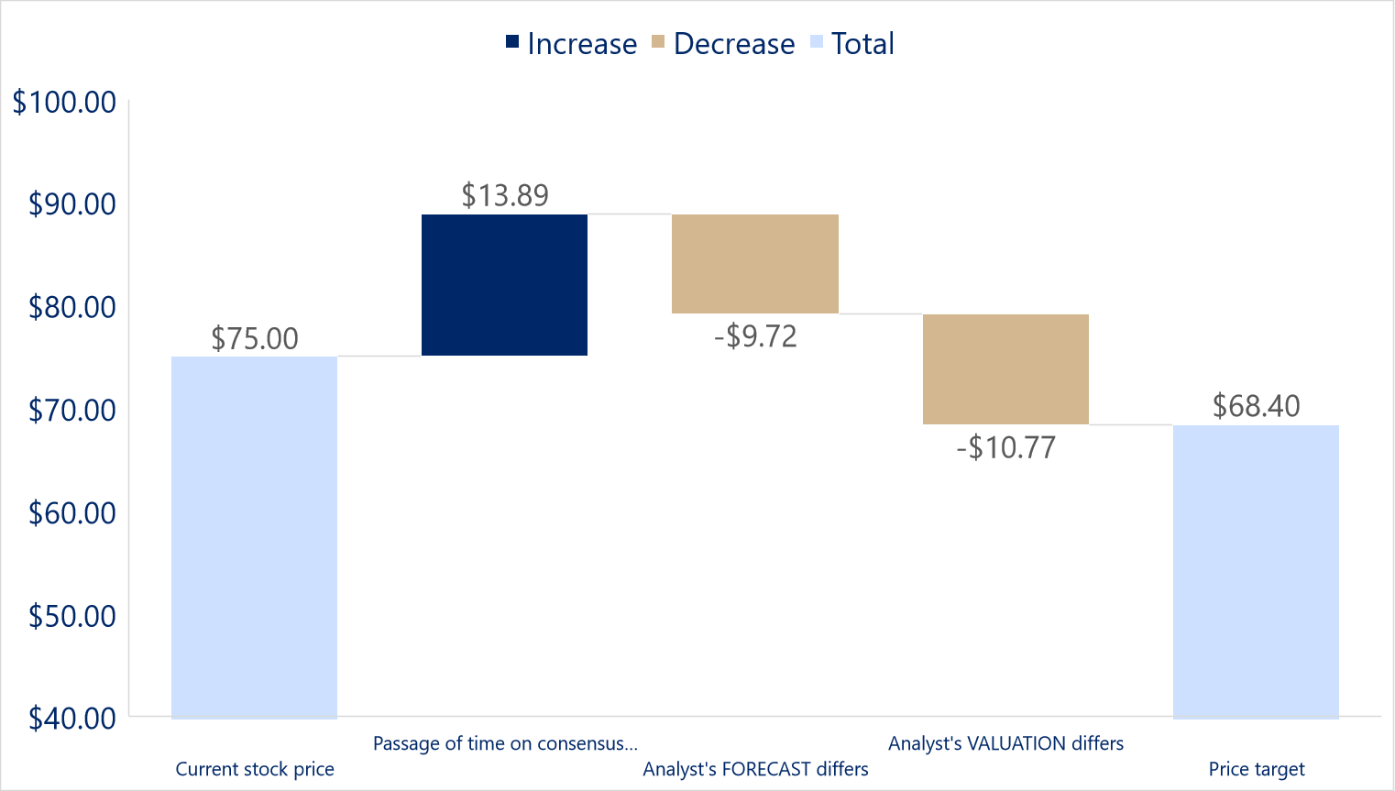
   | Your Answer | Row # | Answer Key | Effect on Stock Price
  1. Current data
  Current stock price | $75.00 | A | $75.00
  Next 12-month (“NTM”) consensus EPS forecast for STOCK at present (we call this "Year 1") | $2.70 | B | $2.70
  Stock's current valuation multiple based on Year 1 EPS (divide row A by row B) | 27.8x | C | 27.8x
  Current market multiple on NTM consensus (for the broad market such as S&P 500) | 15.0x | D | 15.0x
  Stock's current premium or discount to the market multiple (divide row C by row D minus 1, expressed as a percentage above or below 100%: a “discount” should be shown as a negative number) |  | E | 85.2%
  2. Change from consensus EPS between Year 1 and Year 2
  NTM consensus in Year 2 (i.e., forecast at beginning of Year 2 for Year 2) | $3.20 | F | $3.20
  Difference between Year 2 and Year 1 consensus EPS forecasts (divide row F by row B) | 18.5% |  | 18.5% | $13.89
  3. Change due to analyst's financial forecast differing from consensus
  Analyst's NTM EPS forecast in one year (i.e., forecast for Year 2) |  | G | $2.85
  Difference between analyst's estimate in Year 2 and that of consensus (divide row G by row F) |  | H | -10.9% | -$9.72
  4. Change due to analyst's future valuation multiple differing from current multiple
  Analyst's estimate of market multiple at beginning of Year 2 | 15.0x | J | 15.0x
  Analyst's estimate of stock's premium or discount to market multiple at beginning of Year 2 |  | K | 60.0%
  Valuation multiple used for price target at beginning of Year 2 (multiply row J x (1+row K)) |  | L | 24.0x
  Difference between analyst's future multiple and stock's current multiple (divide row L by row C minus 1) |  | M | -14% | -$10.77
  5. Price target (multiply row G x row L) | $68.40 | N | $68.40 | -$6.60
  Change from current price (divide row N by row A) | -8.8% |  | -8.8%
 |  | z |  |  | Did the analyst have a unique call?
 |  | z
 | z |  |  | Scenario 3: Chipotle (CMG)  (Reminder: cover up or minimize your window so that you do not see the two right-most columns below until after you have attempted to complete the scenario.)  “We are recommending the purchase of CMG because we believe the market doesn’t appreciate the company’s earnings power. Specifically, we believe as the company expands into the Northeast, revenue (and profit) per store should increase faster than its historical trend, based on experience we have witnessed from other chains that expand into the Northeast. Our $720 one-year price target, which is 30% above yesterday’s close of $554, is based on the company trading at a 45x P/E ratio (slightly above its current 42.6x) on our $16.00 EPS estimate for next year (Y2) (compared to consensus at $15.50).”
z |  |  |  |  |  | Scenario 3: Chipotle (CMG)  * NTM = next twelve months
   | Your Answer | Row # | Answer Key | Effect on Stock Price
  1. Current data
  Current stock price | $554.00 | A | $554.00
  Next 12-month (“NTM”) consensus EPS forecast for STOCK at present (we call this "Year 1") | $13.00 | B | $13.00
  Stock's current valuation multiple based on Year 1 EPS (divide row A by row B) | 42.6x | C | 42.6x
  Current market multiple on NTM consensus (for the broad market such as S&P 500) | 15.0x | D | 15.0x
  Stock's current premium or discount to the market multiple (divide row C by row D minus 1, expressed as a percentage above or below 100%: a “discount” should be shown as a negative number) |  | E | 184.1%
  2. Change from consensus EPS between Year 1 and Year 2
  NTM consensus in Year 2 (i.e., forecast at beginning of Year 2 for Year 2) | $15.50 | F | $15.50
  Difference between Year 2 and Year 1 consensus EPS forecasts (divide row F by row B) | 19.2% |  | 19.2% | $106.54
  3. Change due to analyst's financial forecast differing from consensus
  Analyst's NTM EPS forecast in one year (i.e., forecast for Year 2) |  | G | $16.00
  Difference between analyst's estimate in Year 2 and that of consensus (divide row G by row F) |  | H | 3.2% | $21.31
  4. Change due to analyst's future valuation multiple differing from current multiple
  Analyst's estimate of market multiple at beginning of Year 2 | 15.0x | J | 15.0x
  Analyst's estimate of stock's premium or discount to market multiple at beginning of Year 2 |  | K | 200.0%
  Valuation multiple used for price target at beginning of Year 2 (multiply row J x (1+row K)) |  | L | 45.0x
  Difference between analyst's future multiple and stock's current multiple (divide row L by row C minus 1) |  | M | 6% | $38.15
  5. Price target (multiply row G x row L) | $720.00 | N | $720.00 | $166.00
  Change from current price (divide row N by row A) | 30.0% |  | 30.0%
 | z |  |  | Breakdown of Analyst’s Price Target vs. Current Price  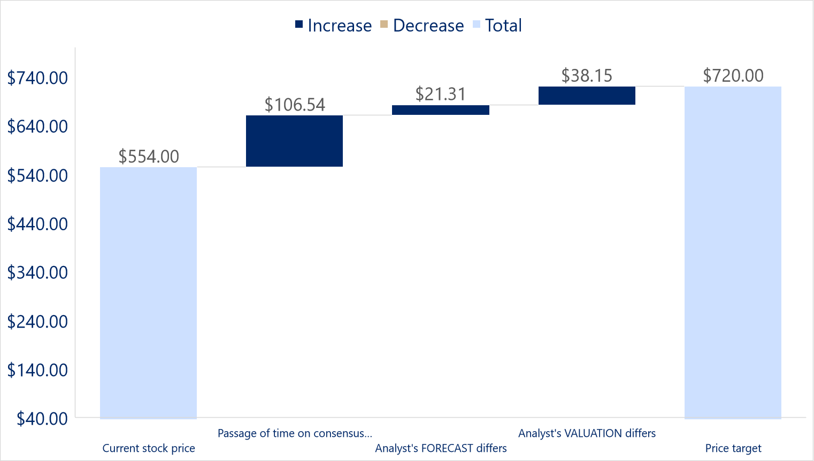  Did the analyst have a unique call?
Answer Key for “Did the analyst have a unique call?”
- McDonald’s
  - Using the FaVeS framework, the biggest driver to the 21% upside to the analyst’s price target is driven by an EPS estimate that is 13% ahead of consensus for next year, and so this is where we need to look to determine if it’s a unique call. The analyst cites “recovering Europe and growing emerging markets”, but it’s not clear if this is based on a hunch or due to unique research. The best stock calls are based on factors that can be forecast better than the market and therefore it’s not clear this is a truly “unique” call
- Starbucks
  - This call is somewhat unique in that it involves an EPS estimate and valuation multiple that are both out of consensus, which means they should both be examined. It appears the analyst has a unique call in terms of the financial forecast (based on a proprietary survey and conversations with industry sources), but it’s not clear that the valuation multiple is truly “unique” because there’s no explanation why 24x is being used versus the stock’s current 28x (why not 25x? or 20x?).
- Chipotle
  - What makes this call interesting is that there is 30% upside to the price target, but the analyst’s EPS forecast is only 3% higher than consensus. About two-thirds of the upside to the price target is driven simply by the company continuing to grow its earnings near 20% which is not unique to the analyst’s work.

“Rank Your Ability” Exercise
Instructions for the “Rank Your Ability” exercise:
- In the table below, rank your ability to perform the 10 tasks in terms of above or below average compared to professional peers at your experience level
- Specifically, rank your ability on a scale of 1% to 100% in terms of where you fall compared to your peers
- 100% would make you the master or “black belt” at that task
- 1% would say you have no idea how to conduct the task
- The column does not need to total 100%

 | z | Rank Your Ability
  Task | Rank Your Ability Compared to Peers (1% to 100%)
  - Using Excel efficiently for financial modeling
  - Accurately forecasting earnings for a universe of stocks
  - Effectively interviewing company management
  - Extracting the most important pieces of information from a company conference call
  - Finding important information quickly in a regulatory filing
  - Setting accurate price targets
  - Efficiently scanning the news wire services for stories that impact my sector
  - Effectively presenting stock ideas to others
  - Being a good listener
  - Being empathetic to other people’s needs

“How Does Your Future Look?” Exercise
Instructions for the “How Does Your Future Look?” exercise:
- Put a check mark next to the events below that have occurred in your life or you believe may occur in your lifetime
 | z | Instructions for the “How Does Your Future Look?” Exercise:
  Life Experience
  Own my own home
  Achieve annual earnings that are in the top 1% of the population of my country
  Travel overseas for 10 or more days with my spouse or family
  Experience a doubling of my personal investment portfolio in a five-year period
  Be among the top 10% of alpha-generators among my peers
  Live past 80 years old
  Be recognized by my peers for a major achievement
  Not spend a night in the hospital until I’m in retirement
  Have an academically-gifted child
  Be at the ideal weight for my age for at least 10 years
  Have a drinking problem
  Permanently lose my house keys
  Get divorced from my spouse (or future spouse)
  Lose my passport when traveling
  Be diagnosed with cancer or heart disease before age 75
  Have dental problems requiring surgery or implants
  Conclude I’m in the wrong career
  Be a victim of a crime
  Be involved in a major car accident
  Home significantly damaged by natural disaster (flood, storm, fire, etc.)

Assess and Influence the Market’s View
z |  | Short Interest as Percentage of Float for Selected Restaurant Stocks (early 2014)
  Ticker | Short Interest % of Float
  DRI.N | 10.1%
  DNKN.O | 8.5%
  NDLS.O | 8.1%
  BJRI.O | 6.1%
  RRGB.O | 5.6%
  SONC.O | 5.5%
  PNRA.O | 5.4%
  BLMN.O | 5.3%
  CAKE.O | 4.8%
  WEN.O | 4.6%
  TXRH.O | 4.0%
  EAT.N | 2.5%
  BWLD.O | 2.3%
  MCD.N | 2.2%
  DPZ.N | 2.2%
  YUM.N | 2.2%
  JACK.O | 2.0%
  CMG.N | 1.8%
  THI.TO | 1.0%
  SBUX.O | 0.6%
 | z |  | Insider Buying and Selling of SBUX
  Trade Date | Participants | Net Sell (Shares) | Net Buy (Shares) | Close Price
  11/15/13 | SCHULTZ HOWARD D, ALST | -104,840 |  | $81.19
  11/14/13 | SCHULTZ HOWARD D, ALST | -53,171 |  | $81.14
  9/30/13 | ALSTEAD TROY M, CULVER |  | 431 | $76.97
  9/30/13 | ALSTEAD TROY M, CULVER |  | 431 | $76.97
  8/19/13 | HOBSON MELLODY |  | 141,573 | $70.29
  8/2/13 | SCHULTZ HOWARD D, ALST | -7,056 |  | $74.23
  6/28/13 | ALSTEAD TROY M, CULVER |  | 568 | $65.51
  6/28/13 | ALSTEAD TROY M, CULVER |  | 568 | $65.51
  6/17/13 | HANSBERRY JEFFERY | -735 |  | $66.03
  5/31/13 | HELM LUCY LEE | -4,066 |  | $63.14
  5/1/13 | GATES ROBERT MICHAEL |  | 3,300 | $60.14
  5/1/13 | GATES ROBERT MICHAEL |  | 3,300 | $60.14
  3/6/13 | SCHULTZ HOWARD D | -900,000 |  | $57.10
  3/5/13 | SCHULTZ HOWARD D | -100,000 |  | $56.51
  2/22/13 | SHENNAN JR JAMES G | -10,000 |  | $54.17
  1/30/13 | GASS MICHELLE P | -35,000 |  | $56.00
  12/31/12 | HANSBERRY JEFFERY, HELM |  | 264 | $53.63
  12/21/12 | SCHULTZ HOWARD D |  | 1,020,000 | $53.60
  12/18/12 | HELM LUCY LEE | -5,227 |  | $54.34
  12/14/12 | SCHULTZ HOWARD D | -50,000 |  | $53.36
  12/12/12 | SCHULTZ HOWARD D, ALST | -91,013 |  | $53.60
  12/10/12 | SCHULTZ HOWARD D, HELM | -200,000 |  | $52.96
  11/29/12 | SHENNAN JR JAMES G | -10,000 |  | $51.80
  11/16/12 | SCHULTZ HOWARD D, ALST | -127,408 |  | $48.76
  11/15/12 | SCHULTZ HOWARD D, ALST | -105,370 |  | $48.43
  9/28/12 | CULVER JOHN, HANSBERRY |  | 425 | $50.71
  9/4/12 | CULVER JOHN | -626 |  | $49.51
  8/24/12 | BRADLEY WILLIAM W |  | 23 | $48.70
  8/20/12 | ULLMAN III MYRON E | -10,000 |  | $48.05
  6/29/12 | CULVER JOHN, HANSBERRY |  | 332 | $53.32
  6/15/12 | HANSBERRY JEFFERY | -711 |  | $52.54
  5/25/12 | BRADLEY WILLIAM W |  | 21 | $54.56
  3/30/12 | CULVER JOHN |  | 142 | $55.89
  3/14/12 | SCHULTZ HOWARD D, GASS | -20,000 |  | $52.68
  3/9/12 | ALSTEAD TROY M, HOBSON | -30,000 |  | $51.84
  2/1/12 | SCHULTZ HOWARD D | -1,480,000 |  | $48.24
  1/30/12 | WEATHERUP CRAIG E, ULLM |  | 10,000 | $81.19
 | z |  | Investment Style of SBUX Largest Institutional Holders (late 2013)
  Holder Name | Investment Style | Market Value ($) | Position Change ($)
  Fidelity Contrafund | Aggressive Growth | 1,195,304,286 | 521,800
  Vanguard Total Stock Market Index Fund | Index | 784,760,310 | 153,094
  T Rowe Price Growth Stock Fund | Aggressive Growth | 673,005,746 | 535,800
  PowerShares QQQ Trust | Index | 603,466,492 | 275,927
  Vanguard Institutional Index Fund | Index | 543,150,307 | 5,878
  Vanguard 500 Index Fund | Index | 533,037,280 | 46,211
  SPDR S&P 500 ETF | Index | 521,562,333 | -946,968
  MainStay Large Cap Growth Fund | Aggressive Growth | 463,338,408 | 0
  American Funds Fundamental Investors | Growth | 432,588,000 | -830,000
  JPMorgan Large Cap Growth Fund | Aggressive Growth | 420,324,497 | -101,700
  Government Pension Fund - Global (The) | GARP | 406,277,265 | 305,275
  T Rowe Price Blue Chip Growth Fund | Aggressive Growth | 389,769,120 | -55,000
  Fidelity Series Growth Company Fund | Aggressive Growth | 356,195,892 | 4,858,100
  Fidelity Growth Company Fund | Aggressive Growth | 351,056,160 | -70,100
  Fidelity Advisor New Insights Fund | Aggressive Growth | 320,650,796 | 0
  Fidelity Capital Appreciation Fund | Aggressive Growth | 294,805,203 | 348,520
  CREF Stock Account | Growth | 276,570,739 | 15,259
  Harbor Capital Appreciation Fund | Aggressive Growth | 272,216,557 | -94,244
  American Funds New Perspective Fund | Aggressive Growth | 260,286,000 | -500,000
  Vanguard Growth Index Fund | Index | 245,024,369 | 50,097
  Janus Twenty Fund | Growth | 241,392,902 | -3,360
  Fidelity Spartan 500 Index Fund | Index | 230,570,870 | 25,391
  Fidelity Blue Chip Growth Fund | Aggressive Growth | 187,611,216 | -19,600
  American Century Ultra Fund | Aggressive Growth | 184,913,040 | 0
  American Funds American Balanced Fund | GARP | 183,300,000 | 0
  iShares Core S&P 500 ETF | Index | 175,528,153 | -55,417
  SPDR Series - Consumer Discretionary Select Sector SPDR Fund | Index | 168,679,552 | -447,759
  Eaton Vance Tax Managed Growth Portfolio | GARP | 166,452,970 | -90,262
  Principal Investors - Large Cap Growth Fund I | Aggressive Growth | 154,098,257 | -114,687
  T Rowe Price Institutional Large Cap Growth Fund | Aggressive Growth | 151,853,052 | 37,000
  CREF Growth Account | Aggressive Growth | 146,776,668 | 13,580
  American Funds Growth Fund of America | Growth | 146,640,000 | 0
  Morgan Stanley Invt. Fds. - US Advantage Fund | Aggressive Growth | 131,627,950 | 46,829
  iShares Russell 1000 Growth ETF | Index | 126,687,868 | -20,302
  American Funds Insurance Series - Growth Fund | Growth | 121,344,600 | -345,000
  Fidelity Puritan Fund | Growth | 121,073,316 | 0
  ASTON/Montag & Caldwell Growth Fund | Growth | 119,753,556 | 0
  Touchstone Sands Capital Select Growth Fund | Aggressive Growth | 116,578,800 | 96,000
  ING Investors Trust - Large Cap Growth Portfolio | Growth | 113,973,447 | 92,766

“Circle the Symbols” Exercise
Instructions for the “Circle the Symbols” exercise:
- Review the table of symbols that follow
- For each row, identify the one that you find the most intriguing
- Put the letter for that symbol in the right-most column

 | z | Circle the Symbols  Note: those shaded are currently ranked as most intriguing by experienced buy-side and sell-side analysts who have participated in this activity in the past
  Row | A | B | C | D | E | Your Choice
  1. | © | ǁ | ♥ | Ѡ | Ӫ
  2. | ԏ | « | Ԅ | Ẅ | ᴥ
  3. | Ѩ | ῃ | ₡ | Ϊ | Ӝ
  4. | ℗ | Ὡ | ₹ | √ | ∞
  5. | ₸ | ᵝ | ᵹ | Ẻ | ӡ
  6. | ↨ | » | ∂ | ∆ | ∏
  7. | └ | ⌂ | ǂ | ʁ | ≡
  8. | ├ | Ѫ | ≥ | ♫ | ⱷ
  9. | ˠ | ₩ | ┐ | ☼ | ┴
  10. | ≈ | ≤ | ♂ | Ᵽ | ╙

Module 4: Review Performance and Thesis
 | "Ski Vacation" Exercise
Instructions for the “Ski Vacation” exercise:
- Review the two options below and record how you would most likely respond.

z |  | - It’s October and you’re looking to book the two ski vacations that you typically take each winter.  - Trip 1: You find a 7-night trip to a nice location for $2,000 and so you purchase it.  - Trip 2: You later find a similar trip to an even better location and it’s discounted down to $1,250, which you book as your second winter ski trip.  - Both trips offer multiple dates to choose from but are non-refundable.  - In November, you unexpectedly take on a new job that will allow you only one week of vacation for the first six months. Neither of your ski vacation packages can be refunded or resold.  - Which one do you chose to use?: _____________

Appendix

Transformation Action Plan (TAP)
Instructions for the Transformation Action Plan (TAP):
- Throughout this workshop complete the TAP below
- Apply the key points after the workshop to help you improve your performance
- This will not be collected and so write in a manner that will help you utilize the concepts being learned

z | Section Are You Producing the Highest Quality Research?  After reviewing the ENTER™ quality checklist you completed in this module, identify areas where you scored a 1 or 2 and would like to improve, all to create higher quality research:
  Based on the ENTER™ quality checklist:
  To improve the quality of my research, I intend to do this more often:
  To improve the quality of my research, I intend to stop doing this:
z |  | Section Improve Your Stock Picking Skills by Reflecting on Module 1  - Complete the self-assessment below and then answer the question in the box that follows  Setting Price Targets Self-assessment  - If you rated any item above as a 1, 2 or 3, in the box below, tell yourself what you will do to adopt best practices (start with the item you rated with the lowest score)
  For stocks I’m recommending, I… | 1 = disagree  5 = agree
  Include a valuation method that includes an element of free cash flows?
  Am aware of all the limitations to the valuation method(s) I currently use
  Forecast multiple EPS (or cash flow) scenarios based on changes to assumptions for my critical factors
  Analyze the stock’s historical valuation trends and current levels in order to create an accurate range of likely valuation multiples that I expect the stock to command at the time my price target should be achieved
  Know which of my stocks trade with peak multiples on peak earnings (or cash flow) and those that trade with peak multiples on trough earnings (or cash flow)
  Apply my multiple valuation scenarios to my multiple EPS (or cash flow) forecasts to derive a range of price targets, which helps me think outside my comfort zone
  Based on the assessment above, I intend to do the following to improve setting price targets:
z | Section Improve Your Stock Picking Skills by Reflecting on Module 2  Briefly review the material covered in Module 2 as well as the DRC/QRCs for “Step 2: Identify & Forecast Catalyst(s)” and provide yourself key coaching tips to use in the future to help improve your stock picking performance.
  Based on this module focused on identifying and forecasting catalysts:
  I intend to do this more often:
  I intend to stop doing this:
z | Section Survey Market Sentiment  For your stock of interest, create 2-3 questions that need to be answered in terms of understanding market sentiment around the critical factor(s) and the types of market participants you can contact to obtain the answers.
  Questions that need to be answered: | Market participant that can provide insight:
  Example: Does the market understand that FedEx has a fuel surcharge in place that generates a short-term profit in times of declining fuel prices? How much of this benefit is currently understood by the market because it could result in $0.05 upside in the quarter if fuel prices stay at current levels or drop further. | I’ll contact 3 other buy-side analysts who cover the stock. I will also call the company’s IR person to see if he knows how much of this is typically modeled by the sell-side.
  1.
  2.
  3.
z | Section Improve Your Stock Picking Skills by Reflecting on Module 3  Briefly review the material covered in Module 3 as well as the DRC/QRCs for “Step 3: Ensure Ideal Entry Point.” Also, briefly review the slides covering Module 3A and 3B so that you can provide yourself key coaching tips in the table below to use in the future to help improve your stock picking performance.
  Based on the module focused on ensuring I find the ideal entry point:
  I intend to do this more often:
  I intend to stop doing this:
z | Section Evaluate Your Comp Table  Self-evaluate the quality of your current comparison (“comp”) table using the table below:  If you rated any item above “3”, note to yourself when you will make the modification in order to better review your performance and thesis.
  My Current Comp Table… | 1=Yes  2=Somewhat  3=No
  - Updates stock prices automatically (via a feed to third-party service)
  - Updates my forecast estimates (e.g. EPS, CFPS, BV, etc.) automatically from my models
  - Includes consensus estimates which are automatically updated (via a feed to third-party service)
  - Highlights when my financial forecasts differ materially from consensus
  - For stocks I’m recommending, shows how much future valuation multiple differs from the current multiple
  - For stocks I’m recommending, includes upside/downside returns to my target prices
  - For stocks I’m recommending, includes a column for me to adjust upside/downside for risk/probability
  - Includes ranges of historical forward relative valuation (e.g. relative P/E)
  - Includes current relative valuation to the market (e.g. relative P/E)
  - Include relative valuation metrics (e.g. P/E) for stocks in other sectors with similar prospects
  - Includes how my recommendations have performed since the last rating change relative to my universe of stocks and the overall market

Notes

End of Module Section - Do not delete or alter this paragraph and bookmark – Insert all module and lesson content prior to this red non-printing paragraph and bookmark

