Matthews International Offsite
Learner Workbook
NOTE: Please ensure you can interact with this document during the workshop in one of these methods:
- With a keyboard (as a Word document); or
- With pen (as a hard copy)

This document has been created for registered participants of AnalystSolutions’ events and should not be copied or re-distributed

Matthews International Offsite

Acknowledgments
Much of the content for this material comes from Best Practices for Equity Research Analysts authored by James J. Valentine, CFA and published by McGraw-Hill.

Trademarks & Copyright Acknowledgments
None of the material in this document can be reproduced or distributed without the written consent of:

AnalystSolutions, LLP
20793 W. High Ridge Drive
Kildeer, IL 60047-7937
USA
+1-203-321-9400
AnalystSolutions.com

Table of Contents

Contents
Table of Contents i
Module: Introduction 2
How Does This Skill Help Me Succeed? 2
Module: Exercises 3
Transformation Action Plan (TAP) 3
Section 1. List Everything (PART 1) 3
Instructions for “List Everything” (PART 2) 5
Section 2: Research Methods’ Ability to Provide Unique Insights 6
Section 3. “Prioritize Goals, Tactics and Activities” Exercise 9
Notes 12

Module: Introduction

How Does This Skill Help Me Succeed?
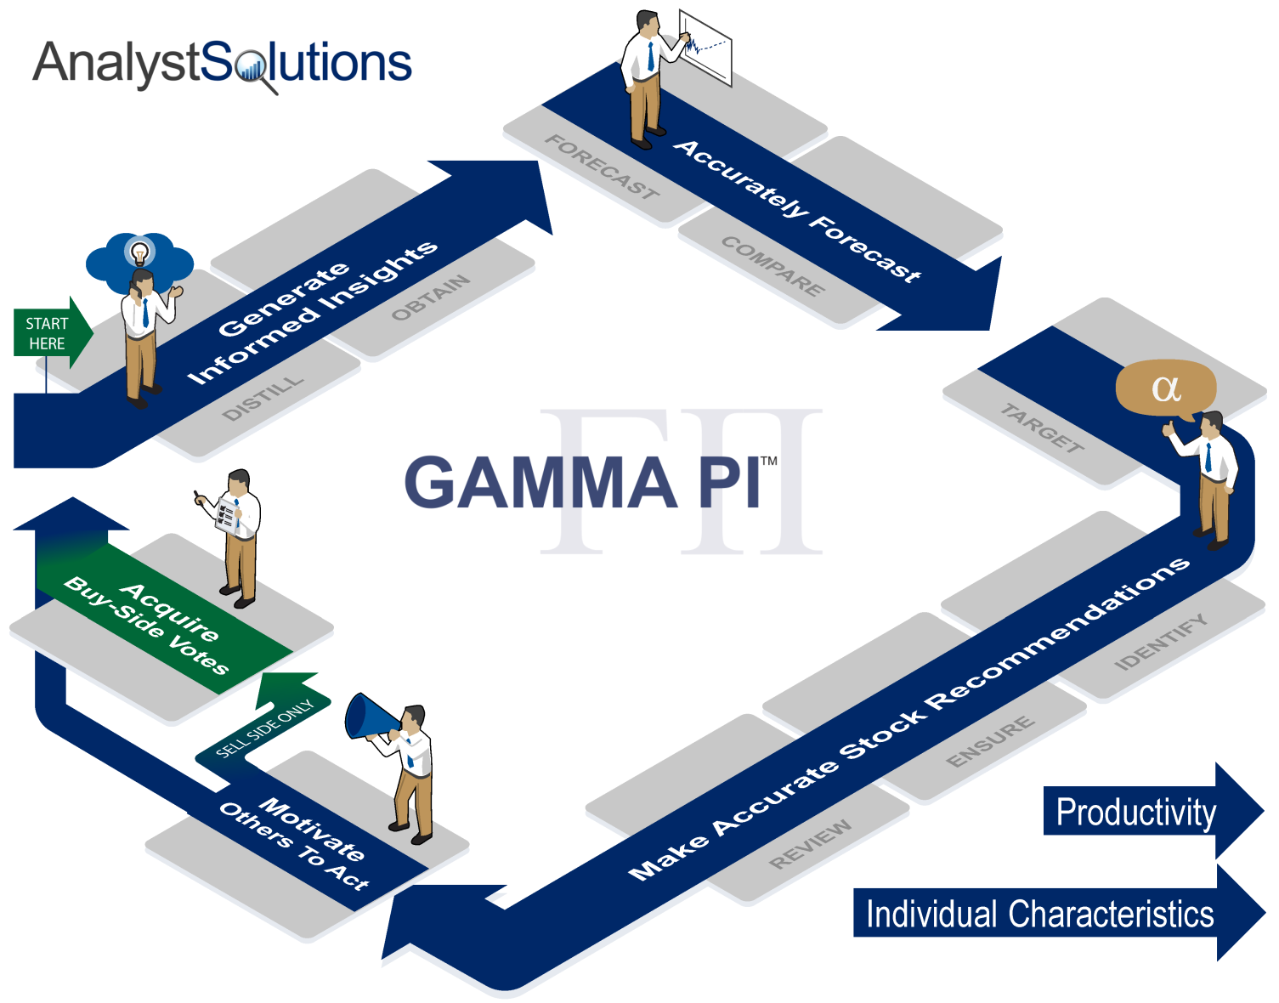

Module: Exercises
 | Transformation Action Plan (TAP)
 |  |  | Instructions for the Transformation Action Plan (TAP):  - Throughout this workshop complete the TAP below  - Apply the key points after the workshop to help you improve your performance.  - This will not be collected and so write in a manner that will help you utilize the concepts being learned.
z |  | Section List Everything (PART 1)  Instructions, Part 1:  - The initial purpose of this exercise is to create a list 5 to 10 factors that will generate investor interest over the next year by using the most-read stories for that stock over the past 6 to 12 months (for a single stock)  - This list will be used for multiple exercises throughout the workshop  - Begin by selecting a stock:  - Among a list we provide at this URL: AnalystSolutions.com/LE (please browse quickly in making your decision because there will not be time to review every headline for every stock listed); OR  - If you were encouraged to compile a list before the workshop, please retrieve the list now  - Once you have selected a stock and reviewed the top headlines, go to the table on the next page (labeled “List Everything” Exercise) and put the ticker at the top of the table  - Using the list of headlines referenced above go to the “List Everything” table on the next page and create a list of 5 to 10 factors that could receive the media’s attention in the future.  - If the subject of the prior headline occurred in the past (e.g. Apple debuted a new iPhone last month), restate the factor as though this event or a similar-type event may re-occur in the future (e.g. Apple will debut a new iPhone in the next 3 months)  - For this step, please complete only the first column (you will be instructed on how to use the other columns at a later stage)
z |  | Exercise: “List Everything”  Ticker: ______________________  (ONLY COMPLETE EACH COLUMN WHEN INSTRUCTED)  (Scale of 1 to 5 with 5=strongly agree)  Company-specific “newsworthy” issues E Zones P K, U-R, U-I Source I C T  EXAMPLE: Company is trying to improve its network efficiency 5 OC 4 U-R - Industry consultant - Private competitor 4 4 17  Please do not continue until told to do so
Z |  | Instructions for “List Everything” (PART 2)  Instructions, Part 2:  - The purpose of Part 2 is to evaluate the list of newsworthy issues using the EPIC™ framework to determine if a “factor” is a “critical factor.”  - Using the directions below, complete the “List Everything” table, but only the specific line items when instructed:  - In the column labeled “E”, do your best at ranking each item on an “Exceed my materiality threshold” scale, if it were to occur or recur (use a 1 to 5 scale with 5 as strongly agree). Don’t get frustrated for not having the company’s financial details (which you will likely need to provide a definitive answer), but instead focus on the process.  - In the column labeled “Zone” list the impact zone(s) for the factor (good or bad), by using:  - “V” for “Volumes” (revenue from additional transactions)  - “P” for “Pricing” (revenue from better pricing)  - “OC” for “Operating costs”  - “O” for “Other” (such as a stock buy-back or lower tax rate)  - “N” “None” (because it’s not likely to impact earnings)  - Using the column labeled “P”, try to rank each issue on “there a high Probability this factor will become much more certain to occur (or deviate materially from the expected trend) during my investment time horizon” (using a 1 to 5 scale with 5 as strongly agree). If the newsworthy issue is focused on something that already occurred, rank the likelihood that a similar event will recur during your investment time horizon.  - In the column labeled “K, U-R, U-I” include one of these letters:  - “K” for “Knowable”: Your prior research provides the insight you need to forecast this factor if it should occur or recur  - “U-R”: “Unknowable, Research Required”: You need to conduct research to accurately forecast this factor  - “U-I”: “Unknowable, Impossible to Forecast”: Nobody can forecast with accuracy even if more research is conducted (e.g. direction of interest rates or oil prices)  - In the column labeled “Source” for those factors you labeled “K” or “U-R” try to explain where you already received or could get information to better assess if this is a critical factor (e.g. industry consultant, private competitor, company source, sell-side analyst, etc.).  - Based on your response to the two items above, in the column labeled “I”, do your best at ranking the statement “I could forecast this factor and its catalyst accurately with a moderate amount of research” using a 1 to 5 scale with 5 as strongly agree. If the issue already occurred, rate the likelihood of forecasting this issue recurring.  - In the column labeled “C”, do your best at ranking each item on “the general Consensus will be poor at accurately forecasting/spotting this factor (or a change from trend).” Remember, “5” is strongly agree which means consensus will be POOR at forecasting if you put a high number.  - In the last column (labeled “T”), add up the four numbers within that row

Section Research Methods’ Ability to Provide Unique Insights
- The purpose of this portion of the TAP is to evaluate the most traditional research methods based on their ability to provide the unique insights required for great stock calls
STEP 1 of 3:
- In the table that follows, the first column consists of typical methods equity research analysts use to collect and analyze information
- Using the scale below, rank each method under the first empty column heading “Method tends to lead to information that is”:
  - 1 = Not differentiated because it’s widely accessed by other analysts
  - 2 = Possibly differentiated because it’s not widely accessed by other analysts
  - 3 = Highly differentiated because it’s not typically accessed by other analysts
- After completing this step, continue with the instructions that follow the table to complete STEP 2 and 3

“How Unique Are Your Information Sources?” Table
- Note, for STEP 1, ignore the 3 right-most columns with headings “Frequency”, “Score” and “Goal to Change”
Research Method for Collecting Information | STEP 1: Method tends to lead to information that is…*  1=Not diff.  3=Highly diff. | STEP 2: Frequency  0=Never  3=Very frequent | STEP 3: Score | STEP 3: Goal to Change
- Review company documents, website, and conference call
- Monitor financial press
- For buy-side only: read sell-side reports
- Speak with company investor relations contact
- For buy-side only: proactively interview sell-side analyst, beyond listening to their pitch
- Review industry trade journal, website, or blog
- Interview company management (other than investor relations)
- Analyze publicly-available economic data in a manner that differs from how it is delivered to the market
- Proactively interview buy-side analyst, portfolio manager, sell-side salesperson or trader to understand investor psychology of a stock
- Interview management of publicly-traded competitor of the stock being researched
- Interview management of publicly-traded customer of, or supplier to, the stock being researched
- Interview consultant, expert, or company retiree who is part of an expert network
- Analyze information from private forecasting service in a manner other than for which it was intended
- Interview journalist, blogger or noted book author for unpublished insights
- Interview government official, staffer, lobbyist or association executive
- Interview management of privately-held competitor of the stock being researched
- Interview management of privately-held customer of, or supplier to, the stock being researched
- Interview consultant, expert, or company retiree who is not in an expert network
- Conduct survey, formal or informal

STEP 2 of 3:
- In the table above, in the column titled “Frequency”, rate the frequency in which you use this method, using this scale:
  - 0 = Never
  - 1 = Rarely (1x to 2x per quarter)
  - 2 = Moderately (> 2x per quarter, < 1x per week)
  - 3 = Very frequently (at least 1x per week)
- Complete this step before proceeding to STEP 3
STEP 3 of 3:
- In the column titled “Score” multiply the number from the two columns to its left
- Review your scores
  - Ideally, the highest scores will be near the bottom of the table because those are the more proprietary sources
  - If your highest scores are near the top suggests you are primarily relying on sources that provide information widely available to other analysts and therefore it’s not unique
- In the right-most column titled “Goal to Change”:
  - Put the word “Increase” or “+” sign if you would like to use this method more;
  - Put the word “Decrease” or “-“ sign if you would like to rely on this method less
  - Note: you can’t add something to your day unless you take something away and so for every item you intend to increase, there should be at least one corresponding item you intend to decrease

Section “Prioritize Goals, Tactics and Activities” Exercise
- Reflect on the questions below and then develop an action plan in the tables that follow.
- Review the “Part B” table in your custom output
  - Review the right-most column. The lower the score the more your day-to-day activities are not aligned with the priority you place on tactics required to achieve your goals. Highlight your two lowest numbers.
  - If your “WOT?” score is not the lowest score in the table, ask if you're placing too much priority on activities that are not necessarily helping you to achieve one of your tactics.
  - If you don’t have the score you want for one or more of the tactics, ask yourself how you can achieve that tactic based on your current prioritization of activities. In the space below, develop an action plan that you can use after the workshop, that answers these questions:
    - For the two tactics with the lowest “Activity Score” (right-most column), review their corresponding activities in “Part C” table, to determine which of the activities for this tactic you need to increase? OR
    - Do you potentially need to lower the importance of this tactic (Item A in the Part B table) because it’s unrealistic it can be achieved?
- Complete the tables that follow:
z | 1. I intend to increase these specific activities in order to support my high priority tactics  2. To make time for these new activities, I intend to decrease or eliminate these specific activities that do not support my tactics  3. Do you potentially need to lower the importance of one or more tactics (“Item A” in “Part B”) because it’s unrealistic it can be achieved? If so, reflect on the risk of reducing the importance of this tactic.  CONTINUE TO THE NEXT INSTRUCTION (stop just before the next “Section” begins)

- Refer to the table in “Part C” and look at the right-most column, which is the difference between the priority you believe an activity should command vs. the priority you’ve been placing on this activity.
  - First, verify that those activities with the highest scores are those that need to be increased the most to help achieve your tactics and goals; and
  - Those with the lowest scores are those that need to be reduced to free up time (this is the most important part of the exercise because you can’t ADD something to your schedule until you REMOVE another activity – old habits die hard)
  - If you have scores of negative three (-3) or lower, and you intend to reduce those activities, in the space below record the steps you will take to ensure your new habits are reinforced day-to-day and week-to-week (to avoid falling back into your existing routine)?
- Review any “WOT?” activities that received a high ranking in the first column of numbers. Highlight the ones you intend to reduce.

Steps I will take to reduce unproductive activities:

Notes

z
z
z
z
z
z
z
z
z
z
z
z
z
z
z
z
z
z
z
z
z
z
z
z

End of Module Section - Do not delete or alter this paragraph and bookmark – Insert all module and lesson content prior to this red non-printing paragraph and bookmark

