Best Practices for Improving Your Equity Research

Learner Workbook
NOTE: Please ensure you can interact with this document during the workshop in one of these methods:
- With pen (as a hard copy);or
- With a keyboard (as a Word document) by going to:
www.analystsolutions.com/EICmaterials

This document has been created for registered participants of AnalystSolutions’ workshops and should not be copied or re-distributed

Best Practices for Improving Your Equity Research

Acknowledgements
Much of the content for this workshop comes from Best Practices for Equity Research Analysts authored by James J. Valentine, CFA and published by McGraw-Hill.

Trademarks & Copyright Acknowledgements
None of the material in this document can be reproduced or distributed without the written consent of:

AnalystSolutions, LLC
244 Fifth Avenue, Suite 200
New York, NY 10001
USA
+1-203-321-9400
AnalystSolutions.com

Table of Contents

Part 1: Identify & Monitor Your Stock’s Critical Factors 2
Exercise: “List Everything” 2
Exercise "What's Material to You?" 3
“Is It Worth Your Time?” Exercise 4
Example Critical Factors 6
Part 2: Get Noticed With Differentiated Stock Calls 8
"How Do You Differ?" Exercise 8
Find the Fs 16
“Rank Your Ability” Exercise 17
“How Does Your Future Look?” Exercise 18
Notes 19

Part 1: Identify & Monitor Your Stock’s Critical Factors

Exercise: “List Everything”
z | Ticker:______________________  Rank each factor on a scale of 1 to 5, with 5 as “strongly agree”  Company-specific issues in the press If this factor were to occur or change from trend, it would cause changes in consensus’ expectations to Exceed my materiality threshold This factor will Probably deviate materially from consensus expectations during my investment time horizon Based on my research on the factor, I'm good at forecasting this factor and its catalyst (it’s not just a guess) The overall Consensus will be poor at accurately forecasting or spotting an anomaly for this factor Total  0  0  0  0  0  0  0  0  0  0  0  0  0

Exercise "What's Material to You?"
 |  | Instructions for What’s “Material” to You? exercise:  - Approximately how much does a stock need to move relative to a benchmark or in absolute terms for you to consider recommending it as a buy at your firm?: _______%  - For the table below, list three stocks in the first column that you are familiar with  - Ignore the other columns until you receive further instructions from the facilitator
z | Ticker Revenue from Volume Revenue from Pricing Expenses

 | “Is It Worth Your Time?” Exercise
Instructions for “Is It Worth Your Time?” Exercise:
- From your research you have come across the following scenarios. Using the basic income statement data below, determine if each is material, assuming “materiality” is defined as a 10% change to EPS.
  - FDX has had a 4% fuel surcharge for the past year but only collected half (2%) from its customers. Due to a new policy, the company is going to start to collect 3%. Is this 1 percentage point increase material? To keep the math simple, assume the surcharge covers all of FedEx’s revenue (in reality some of its revenue is not subject to a fuel surcharge).
  - FDX is going to change a pension assumption that will raise the company’s overall costs by $150 million per year.
  - FDX has just won a new agreement with the U.S. Postal service to haul Priority Mail, which will likely result in $1 billion of additional annual revenue. This new contract has been priced to achieve the overall company’s existing margins.

z |  | Data Below is Actual for Fiscal Year Ending: 30-May-12  Total Revenue $42,800  Total Operating Expenses $39,600  EBIT $3,200  EBIT margin 7.5%  Interest Expense $55  Interest Income $0  Other $0  Pre-tax Income $3,145  Tax Expense $1,116  Effective Tax Rate 35.5%  Net Income $2,029  EPS $6.42  Fully Diluted Share Count 316

z | Answer Key  Scenario EPS Impact Change to EPS  1% higher pricing from better fuel surcharge collection $0.87 14%  $150 million higher pension costs $0.31 5%  $1 billion of USPS revenue $0.15 2%  Company ticker: FDX  Company name: FedEx  Step 1: Compute 10% of net income  10% change to last fiscal year's EPS 0.64  Materiality threshold as measured in net income $203  Step 2: Convert to pre-tax EBIT  Materiality threshold as measured in pre-tax EBIT $315  Step 3: Compute threshold for changes from pricing and expenses  Materiality threshold as measured in changes to pricing¹ 0.7%  Materiality threshold as measured in changes in expenses² 0.8%  Step 4: Compute threshold for change in revenue from sales/volume  Materiality threshold as measured in changes from sales/volume³ $4,206  As a percent of revenue 9.8%  Data Below is Actual for Fiscal Year Ending: 30-May-12  Total Revenue $42,800  Total Operating Expenses $39,600  EBIT $3,200  EBIT margin 7.5%  Interest Expense $55  Interest Income $0  Other $0  Pre-tax Income $3,145  Tax Expense $1,116  Effective Tax Rate 35.5%  Net Income $2,029  EPS $6.42  Fully Diluted Share Count 316  ¹ Assuming pricing drops directly to EBIT  ² Assuming expenses change with no change in volumes or sales  ³ Assuming all incremental revenue is at average EBIT margins

Example Critical Factors
z | Example Critical Factors and Key Assumptions*  Sector or Stock Critical Factor Assumption #1 Assumption #2  Amazon.com Market share shift from traditional retailers Adoption rate of e-commerce within emerging markets Adoption rate of mobile apps for retail purchases  Ford Motor Company New car pricing in North America Change in capacity in the North American market Changes in lending standards  Time Warner Cable Growth of competing content providers such as Netflix, Amazon and HBO Customer loyalty for the cable bundle vs. new entrants Potential growth of cable-provider broadband offering (which is required to access new entrants)  Interpublic Group (advertising) Changes in ad spending for traditional channels (e.g. TV, print) Adoption of advertising on mobile devices Adoption of online video advertising  Nike Top line growth rate keeping up with historical trends Changes in demand from international markets Changes in broad athletic activities  Union Pacific Freight railroad customer pricing Changes in freight railroad capacity Changes in competing mode (trucking and barge) capacity  SolarCity Growth of renewable energy revenue Changes in energy storage costs Impact from changes in oil and natural gas prices  The Gap Apparel pricing deflation Adoption of off-price and low-price fashion Use of mobile devices for price discovery  VMware (software) Growth of Open Source software vs. traditional vendors Open Source providers going public IT leaders selling services that rely on Open Source solutions  T-Mobile Competitive pricing among the wireless carriers Timing when domestic smartphone becomes saturated Changing regulations  Walgreens (drug retailer) Generic drug price inflation Changes in FDA regulation of non-generic drug manufacturers Distribution channel consolidation  * These critical factors may become out of date over time and should be viewed as just an example

z | Examples for FedEx  Factors for: FedEx in the 2005-2006 time period, ranked by “Total” column  Factor to Potentially Be Researched If this factor were to occur or change from trend, it would cause changes in consensus’ expectations to Exceed my materiality threshold This factor will Probably deviate materially from consensus expectations during my investment time horizon Based on my research on the factor, I'm good at forecasting this factor and its catalyst (it’s not just a guess) The overall Consensus will be poor at accurately forecasting or spotting an anomaly for this factor Total  Cost management/productivity/Improved network efficiency 5 4 4 5 18  Level of fuel surcharge collected 5 4 4 4 17  Acquisition(s) 5 3 2 5 15  Ground package volume growth 3 4 4 4 15  Domestic Express package pricing/yield 4 3 4 3 14  Ground package pricing/yield 4 3 3 4 14  International Priority package pricing/yield 3 4 3 4 14  International Priority package volume growth 2 4 4 4 14  Service levels other than during the holiday season 3 2 4 5 14  Change in senior management 5 2 2 4 13  Electronic documents reducing need for overnight envelopes 2 4 3 4 13  GDP growth 5 3 2 3 13  Labor cost trends 3 3 3 4 13  Domestic Express package volume growth 2 3 4 3 12  Service levels at holiday season 2 2 3 5 12  Asia-Pacific volume growth 2 3 4 2 11  Change in level of tech shippers vs. non-tech shippers 4 2 3 2 11  Purchase of new aircraft 1 3 3 4 11  Level of major weather disruptions 1 3 1 5 10  Depreciation rate 1 2 2 4 9  Note: Some of the new or emerging factors you highlighted in Part C of the simulation may not be in the list above because this list is for the period ending mid-2006

Part 2: Get Noticed With Differentiated Stock Calls

"How Do You Differ?" Exercise
Instructions for the “How Do You Differ?” exercise:
- This exercise helps to reinforce the critically-important concept that all great stock calls must differ from consensus. You will do this using the FaVeS™ framework, specifically, looking for an out-of-consensus view in one of these areas:
  - Financial forecast; or
  - Valuation multiple or method; or
  - Sentiment towards the stock (void of impending changes to the financial forecast or valuation multiple/method above, which is rare, but does occur)
- Review the 3 scenarios below, noting they are occurring at the start of calendar Year 1 (Y1) and so one-year price targets are based on forecast earnings for Y2. The term “NTM” is “next 12 months.”
  - To ensure you arrive at the same answer as our answer key, we assume the market’s multiple is 15x NTM earnings (not the stock’s multiple)
  - Before reading the scenario, cover up or minimize your window so that you do not see the two right-most columns until after you have tried to complete the scenario
  - After reading the passage, complete the column titled “Your Answer” and then check the right-most columns to see if you were correct
  - After reviewing the answer key, answer the question “Did the analyst have a unique call” which can be found below each answer key
- Note the answer key may differ slightly from your answer due to rounding issues
- Using a calculator will likely speed up the exercise

 |  | z |  | Scenario 1: McDonald’s  (Reminder: cover up or minimize your window so that you do not see the two right-most columns below until after you have attempted to complete the scenario.)  “We are recommending purchasing McDonald’s Corp (MCD) and have a one-year price target of $116 (up 21% from its current $96). We believe a recovering Europe and growing emerging markets will allow the company to beat Y2 consensus EPS of $6.20 (we are at $7.00). Our price target assumes the stock continues to trade at its current 10% premium to the market’s 15x multiple (putting MCD at a 16.6x forward multiple).”  Scenario 1: McDonald’s  Your Answer Answer Key Stock Price Impact  1. Current data  Current stock price $96.00  Next 12-month (“NTM”) consensus EPS forecast at present (we call this "Year 1") $5.80  Stock's current valuation multiple based on Year 1 EPS 16.6  Current market multiple 15.0 15.0  Stock's current premium or discount to the market multiple 10%  2. Change from consensus EPS between Year 1 and Year 2  NTM consensus in Year 2 (i.e. forecast at beginning of Year 2 for Year 2) $6.20  Difference between Year 2 and Year 1 consensus forecasts 7% $6.62  Item #2 above is due to passage of time while #3 and #4 below are influenced by the analyst  3. Change due to analyst's financial forecast differing from consensus  Analyst's NTM EPS forecast in one year (i.e. forecast for Year 2) $7.00  Premium or discount of analyst's EPS estimate in Year 2 compared to consensus' 13% $13.24  4. Change due to analyst's future valuation multiple differing from current multiple  Analyst's estimate of market multiple at beginning of Year 2 (typically keep same as present) 15.0 15.0  Analyst's estimate of stock's premium or discount to market multiple at beginning of Year 2 10%  Valuation multiple used for price target at beginning of Year 2 16.6  Difference between analyst's future multiple and stock's current multiple 0% $0.00  5. Price target $115.86 $19.86  Change from current price 21%  * NTM = next twelve months
 |  | z |  | Breakdown of Analyst’s Price Target vs. Current Price  Did the analyst have a unique call?
 |  | z
 |  | z |  | Scenario 2: Starbucks (SBUX)  (Reminder: cover up or minimize your window so that you do not see the two right-most columns below until after you have attempted to complete the scenario.)  “We are no longer recommending purchasing SBUX because we believe the consensus expectations for the next fiscal year (Y2) are 11% too high. Using our EPS forecast for next year (our Y2 estimate is $2.85, while consensus is at $3.20); we arrive at a base-case scenario price target of $68, which would be a 9%-10% drop from the stock’s close of $75. Our proprietary work (survey and interview with industry sources) suggests the company will be unable to pass through the upward labor cost pressure driven by increases in minimum wages. The company will see higher cost inflation or, if it raises prices, slower unit sales, either of which will slow EPS growth. Given the company’s current above-average valuation multiple of 28x current consensus Y1 earnings (which is an 85% premium to the market multiple of 15x), we believe this multiple will contract to 24x when the market realizes next year’s consensus earnings are too high.”
z |  |  |  |  | Scenario 2: Starbucks (SBUX)  Your Answer Answer Key Stock Price Impact  1. Current data  Current stock price $75.00  Next 12-month (“NTM”) consensus EPS forecast at present (we call this "Year 1") $2.70  Stock's current valuation multiple based on Year 1 EPS 27.8  Current market multiple 15.0 15.0  Stock's current premium or discount to the market multiple 85%  2. Change from consensus EPS between Year 1 and Year 2  NTM consensus in Year 2 (i.e. forecast at beginning of Year 2 for Year 2) $3.20  Difference between Year 2 and Year 1 consensus forecasts 19% $13.89  Item #2 above is due to passage of time while #3 and #4 below are influenced by the analyst  3. Change due to analyst's financial forecast differing from consensus  Analyst's NTM EPS forecast in one year (i.e. forecast for Year 2) $2.85  Premium or discount of analyst's EPS estimate in Year 2 compared to consensus' -11% -$8.40  4. Change due to analyst's future valuation multiple differing from current multiple  Analyst's estimate of market multiple at beginning of Year 2 (typically keep same as present) 15.0 15.0  Analyst's estimate of stock's premium or discount to market multiple at beginning of Year 2 60%  Valuation multiple used for price target at beginning of Year 2 24.0  Difference between analyst's future multiple and stock's current multiple -14% -$12.09  5. Price target $68.40 -$6.60  Change from current price -9%  * NTM = next twelve months
z |  |  |  |  | Did the analyst have a unique call?
 | z |  | Scenario 3: Chipotle (CMG)  (Reminder: cover up or minimize your window so that you do not see the two right-most columns below until after you have attempted to complete the scenario.)  “We are recommending the purchase of CMG because we believe the market doesn’t appreciate the company’s earnings power. Specifically, we believe as the company expands into the Northeast, revenue (and profit) per store should increase faster than its historical trend, based on experience we have witnessed from other chains that expand into the Northeast. Our $720 one-year price target, which is 30% above yesterday’s close of $554, is based on the company trading at a 45x P/E ratio (slightly above its current 42.6x) on our $16.00 EPS estimate for next year (Y2) (compared to consensus at $15.50).”
z |  |  |  |  | Scenario 3: Chipotle (CMG)  Your Answer Answer Key Stock Price Impact  1. Current data  Current stock price $554.00  Next 12-month (“NTM”) consensus EPS forecast at present (we call this "Year 1") $13.00  Stock's current valuation multiple based on Year 1 EPS 42.6  Current market multiple 15.0 15.0  Stock's current premium or discount to the market multiple 184%  2. Change from consensus EPS between Year 1 and Year 2  NTM consensus in Year 2 (i.e. forecast at beginning of Year 2 for Year 2) $15.50  Difference between Year 2 and Year 1 consensus forecasts 19% $106.54  Item #2 above is due to passage of time while #3 and #4 below are influenced by the analyst  3. Change due to analyst's financial forecast differing from consensus  Analyst's NTM EPS forecast in one year (i.e. forecast for Year 2) $16.00  Premium or discount of analyst's EPS estimate in Year 2 compared to consensus' 3% $22.50  4. Change due to analyst's future valuation multiple differing from current multiple  Analyst's estimate of market multiple at beginning of Year 2 (typically keep same as present) 15.0 15.0  Analyst's estimate of stock's premium or discount to market multiple at beginning of Year 2 200%  Valuation multiple used for price target at beginning of Year 2 45.0  Difference between analyst's future multiple and stock's current multiple 6% $36.96  5. Price target $720.00 $166.00  Change from current price 30%  * NTM = next twelve months
 | z |  | Breakdown of Analyst’s Price Target vs. Current Price  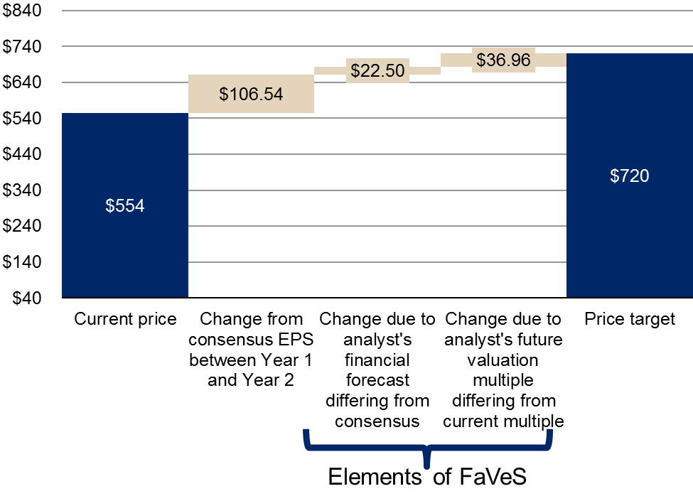  Did the analyst have a unique call?
Answer Key for “Did the analyst have a unique call?”
- McDonald’s
  - Using the FaVeS framework, the biggest driver to the 21% upside to the analyst’s price target is driven by an EPS estimate that is 13% ahead of consensus for next year, and so this is where we need to look to determine if it’s a unique call. The analyst cites “recovering Europe and growing emerging markets”, but it’s not clear if this is based on a hunch or due to unique research. The best stock calls are based on factors that can be forecasted better than the market and therefore it’s not clear this is a truly “unique” call.
- Starbucks
  - This call is somewhat unique in that it involves an EPS estimate and valuation multiple that are both out of consensus, which means they should both be examined. It appears the analyst has a unique call in terms of the financial forecast (based on a proprietary survey and conversations with industry sources), but it’s not clear that the valuation multiple is truly “unique” because there’s no explanation why 24x is being used versus the stock’s current 28x (why not 25x? or 20x?).
- Chipotle
  - What makes this call interesting is that the analyst’s EPS forecast is only 6% higher than consensus and the P/E ratio is essentially in line with consensus (i.e. the current P/E multiple). About two-thirds of the upside to the price target is driven simply by the company continuing to grow its earnings near 20%. Regardless of how the analyst wants to pitch the story, given that his EPS estimate and multiple do not differ much from consensus, he doesn’t have a “unique” stock call. (Unfortunately, this happens all too often.)

Find the F’s
Instructions for the “Find the F’s” exercise:
- Step 1: Count the number of “f's" you see in the sentence below:_______
- Step 2: Wait for additional instruction from the facilitator

Two of the most powerful and effective of all human fears are the fear of failure and the fear of success.

“Rank Your Ability” Exercise
Instructions for the “Rank Your Ability” exercise:
- In the table below, rank your ability to perform the 10 tasks in terms of above or below average compared to professional peers at your experience level
- Specifically, rank your ability on a scale of 1% to 100% in terms of where you fall compared to your peers
- 100% would make you the master or “black belt” at that task
- 1% would say you have no idea how to conduct the task
- The column does not need to total 100%

 | z | Rank Your Ability  Task Rank Your Ability Compared to Peers (1% to 100%)  - Using Excel efficiently for financial modeling  - Accurately forecasting earnings for a universe of stocks  - Effectively interviewing company management  - Extracting the most important pieces of information from a company conference call  - Finding important information quickly in a regulatory filing  - Setting accurate price targets  - Efficiently scanning the news wire services for stories that impact my sector  - Effectively presenting stock ideas to others  - Being a good listener  - Being empathetic to other people’s needs

“How Does Your Future Look?” Exercise
Instructions for the “How Does Your Future Look?” exercise:
- Put a check mark next to the events below that have occurred in your life or you believe may occur in your lifetime
 | z | Instructions for the “How Does Your Future Look?” Exercise:  Life Experience  Own my own home  Achieve annual earnings that are in the top 1% of the population of my country  Travel overseas for 10 or more days with my spouse or family  Experience a doubling of my personal investment portfolio in a five year period  Be among the top 10% of alpha-generators among my peers  Live past 80 years old  Be recognized by my peers for a major achievement  Not spend a night in the hospital until I’m over 70 years old  Have an academically-gifted child  Be at the ideal weight for my age for at least 10 years  Have a drinking problem  Permanently lose my house keys  Get divorced from my spouse (or future spouse)  Lose my passport when traveling  Be diagnosed with cancer or heart disease before age 75  Have dental problems requiring surgery or implants  Conclude I’m in the wrong career  Be a victim of a crime  Be involved in a major car accident  Home significantly damaged by natural disaster (flood, storm, fire, etc.)

Notes
z
z
z
z
z
z
z
z
z
z
z
z
z
z
z
z
z
z
z
z
z
z
z

End of Module Section - Do not delete or alter this paragraph and bookmark – Insert all module and lesson content prior to this red non-printing paragraph and bookmark

