Develop and Deploy a Marketing Strategy That Maximizes Wallet Share

Learner Workbook
NOTE: Please ensure you can interact with this document during the workshop in one of these methods:
- With a keyboard (as a Word document); or
- With pen (as a hard copy)

This document has been created for registered participants of AnalystSolutions’ workshops and should not be copied or re-distributed

Develop and Deploy a Marketing Strategy That Maximizes Wallet Share

Acknowledgments
Some of the content for this workshop comes from Best Practices for Equity Research Analysts, authored by James J. Valentine, CFA, and published by McGraw-Hill.

Trademarks & Copyright Acknowledgements
None of the material in this document can be reproduced or distributed without the written consent of:

AnalystSolutions, LLP
1685 Burr Oak Drive
Libertyville, IL 60048-9477
USA
+1-203-321-9400
AnalystSolutions.com

Table of Contents

Overview 1
Purpose 1
Module: Introduction 2
Self-Assessment: Sell-side Marketing Efforts 2
Module: Build Optimal Marketing Plan 5
Selecting Marketing Channels 5
Module: Research Investment Controversies 7
Exercise: Select Optimal Universe 7
Identify Critical Factors and Key Assumptions 9
Exercise: Evaluate Your Research Process 11
Module: Effectively Communicate Using ADViCE™ 13
Exercise: Evaluate Your Communication Effectiveness 13
Module: Assemble & Prioritize Client List 15
Example Lists from Market Data Services 15
Module: Develop Client Relationships with PRACTICE™ 17
PRACTICE™ Framework 17
Appendix 18
Transformation Action Plan 18
Section 1: One-Year Marketing Goals 18
Section 2: Client Interaction Metrics 19
Section 3: Locations for Marketing Days 20
Section 4: Optimize Your Coverage Universe 21
Section 5: Develop Commercial Research Ideas 22
Section 6: Market Research for Your Services 23
Section 7: Self-Assess Your Client Call List 24
Section 8: Developing Client Relationships with PRACTICE™ 25
Notes 27

Overview

Purpose
 | Why a Develop and Deploy a Marketing Strategy That Maximizes Wallet Share program?  The buy-side spends over $10 billion on sell-side equity research, with the majority concentrated around a small portion of analysts from fewer than ten of the largest firms, suggesting there is an elite group that has cracked the code of successful marketing, leaving the majority of the sell-side on the outside.  This workshop takes analysts through the best practices of the highest-rated analysts to de-mystify and systematize the core elements of successful marketing initiatives, all with the goal of increasing market share.
 | Learning Objectives  After completing this program (covering the BREAD™ framework), participants will be able to:  - Build a 12-month marketing plan with quantifiable goals for all of the key marketing efforts, such as number of client interactions, morning call appearances, cities/regions to be visited, reports to be written, etc.  - Research client-centric investment controversies by covering the optimal universe of stocks and conducting research to answer the questions surrounding each stock’s 1-4 critical factors (EPIC™ framework)  - Effectively communicate in a manner buy-side clients want to receive (ADViCE™ framework) by 1) showing awareness of alternative views, 2) being differentiated, 3) validating out-of-consensus views, 4) being conclusion-oriented; and 5) delivering the message so it’s easy to consume  - Assemble and prioritize a client call list that maximizes votes and commissions  - Develop client relationships by mastering 8 key influence skills (PRACTICE™ framework)

Module: Introduction

Self-Assessment: Sell-side Marketing Efforts
Instructions for Sell-side Marketing Efforts Self-Assessment:
- Answer the questions as truthfully below as possible (you will not be asked to share your results with anyone)
- For Table 1, complete the “Response” column on a scale of 1 to 5
  - 1 = Strongly disagree
  - 5 = Strongly agree
- For Table 2, respond with the appropriate number
- Wait for instructions to score your results

z | Sell-side Marketing Efforts Assessment, Table 1  Question Response (Strongly Agree = 5) Score (wait for instructions)  - My best sources of insights about a company are its firm management.  - I am ranked among the top 20% of my peers (internal or external)  - My institutional sales force is a critical tool that I leverage regularly for getting my message to clients  - My clients tell me I publish reports on topics not being discussed by other sell-side analysts  - I enjoy creating and publishing quarterly review reports.  - I am uncomfortable when clients disagree with my view.  - I find my best days at work are when I speak with many clients  Total for “Score” column  Divide “Total” above by the number of questions to get the average per question  Divide the row above by 5 to get the percentage of the maximum possible %  Sell-side Marketing Efforts Assessment, Table 2  Question Response  - On average, I (and my team, if relevant) proactively work on approximately this many research projects at any point in time, so that I have product to publish on a regular basis  - I receive this many incoming calls from our firm's top-tier clients in a typical month  - I have a "strong" relationship with this many clients, defined as: "I'm one of their top 3 sources for my assigned universe of stocks"  - I have this many interactions with my firm's top-tier clients in a typical month (personalized interactions where the client is responding). Excludes non-personalized blast emails/voicemails.  - Over a typical 3-month period, I spend this percentage of my professional time (e.g., “work hours”) speaking with clients, via phone or in person, excluding travel time  Please DO NOT proceed to the next page until told to do so

z | Table 2 Ideal Scores  Question Ideal Score  - On average, I (and team, if relevant) proactively work on approximately this many research projects at any point in time, so that I have product to publish on a regular basis 3 to 5  - I receive this many incoming calls from our firm's top-tier clients in a typical month Over 20 is good Over 40 is great  - I have a "strong" relationship with this many clients, defined as: "I'm one of their top 3 sources for my assigned universe of stocks" Over 30 is good Over 50 is great  - I have this many interactions with my firm's top-tier clients in a typical month (personalized interactions where the client is responding). Excludes non-personalized blast emails/voicemails. Over 100 is good Over 150 is great  - Over a typical 3-month period, I spend this percentage of my professional time (e.g., “work hours”) speaking with clients, via phone or in person, excluding travel time 25% to 50% is ideal, depending on team size

Module: Build Optimal Marketing Plan
Goes to 600

Selecting Marketing Channels
z | Marketing Time Per Channel
z | Complete the Excel Worksheet to Identify Available Marketing Hours:  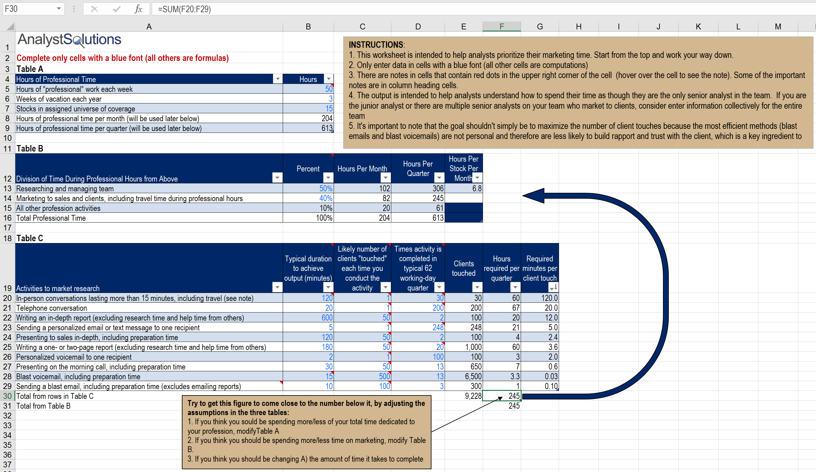

Module: Research Investment Controversies

Exercise: Select Optimal Universe
Instructions for “Select Optimal Universe” Exercise:
- The goal of this exercise is to identify the optimal research universe that will allow you to be relevant to at least 80% of your firm’s largest clients while ensuring adequate time for marketing
- Use your preferred service to identify the most granular sub-industries you cover (GICS level 4, FactSet’s RBICS’ level 6, Refinitiv’s/LSEG TRBC, level 5, etc.) For example, the GICS consists of approximately 11 sectors, 24 industry groups, 68 industries and 157 sub-industries. The size of your local market and the number of stocks you are expected to cover will dictate if you can focus on one or many sub-industries. See the table that follows for examples of classifications that have many candidates while others have few.
- Remove stocks from your universe that do not fall within your selected classification level unless required to follow for internal reasons or they provide a tremendous competitive advantage (recall any information spent on these stocks takes time away from your core franchise, which puts you at a competitive disadvantage)
- Using your market data service provider (e.g., Bloomberg, FactSet, Refinitiv/LSEG, etc.), download the following data for all stocks that have the same GICS industry group and industry or ICB sector as stocks in your current universe (see example report that follows):
  - Ticker
  - Company name
  - Market capitalization
  - Average daily trading volume (in shares, if commissions are paid per share or in dollar value, if commissions are paid as a percentage of trade value)
  - Number of analysts covering stock
- Strongly consider dropping stocks in the bottom 20% of trading volume (see those highlighted in red below) unless they provide a tremendous competitive advantage
- If not already covered, strongly consider picking up coverage of any stocks within the top half of trading volume for your sub-industrie(s), especially if they have a below-average number of analysts covering the stock
- Go to the Transformation Action Plan (TAP) section titled “Optimize Your Coverage Universe” to identify stocks you will likely pick up or drop in order to ensure you are covering the optimal universe of stocks
z | Example Report of GICS Sectors and Industries  Short Name Market Cap Total Analysts Average Volume GICS Sector GICS Ind Grp Name GICS Ind Name  UNITED PARCEL-B $95,894 24 2,200,175 Industrials Transport Air Freight & Logistics  FEDEX CORP $46,346 25 1,512,924 Industrials Transport Air Freight & Logistics  CH ROBINSON $9,931 29 1,247,365 Industrials Transport Air Freight & Logistics  EXPEDITORS INTL $9,210 18 866,886 Industrials Transport Air Freight & Logistics  XPO LOGISTICS IN $3,891 19 1,307,189 Industrials Transport Air Freight & Logistics  HUB GROUP-A $1,384 20 214,451 Industrials Transport Air Freight & Logistics  FORWARD AIR CORP $1,286 13 125,088 Industrials Transport Air Freight & Logistics  ATLAS AIR WORLDW $1,010 9 287,088 Industrials Transport Air Freight & Logistics  AIR TRANSPORT SE $813 6 234,024 Industrials Transport Air Freight & Logistics  ECHO GLOBAL LOGI $676 13 278,913 Industrials Transport Air Freight & Logistics  DELTA AIR LI $29,043 15 9,453,867 Industrials Transport Airlines  SOUTHWEST AIR $23,097 17 5,794,826 Industrials Transport Airlines  AMERICAN AIRLINE $18,838 14 7,766,793 Industrials Transport Airlines  UNITED CONTINENT $16,427 16 4,437,394 Industrials Transport Airlines  ALASKA AIR GROUP $8,096 12 1,194,654 Industrials Transport Airlines  JETBLUE AIRWAYS $5,589 14 5,665,385 Industrials Transport Airlines  WESTJET AIRLINES $2,836 17 330,819 Industrials Transport Airlines  SPIRIT AIRLINES $2,781 12 1,089,393 Industrials Transport Airlines  AIR CANADA $2,665 16 1,739,559 Industrials Transport Airlines  HAWAIIAN HOLDING $2,537 10 500,112 Industrials Transport Airlines  VIRGIN AMERICA I $2,415 10 886,844 Industrials Transport Airlines  ALLEGIANT TRAVEL $2,204 11 128,102 Industrials Transport Airlines  SKYWEST INC $1,360 5 343,184 Industrials Transport Airlines  EXCHANGE INCOME $976 10 106,512 Industrials Transport Airlines  CHORUS AVIATION $808 8 390,002 Industrials Transport Airlines  KIRBY CORP $3,207 12 813,996 Industrials Transport Marine  MATSON INC $1,721 5 250,297 Industrials Transport Marine  UNION PAC CORP $78,569 28 3,020,812 Industrials Transport Road & Rail  CAN NATL RAILWAY $65,245 28 1,903,939 Industrials Transport Road & Rail  CANADIAN PACIFIC $28,491 29 446,590 Industrials Transport Road & Rail  CSX CORP $28,039 28 5,999,848 Industrials Transport Road & Rail  NORFOLK SOUTHERN $27,482 28 1,289,550 Industrials Transport Road & Rail  KANSAS CITY SOUT $9,681 21 1,178,382 Industrials Transport Road & Rail  GENESEE & WYOMIN $3,836 13 347,972 Industrials Transport Road & Rail

Identify Critical Factors and Key Assumptions
Identify Critical Factors and Key Assumptions
- The purpose of this exercise is to identify the key assumptions surrounding the critical factors for at least one stock, which is the first step before reaching out to information sources
- Properly identifying the 1-4 critical factors for a given stock requires detailed research (typically 3-10 hours of work), which is beyond the scope of this workshop and so it’s worth noting the steps below are an abbreviated (and inferior) method compared to the full method (discussed in our workshop Identify & Monitor a Stock’s Critical Factors)
- Using our EPIC™ framework the ideal critical factor will meet all of these criteria:
  - Exceed my materiality threshold
  - Probably going to occur during my time horizon
  - I’m good at forecasting factor and catalyst
  - Consensus is poor at forecasting or spotting factor
- After reviewing the examples in the table below, list 1-3 critical factors for a stock of interest
- In the two right-most columns below, provide assumptions that must be better understood to gain greater clarity around each of your critical factors
- Avoid falling into the “confirmation bias” mind trap, by:
  - Not creating assumptions like this: “Worsening regulatory environment”
  - Instead, phrase the assumption more neutrally, like this: “Changes in regulatory environment.” This keeps you open to the idea that your research may find the environment isn’t worsening but is actually improving
  - Recall the goal is to identify the assumptions for the critical factors, because they should be the primary targets of your future research

 | z | Identify Critical Factors and Key Assumptions Table  Sector or Stock Critical Factor Assumption #1 Assumption #2  Airbnb (online travel agency) Growth of online travel agencies Rate of market share gains from traditional hotel channels Cost advantage of online travel agency vs. traditional channels  Amazon.com Market share shift from traditional retailers Adoption rate of e-commerce within emerging markets Adoption rate of mobile apps for retail purchases  IBM Migration to cloud-based solutions Rate of growth of cloud-based enterprise applications Level of security offered in the cloud vs. in-house options  Nike Top line growth rate keeping up with historical trends Changes in demand from international markets Changes in broad athletic activities  NVIDIA (graphics tech) Growth of virtual reality as mainstream product Adoption of virtual reality by mass markets Cost to produce high quality virtual reality devices that can be used in the home  SolarCity Growth of renewable energy revenue Changes in energy storage costs Impact from changes in oil and natural gas prices  The Gap Apparel pricing deflation Adoption of off-price and low-price fashion Use of mobile devices for price discovery  Time Warner Cable Growth of competing content providers such as Netflix, Amazon and HBO Customer loyalty for the cable bundle vs. new entrants Potential growth of cable-provider broadband offering (which is required to access new entrants)  T-Mobile Competitive pricing among the wireless carriers Timing when domestic smartphone becomes saturated Changing regulations  VMware (software) Growth of Open Source software vs. traditional vendors Open Source providers going public IT leaders selling services that rely on Open Source solutions  Walgreens (drug retailer) Generic drug price inflation Changes in FDA regulation of non-generic drug manufacturers Distribution channel consolidation  Your Stock #1: Your Critical Factor #1: Your Assumption #1: Your Assumption #2:  Your Stock #2 Your Critical Factor #2: Your Assumption #1: Your Assumption #2:  Your Stock #3: Your Critical Factor #3: Your Assumption #1: Your Assumption #2:

Exercise: Evaluate Your Research Process
Evaluate Your Research Process
- The purpose of this exercise is to determine if you are conducting research in a manner that will yield proprietary, differentiated insights, which is the demand of buy-side clients
- Evaluate 1 to 3 of your reports or presentations (one at a time) using the table below
- In this stage your focus should be on your research process, rather than your communications style, which will be covered in the next module
z | ENTER™ Quality Checklist  ENTER™ Quality Checklist Yes/No/Not Clear  Expectational  Do you have a forward-looking view in terms of the stock and the critical factor(s) likely to move the stock?  Have you identified the catalyst(s) likely to move the stock and important dates when the catalyst is most likely to cause the stock to move to your price target?  Have you framed company management’s forecast in terms of your independent financial forecast (rather than just repeat management)?  Novel  Do you have a piece of information or insight that is new and not widely understood within the financial markets?  Have you explained where your view falls within the FaVeS™ framework, in terms of identifying if he has a superior Financial forecast, Valuation method/multiple, or unique view about market Sentiment?  Do you know why the market does not have your view?  Thorough  For the critical factors that are key to the stock call, did you research more than one source or confirm the insight with an independent source?  Did you conduct detailed modeling in the area surrounding the critical factor(s)?  Do you avoid using management guidance as the primary justification for the call?  Examinable  Do you have the following details that could be presented to a stock selection committee?  - Data or insights about the critical factor(s)?  - Detailed financial forecast or valuation analysis, key to the investment thesis?  Revealing  Have you created upside, downside, and base-case scenarios to identify where the investment thesis could have flaws?  Have you identified specific risks beyond the macro?  Have you provided his conviction level to others, even if it is not strong?

Module: Effectively Communicate Using ADViCE™

Exercise: Evaluate Your Communication Effectiveness
Evaluate Your Communication Effectiveness
- The purpose of this exercise is to determine if you are communicating effectively to clients (the prior section was on researching effectively)
- Evaluate 1 to 3 of your reports or presentations (one at a time) using the table that follows (5 = strongly agree)
- In this stage, your focus should be on your communications rather than your research process
z | Checklist for Communicating Stock Calls Successfully  Criteria 1=Strongly Disagree 5=Strongly Agree  - The communication focuses primarily on something not widely known by the market (if not, why is this being communicated?)  - The communication focuses on the future (If it is discussing quarterly results or other historical data is the focus on how this information helps in forecasting the future)?  - The communication begins with a brief conclusion that explains:  - If you are positive/negative towards the stock; and  - How your forward view is changing or being reinforced with this communications  Evaluate only one of the following:  - If the communication is not about a recommended stock, it adds significant forward-looking insights for those who have an interest in the stock?  - If the communication is about a recommended stock, it includes:  - A future price target; and  - How you differ from consensus in at least one of these areas (for the future price target):  - Financial forecast  - Valuation multiple  - Valuation method  Evaluate one of the following (unless the analyst differs in both areas):  - If the forecast differs from consensus:  - The communication focuses on why consensus is likely wrong, other than just supplying company management’s view  - There is a financial model identifying how you differ from consensus  - If the valuation multiple/method differs from consensus, the communication focuses on why the market is likely to change its view between now and the price target date  - The communication identifies the catalyst (and its timing) that will need to occur to get consensus to change its current forecast or valuation multiple/method  - The communication includes upside, downside, and base-case scenarios for the assumptions surrounding the area(s) that differ from consensus  - It includes alternative views and why they are less likely to occur than your view  - It explains the most significant risks to the call, beyond the macro  - The communication is easy to understand for a generalist analyst or portfolio manager

Module: Assemble & Prioritize Client List

Example Lists from Market Data Services
z | Bloomberg Holders Matrix (HDSM)  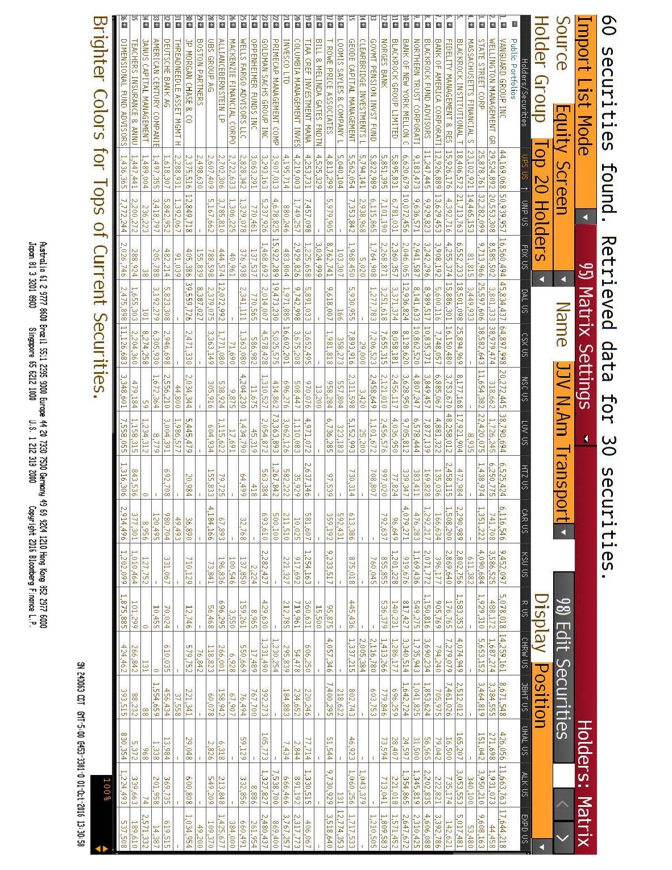
z | FactSet Comprehensive Ownership Report  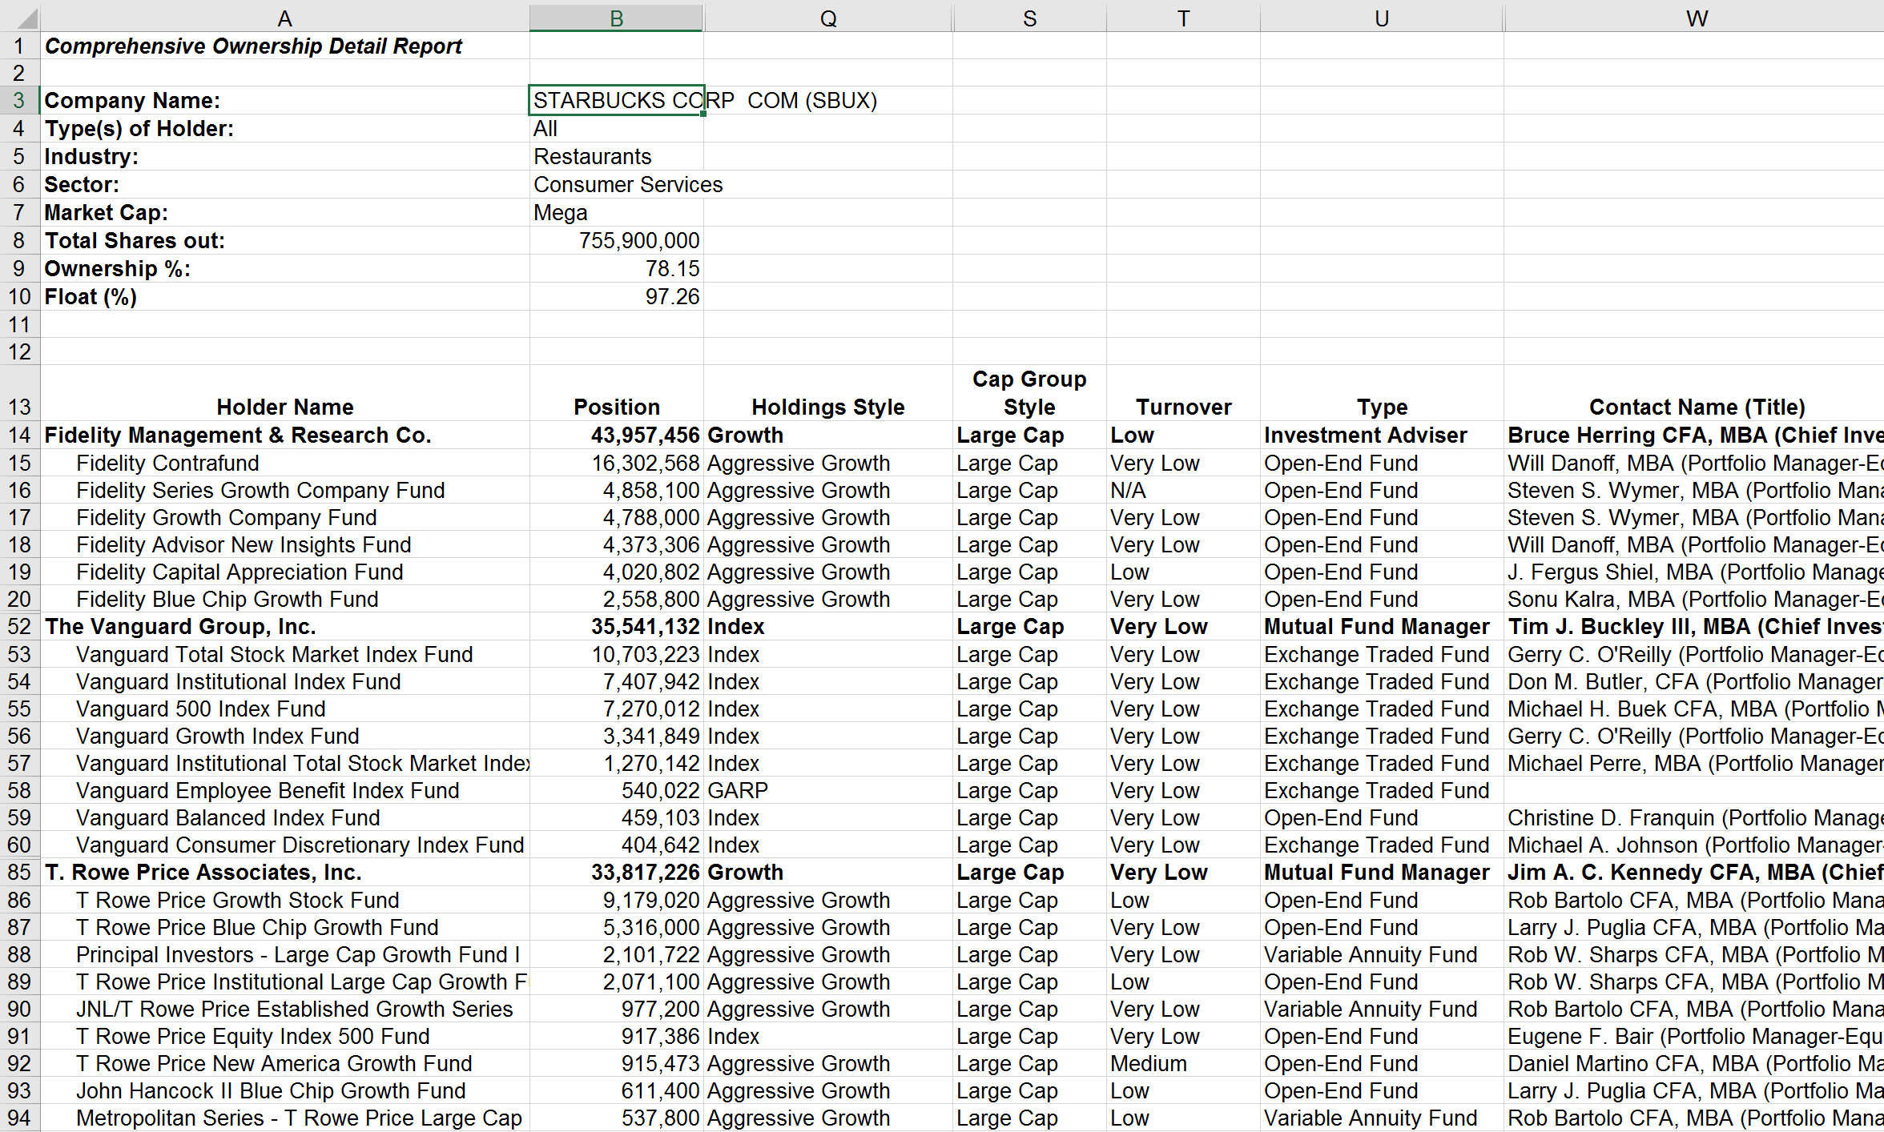

Module: Develop Client Relationships with PRACTICE™

PRACTICE™ Framework
z

Appendix

Transformation Action Plan
Instructions for the Transformation Action Plan (TAP):
- Throughout this workshop, complete the TAP below
- Apply the key points after the workshop to help you improve your performance
- This will not be collected, so write in a manner that will help you utilize the concepts being learned

Section One-Year Marketing Goals
- In the space below, highlight where you currently stand and where you would like to be in one year (If you are uncertain of a current metric, provide your best estimate)
z | One-Year Marketing Goals  Metric Current Level One-Year Goal  - Rank within the department for client votes  - Rank within the department for the salesforce poll  - Rank in a public poll (if relevant to you)  - Rank within the department for the number of non-deal corporate roadshows  - Number of monthly incoming client calls  - Number of monthly client conversations  - Number of reads for major reports (e.g., upgrades, think-pieces)  - Compensation as a percentage of the top performing analyst within my firm (e.g., 50%, 90%, etc.)

Section Client Interaction Metrics
- After completing the Excel file “Available Marketing Hours,” create your marketing plan for the next 12 months by completing the table below
- The information you provide is on a quarterly basis because it’s good to periodically check on your performance (at least quarterly and preferably monthly)
z | Your Goal for Client Interaction Metrics for Next 12 Months (on a quarterly basis)  Marketing Plan Frequency per quarter  - In-person conversations lasting more than 15 minutes, including travel  - Telephone conversations  - Writing an in-depth report (excluding research time and help time from others)  - Sending a personalized email or text message to one recipient  - Presenting to sales in-depth, including preparation time  - Writing a one- or two-page report (excluding research time and help time from others)  - Personalized voicemail to one recipient  - Presenting on the morning call, including preparation time  - Sending a blast email, including preparation time (excludes emailing reports)

Section Locations for Marketing Days
- Looking at the prior table, review the number of “in-person conversations…including travel)
- Estimate the number of client meetings you will typically have in a day when you are conducting marketing out of the office (include meetings in the city where you work)
- Divide the number of in-person conversations you intend to have by the number of meetings per day you are likely to achieve to determine the number of days you will be out of the office for marketing. Multiply this number by 4 to get an annual number. Put this in the “Total” box below
- Based on the number of days, complete the table below
z | Locations to Visit for Marketing  City/region Number of marketing days within the next 12 months  Total Marketing Days Per Year

Section Optimize Your Coverage Universe
- Based on the exercise in Module 2, identify the stocks you will likely pick up or drop in order to optimize your coverage universe
z | Optimize Stock Universe  Stock Pick-up or Drop? Rationale

Section Develop Commercial Research Ideas
- The purpose of this portion of the TAP is to generate the report or presentation titles you intend to research that will appeal to clients
- From the critical factor assumptions completed in the prior exercise, derive possible outcomes you will likely reach after conducting research. This can be in the form of a hypothesis or report/presentation title.
- Also, record the type of research you will need to conduct to better measure the assumptions for the critical factors (e.g. primary research, individuals to contact, etc.)
z | Develop Commercial Research Ideas  Hypothesis or Report/Presentation Title Individuals/roles to contact or research to be conducted  Example: Netflix’s expansion into international markets will allow for significantly faster growth than current market expectations - Conduct survey of potential users in Netflix’s new international markets - Speak to John Smith and Jane Doe, industry experts on Netflix’s new international markets

Section Market Research for Your Services
- Think of your 3 to 5 smartest clients in terms of understanding the sector and company fundamentals for your sector (if you are new to a sector, ask institutional salespeople for the clients they believe are the most knowledgeable about your sector)
- In the tables that follow, list the client names and the questions you could ask in order to conduct market research to understand the need for your services better
- Contact these clients, but do so differently than typical marketing. Email or phone them to ask them “Would you have 15-20 minutes to help me with a project?” Buy-side analysts are often flattered to help if they believe they are among a few select “experts” you seek help from (make sure to pitch it this way). When clients do not have time, they will usually respond as such.
z | Table 1, Clients to Contact  Client Name Rationale (client’s strengths)  Table 2, Questions to Ask  Question  - Competitor’s strengths (and weaknesses if client is comfortable discussing)  - Capabilities missing among existing sell-side analysts  - Topics not being researched by the sell-side  - Likes/dislikes of sell-side analyst’s research and marketing  - Other:  - Other:

Section Self-Assess Your Client Call List
Instructions for Assessing Your Client Call List
- Evaluate each item on a scale of 1 to 5, with 5 as “strongly agree”
z | Self-Assess Your Client Call List  Topic Your Response  - I always have an updated list of my firm’s priority accounts  - I periodically check to see which of my firm’s priority accounts have little or no interest in my sector(s) and why (unless it’s obvious based on their investment mandate)  - I periodically check to see which firms are among the top 20 holders of each of my stocks  - I know at least one counterpart at each of my firm’s top priority accounts where there is interest in my stocks  - I proactively contact sales (or seek out on my own) when I do not have a contact at any of my firm’s top priority accounts where there is interest in my stocks  - I have at least 50 clients identified to call when I change a stock recommendation, prioritized by potential votes/commissions for my firm  If you self-scored yourself less than a “4” on any of the items above, create an action plan for yourself on how you can make improvement in this area(s):

Section Developing Client Relationships with PRACTICE™
- This portion of the TAP reinforces the PRACTICE™ framework
- Most of the items in the table that follows are best practices to develop and strengthen client relationships (as part of the PRACTICE™ framework)
- Review the table that follows and rate each element using this scale:
  - 1 = Already firmly in my routine
  - 2 = Part of my routine but want to improve further
  - 3 = Not part of my routine and want to develop
  - N/A = Not interested in making this part of my routine
z | Elements of the PRACTICE™ Framework  Marketing Skill Element of PRACTICE™ Rating  - I focus my influencing efforts on my firm’s most profitable clients Prepare  - Before meeting new clients, I speak with sales to understand the client’s preferences and demeanor Prepare  - Before meeting/speaking with clients I ensure I am an expert on the critical factors most likely to drive my stocks Prepare  - I am an excellent communicator of my ideas Prepare  - I am an excellent listener (never interrupt; periodically check to ensure I understand client’s concerns, empathetic, etc.) Prepare, Rapport  - When I learn I have a new client, I proactively reach out to them immediately Rapport  - When starting a conversation with a client I make them feel important by using their name, offering a compliment and ask questions about them Rapport  - I am confident in my presentation style but not arrogant in that I never put down a client for not knowing more than me Rapport  - I start client meetings by asking the client about their current interests and how they would like to use the time Rapport Conform  - I always probe to understand a client’s needs as they pertain to my universe of stocks Ask about needs  - When speaking with a client, I begin by thinking in their style of investing to position my view Conform  - When meeting a new client, I show interest in something that is unique about them or their firm Conform  - I match my presentation style to the delivery style most desired by the client (formal vs. casual, cynical vs. open-mined, judicious vs. related with time, loud vs. quiet) Conform  - I avoid overuse of jargon when it may be misunderstood Conform  - I never mislead a client about my abilities Trustworthy  - I openly acknowledge where I could be wrong Trustworthy  - I follow through on my commitments to send follow-up information Trustworthy Ensure needs are met  - When meeting with or speaking with clients, I am always “in the moment” and remove all distractions from my thoughts (not looking at computer, phone, thinking about my return flight, etc.) Ignore distractions  - I periodically ask clients for their opinion on important topics Communicate persuasively  - When speaking with clients, I use metaphors, stories, analogies and visioning Communicate persuasively  - When meeting with clients, I use good body language (energetic, good eye contact, posture, smile, not crossing hands or legs, no smirks or signs of skeptics) Communicate persuasively  - I use weapons of influence to influence clients (reciprocation, commitment and consistency, social proof, liking, authority and scarcity) Communicate persuasively  - After meeting with a client, I ensure I meet all of their immediate needs within 24 hours Ensure needs are met  If you self-scored yourself a “2” or “3” on any of the items above, create an action plan for yourself on how you can make improvement in this area(s):

Notes

End of Module Section - Do not delete or alter this paragraph and bookmark – Insert all module and lesson content prior to this red non-printing paragraph and bookmark

