Maximize Your Time for Alpha Generation

Learner Workbook
NOTE: Please ensure you can interact with this document during the workshop in one of these methods:
- With a keyboard (as a Word document) or
- With pen (as a hard copy)

This document has been created for registered participants of AnalystSolutions’ workshops and should not be copied or re-distributed

Maximize Your Time for Alpha Generation

Acknowledgments
Much of the content for this workshop comes from Best Practices for Equity Research Analysts, authored by James J. Valentine, CFA, and published by McGraw-Hill.

Trademarks & Copyright Acknowledgements
None of the material in this document can be reproduced or distributed without the written consent of:

AnalystSolutions, LLP
1685 Burr Oak Dr,
Libertyville, IL 60048-9477
USA
+1-203-321-9400
AnalystSolutions.com

Table of Contents

Overview 1
Purpose & Learning Objectives 1
Introduction 2
Key Activities of Successful Analysts 2
“Do I Need to Improve P, S or E?” Exercise 4
Best Practices for Prioritization 6
Working Offensively vs. Defensively Case Study 6
Best Practices for Scheduling 7
Evaluate Your Professional Calendar Exercise 7
Best Practices for Working Efficiently 8
Responding to Interruptions Self-Assessment 8
Best Practices for Automating, Delegating, and Outsourcing 9
Automate, Delegate or Outsource Exercise 9
Appendix 11
Transformation Action Plan (TAP) 11
Section 1. “Prioritization, Scheduling, and Efficiency” Exercise 11
Section 2. “Prioritize Goals, Tactics and Activities” Exercise 11
Section 3. Best Practices for Scheduling 14
Section 4. Control Distractions and Disruptions 14
Section 5. Automate, Delegate or Outsource 14
Notes 15

Overview

Purpose & Learning Objectives
 | Why have a Maximize Your Time for Alpha Generation workshop?  Most analysts’ daily workflow prevents them from gaining an edge in generating alpha. Distractions such as an overfilled inbox, non-stop news alerts and too many unnecessary conference calls and meetings cause many analysts to lose their focus. The result can be following the herd for stock picks. Only by taking control of their day, can analysts create the time to develop a great out-of-consensus idea.  Strategic allocation of time is the best weapon in an analyst’s arsenal. As discussed in the best-selling book Best Practices for Equity Research Analysts, after watching hundreds of buy-side and sell-side analysts perform their jobs over 15 years, one fact is clear: the top analysts play offense with their time while everyone else plays defense. They ignore most, if not all, of the typical distractions found in their role. This allows them the time to explore unique avenues that lead to great stock picks. AnalystSolutions provides a highly innovative approach to help analysts shift from researching defensively to researching offensively in order to improve stock picking success.
 | Learning Objectives  After completing this program, participants will be able to:  - Utilize our prioritization pyramid and four-step process to dominate your calendar with alpha-generating activities and minimize low-value activities  - Through a comprehensive self-assessment, identify which of the 30 most common analyst activities support the tactics required to achieve your professional goals  - Utilize strategies to play “offense” by proactively filling your calendar with value-added activities and removing the “defense” activities often put there by others  - Apply guidelines for assessing the appropriate amount of time to spend on the most common equity research activities  - Utilize best practices to work more efficiently, including tactics to reduce interruptions and distractions from others  - Apply best practices for delegating, automating, and outsourcing the low-valued activities not likely to generate alpha

Introduction

Key Activities of Successful Analysts
z | GAMMA PI™  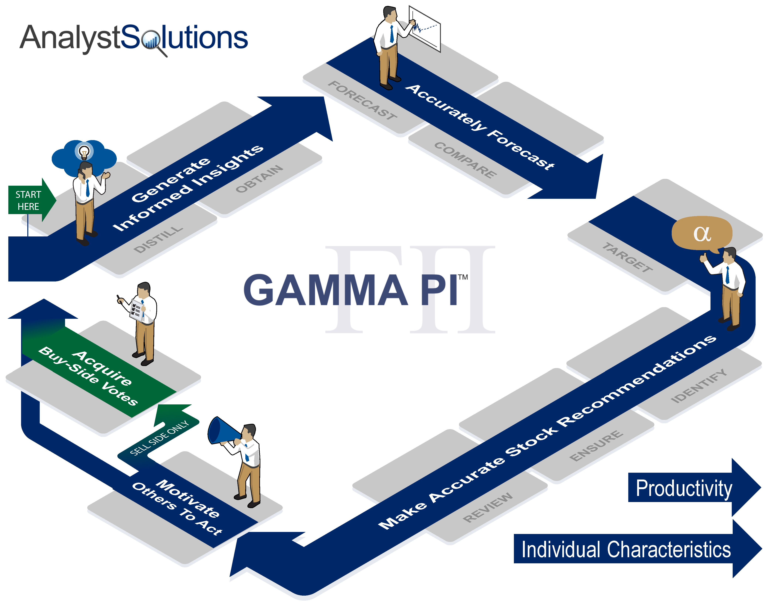

“Do I Need to Improve P, S or E?” Exercise
Instructions for the “Do I Need to Improve P, S or E?” exercise:
- Instructions: The purpose of this activity is to help you learn about what you need in order to be a good time manager, and to help you create an action plan to improve your time management skills
- Place an “X” in one of the boxes to the right of each item, depending on how you see yourself today- no one will see your ratings, so please be honest with yourself
- Ignore the letters in the second column and text below the table, which will be explained later
- When done:
  - If participating on-demand, play the video (which should be paused while conducting the activity)
  - If participating online with a live facilitator, designate when you are done by following the process explained at the beginning of the workshop
  - If participating in person, put down your pen, look up and await instructions
z | Behaviors Never Rarely Sometimes Frequently Always  - Accurately estimate how long tasks will take S  - Create an orderly workspace E  - Automate, delegate, or avoid low-value activities E  - Effectively handle interruptions E  - Exercise less frequently than I would like P  - Feel overwhelmed by email or voicemail P  - Frequently feel exhausted or stressed P  - Have my calendar, tasks, and contacts in one place E  - Have a note-taking system nearby to capture information E  - Know exactly where my time goes every day S  - Manage information effectively (review only once) E  - Miss a meal during the day P  - Multitask at work P  - Not clear about my goals and lack a plan to achieve them P  - On-time to meetings and conference calls S  - Participate in calls not relevant to my stocks P  - Process email and voicemail at specific times E  - Procrastinate on large projects P  - Schedule my week in advance, noting important tasks S  - Spend time in unnecessary meetings P  - Take time to listen to office gossip P  - Unsure how to best use my time at work P  - Use organizational tools/technology effectively E  - Use the first 5–10 minutes of the day to plan S  - Utilize a system for prioritizing my to-do list E  You will need instructions from the facilitator to proceed and score your results  P= S=  E=  Source: Adapted from Lisa J. Downs, Time Management Self-Assessment, American Society for Training and Development (ASTD) with modifications by James Valentine.

Best Practices for Prioritization

Working Offensively vs. Defensively Case Study
Instructions for the Working Offensively vs. Defensively case study:
- Read the case below and be prepared to answer the questions at the end
z | Amit and Lucas  There are two analysts, Amit and Lucas who work for Nickel Mine Asset Management. Both were hired 18 months ago from the same MBA class at Ivy League University.  Amit runs from one event to the next…  - Reading the 300-400 emails/messages and listening to the 10-15 voicemails he receives daily  - Reading 50-60 news stories for stocks under his coverage  - Participating in 5-7 calls and meetings requested by the sell-side, companies he covers, and his boss  - He struggles to leave the office before 8 pm each night because he’s so preoccupied with making sure no new piece of information regarding his universe of stocks gets past him. He finds he rarely has any unique ideas to offer his portfolio manager. As such, it doesn’t appear as though he’s going to be up for promotion.  Lucas spends part of his day on the same activities, but is more strategic in using his time…  - Lucas manages his inbound emails/messages in a manner so that he receives about 100 per day, only 25% as many as Amit. Over 30% of the emails/messages he receives are from individuals who have proven their value to his efforts. He scans the remaining 70% in about 15 minutes because he’s only looking for insights that impact the 2-4 most important factors surrounding each of his stocks.  - He has taken control of his voicemails in a similar fashion and finds he receives 3-7 per day, mostly from individuals returning his calls for information  - He sets aside 15 minutes twice a day to scan the major news outlets and read only stories that pertain to the 2-4 most important factors he has identified for his universe of stocks  - He rarely has more than ten phone calls or five meetings on a given day and those interactions are almost always initiated by him to better understand the most important factors surrounding one of his stocks  - Portfolio managers at his firm admire that Lucas usually has at least one significant insight every other week, and multiple smaller useful insights throughout the week. Confident that he’s likely to get promoted soon; he leaves work most evenings between 6 and 7 pm so that he can have dinner with his girlfriend.  Questions:  - Who is playing defense?  - What is preventing him from playing offense?

Best Practices for Scheduling

Evaluate Your Professional Calendar Exercise
z | Activity Generates Differentiated Insights Useful for Stock Picking  LOW HIGH  Initiating vs. Responding YOU INITIATE (OFFENSE) “Enabler” for Alpha Generate Alpha  YOU RESPOND (DEFENSE)  Waste of Time? Surprise Find

Best Practices for Working Efficiently

Responding to Interruptions Self-Assessment
Instructions for the Responding to Interruptions Self-Assessment:
- Use this assessment to evaluate the way you handle interruptions and distractions and to determine areas for improvement.
- Place an “X” in one of the boxes to the right of each item.
- Please complete the assessment honestly based on how you tend to behave right now (no one will see your results).
- Ignore the column titled “Letter”– it will be used to score your results later
- You will need help from the facilitator to score the results:
  - If participating on-demand, play the video (which should be paused while conducting the activity)
  - If participating online with a live facilitator, designate when you are done by following the process explained at the beginning of the workshop
  - If participating in person, put down your pen, look up and await instructions
z | Distraction Behaviors Letter Rarely To some extent For the most part To a great extent  When handling interruptions, I...  - Specify a time to get back to the interrupter E  - Remove myself from the distracting environment F  - Notify others when I cannot be disturbed E  - Block off time to work on priorities F  - Send calls to voicemail when I must focus E  - Close out of email or turn off the pop-up box F  - Avoid unnecessary meetings and events E  When interrupting others, I...  - Am mindful of their mood and demeanor A  - Leave a voicemail or note if they look busy A  - Avoid sitting with them for long periods of time A  - Keep conversations concise and to the point A  - Ask if they are available and, if not, when they will be A  - Am mindful if they ask not to be disturbed A  - Keep personal conversations to a minimum A  You will need instructions from the facilitator to proceed and score your results  E = Set Expectations with Others, F = Get More Focused, A = Aware of Your Behaviors  Source: Adapted from Lisa J. Downs, Time Management Self-Assessment, American Society for Training and Development (ASTD) with modifications by James Valentine.

Best Practices for Automating, Delegating, and Outsourcing

Automate, Delegate or Outsource Exercise
Instructions for the “Automate, Delegate, or Outsource Low-Valued Activities” Exercise:
- For this exercise, assume you have resources to help you with your daily activities, such as a capable internal associate who understands finance or an outside vendor who can complete basic financial analysis
- For each of the activities below, place an “X” in the box that represents the best course of action among these options:
  - Delegate
  - Automate
  - Outsource; or
  - Complete on your own
z | Automate, Delegate or Outsource Exercise  Activity Delegate Automate Outsource Self  - Update earnings model within 10 minutes of a company reporting earnings  - Update the balance sheet in an earnings model with information only available from the quarterly regulatory filing  - Call a company to ask for its expected depreciation level and tax rate for the next 4 quarters  - Update financial forecast based on new insight obtained during a one-on-one with a CFO  - Compute the inventory-to-sales ratio for each company in your universe of stocks  - Reformat an earnings model after a company radically changes its segment breakdown  - Listen to a company’s quarterly call immediately after it reports a big upside surprise  - Create the mechanics in a model for upside, downside and base-case scenarios  - Build a food-chain analysis of your sector by speaking with investor relations contacts and industry association representatives  - Build 10 years of quarterly historical financial statements for a company you’ve been asked to cover  - Identify the 2-4 critical factors most likely to move a stock  - Build a comp page to identify how current valuations vary from historical levels  - Enter your updated earnings estimates into a comp table  - Compile a list of upcoming earnings release dates for the stocks in your universe  - Scan all news stories in your sector to identify those that have key words of importance to your efforts  - Periodically check to see if your companies have filed their most recent regulatory filing  - Speak to trader about market concerns that are pushing down a buy-rated stock  - Read the entire first section of the financial paper (e.g., Wall Street Journal, Financial Times)  - Make travel plans to visit a company  - Send emails to a purchased list of industry contacts that contains a monthly survey asking for their feedback about critical factors for your universe of stocks  - Understand market psychology by speaking to buy-side analysts (and sell-side analysts if on the buy-side)  - Create a report to communicate an upgrade of a stock  - Read all inbound emails

Appendix

Transformation Action Plan (TAP)
Instructions for the Transformation Action Plan (TAP):
- Throughout this workshop, complete the TAP below
- Apply the critical points after the workshop to help you improve your performance
- This will not be collected, so write in a manner that will help you utilize the concepts being learned

Section “Prioritization, Scheduling, and Efficiency” Exercise
Based on the “Prioritization, Scheduling and Efficiency” exercise, in the table below, briefly discuss the specific area(s) where you want to improve:
Area | Action Plan
Prioritization
Scheduling
Efficiency

Section “Prioritize Goals, Tactics, and Activities” Exercise
- Reflect on the questions below and then develop an action plan in the following tables.
- Review the “Part B” table in your custom output
  - Review the right-most column. The lower the score, the more your day-to-day activities are not aligned with the priority you place on tactics required to achieve your goals. Highlight your two lowest numbers.
  - If your “WOT?” score is not the lowest score in the table, ask if you're placing too much priority on activities that are not necessarily helping you to achieve one of your tactics.
  - If you don’t have the score you want for one or more of the tactics, ask yourself how you can achieve that tactic based on your current prioritization of activities. In the space below, develop an action plan that you can use after the workshop, that answers these questions:
    - For the two tactics with the lowest “Activity Score” (right-most column), review their corresponding activities in “Part C” table, to determine which of the activities for this tactic you need to increase? OR
    - Do you potentially need to lower the importance of this tactic (Item A in the Part B table) because it’s unrealistic it can be achieved?
- Complete the tables that follow:
z | 1. I intend to increase these specific activities in order to support my high priority tactics  2. To make time for these new activities, I intend to decrease or eliminate these specific activities that do not support my tactics  3. Do you potentially need to lower the importance of one or more tactics (“Item A” in “Part B”) because it’s unrealistic it can be achieved? If so, reflect on the risk of reducing the importance of this tactic.  CONTINUE TO THE NEXT INSTRUCTION (stop just before the next “Section” begins)
z | - Refer to the table in “Part C” and look at the right-most column, which is the difference between the priority you believe an activity should command vs. the priority you’ve been placing on this activity.  - First, verify that those activities with the highest scores are those that need to be increased the most to help achieve your tactics and goals; and  - Those with the lowest scores are those that need to be reduced to free up time (this is the most important part of the exercise because you can’t ADD something to your schedule until you REMOVE another activity – old habits die hard)  - If you have scores of negative three (-3) or lower, and you intend to reduce those activities, in the space below record the steps you will take to ensure your new habits are reinforced day-to-day and week-to-week (to avoid falling back into your existing routine)?  - Review any “WOT?” activities that received a high ranking in the first column of numbers. Highlight the ones you intend to reduce.  Steps I will take to reduce unproductive activities:  STOP HERE UNTIL INSTRUCTED TO MOVE FORWARD
z | Section Best Practices for Scheduling  - After reviewing your schedule and best practices for scheduling, what changes will you make to maximize your schedule for alpha generation?  Steps I will take to optimize my SCHEDULE for alpha generation (and maximizing client votes for sell-side analysts):  I will reinforce these new best practices by:
z | Section Control Distractions and Disruptions  After reviewing the QRCs and self-assessment from this module on working more efficiently, these are steps I can take to better control distractions and disruptions:
z | Section Automate, Delegate or Outsource  These are low-valued activities that I can automate, delegate, or outsource:

Notes
End of Module Section - Do not delete or alter this paragraph and bookmark – Insert all module and lesson content prior to this red non-printing paragraph and bookmark

